# EC2 instance creation

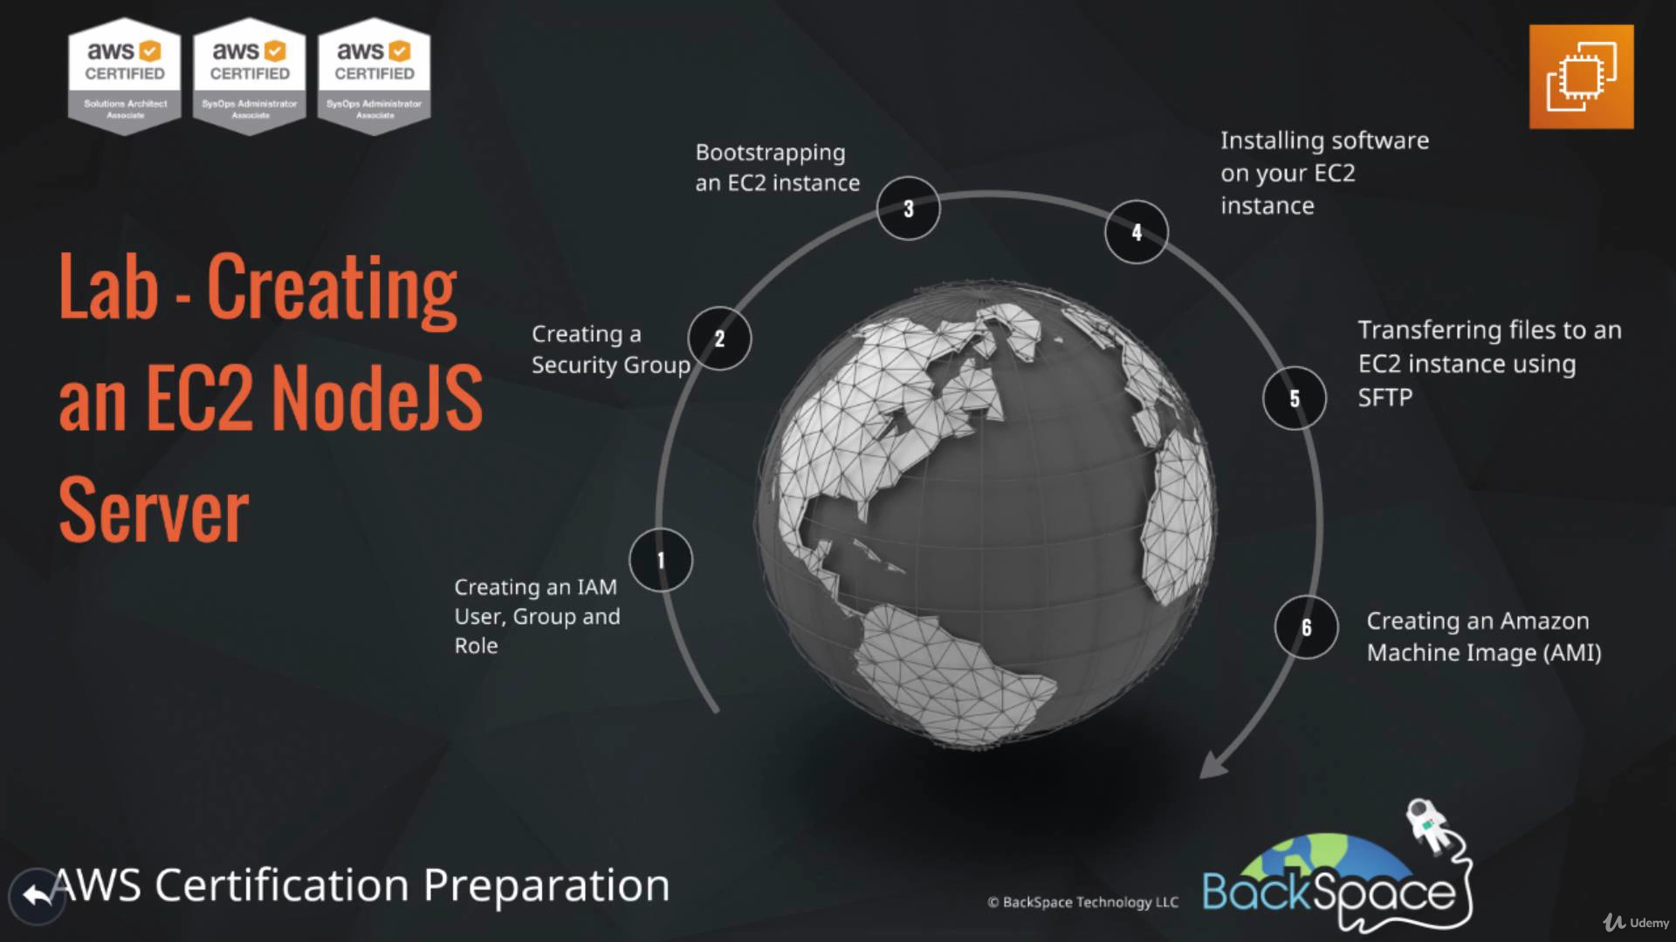

1. First we need to create the IAM user as the AWS general account comes with root access and its not good practice to use this account ( also this will help other people to loginto aws.)
2. Now add this user to some group (ex developer group)
3. Now user and group is created but it will not be able to access anything until we assign AWS policies to it.
4. Once User created download the below access keys
5. 9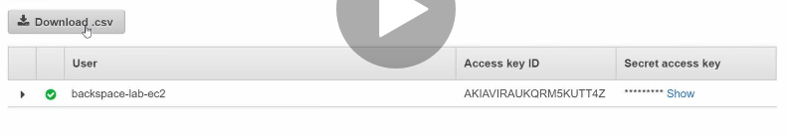
6. Now Attach a policy to the group (policy can be attached to user). Example – developerpoweruser policy.
7. Role -> This will help EC2 instance to access the AWS resources ( like other servers, disk etc) other wise EC2 instance will stay isolate.
8. While Creating Role, below category can be used.
9. 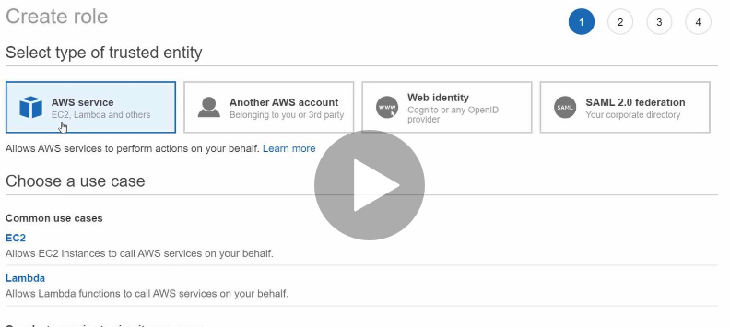
10. Now if we want to give this EC2 server access to S2 bucket then select the below policy
11. 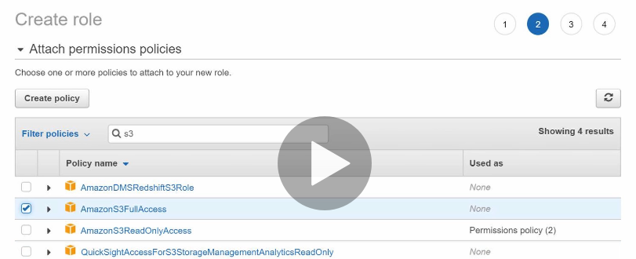
12. **Security Group –** This will allow incoming and outgoing traffic from EC2 server and also allow the secure file tranfer. So when ever some EC2 instance is created, some security group is a assigned to it.
13. **Inbound rules for security group should be like below**
14. 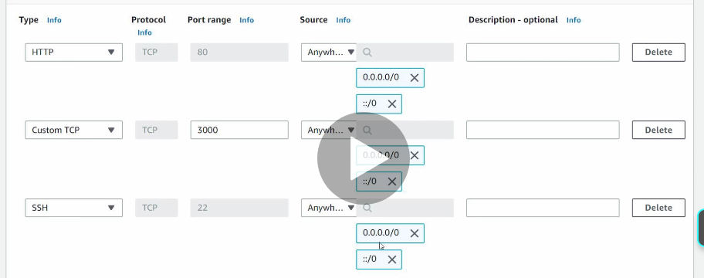
15. **Now Launch the EC2 instance and assign it to this security group**
16. 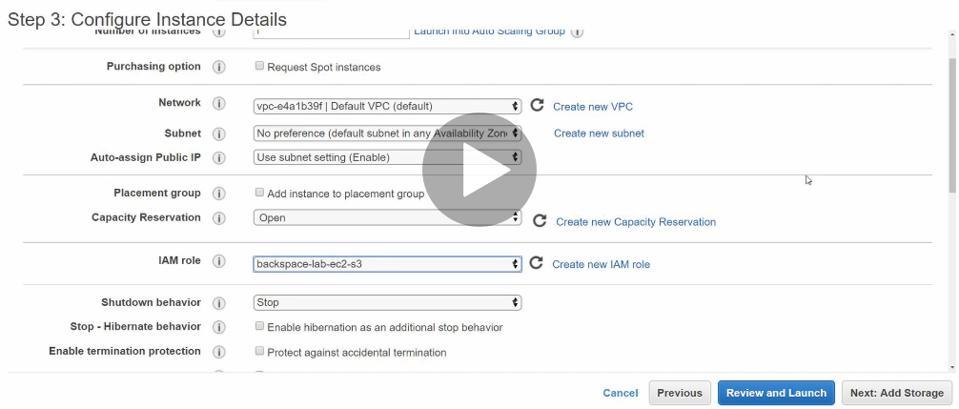
17. **In the Advance details of EC2 configuration,** we need to place a bash script which will run when the instance will be launch. This is nessacery to do few things like yum update, setting firewall rules of EC2 linux OS.(Like here we need to divert the incoming traffic from port 80 to 3000.)
18. 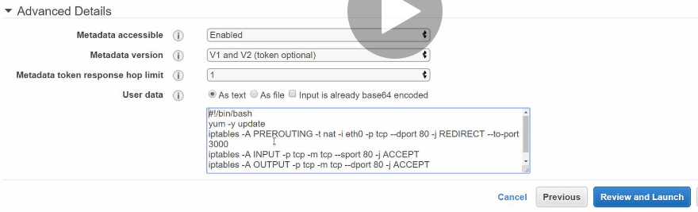
19. **Now instance is launched with security grp.**
20. **Now we need to install few software on EC2 like app servers, agents etc.to do that first we need to copy those software to EC2.**
21. **After connecting the server manually through ssh putty we do all file copy and software installation manully.**
22. **Once the EC2 is ready, now we need to create the AMI Image ( so that we done need to copy and install all those softwares on every servers)**
23. **Create Image from existing server**
24. 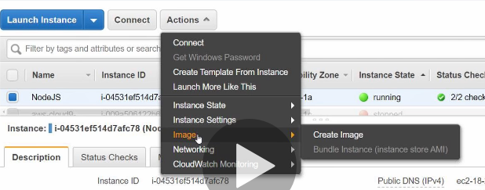
25. **Now Launch new EC2 instance from AMI image.**
26. 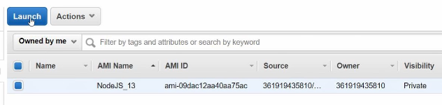
27. **After launching , set the configuration like before ex , public IP setting, IAM Role and Advance setting for EC2 instance launch time bash script**
28. **Give the tag details and assign a security grp to it and lauch.**
29. **Once launched, you will see all the files and softwares are preinstalled from base AMI image.**

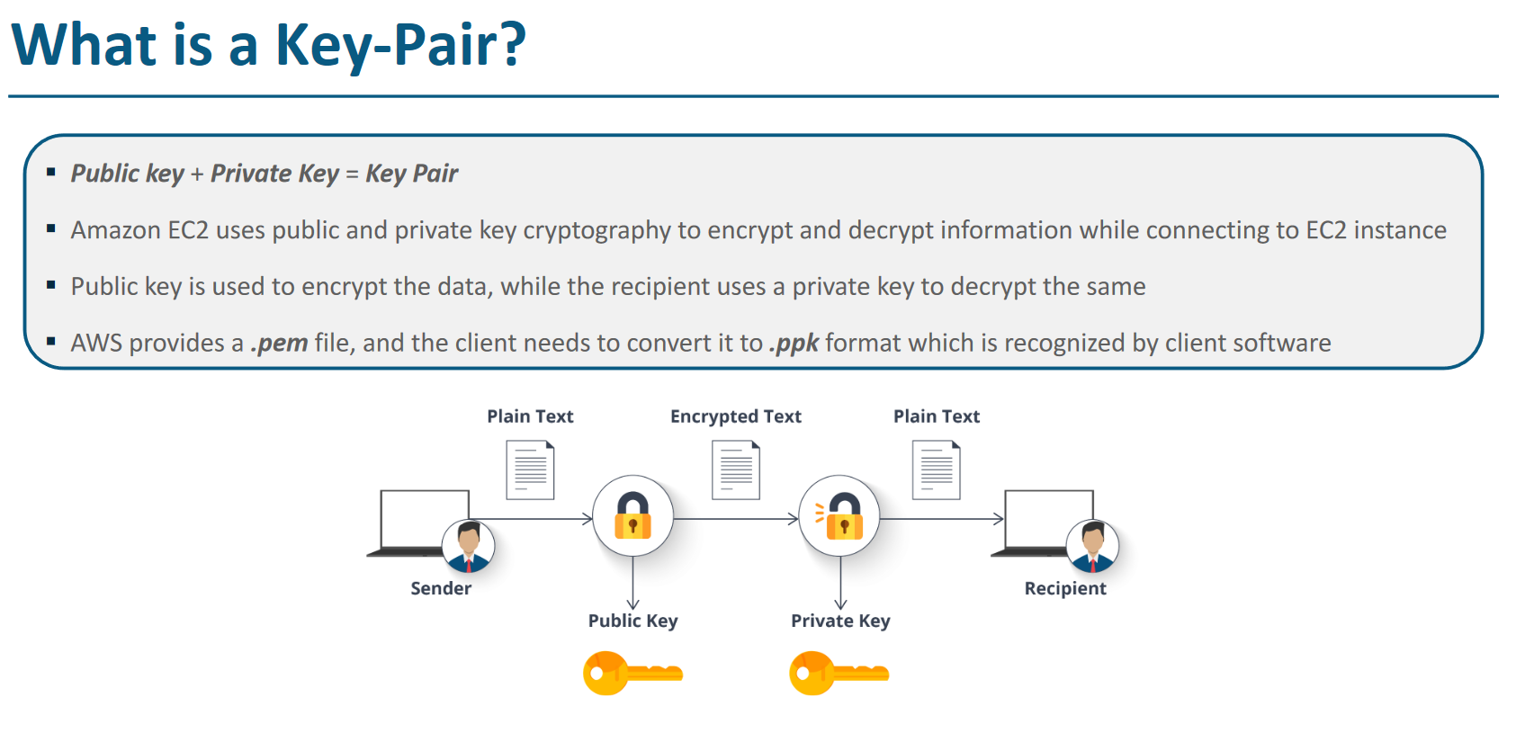

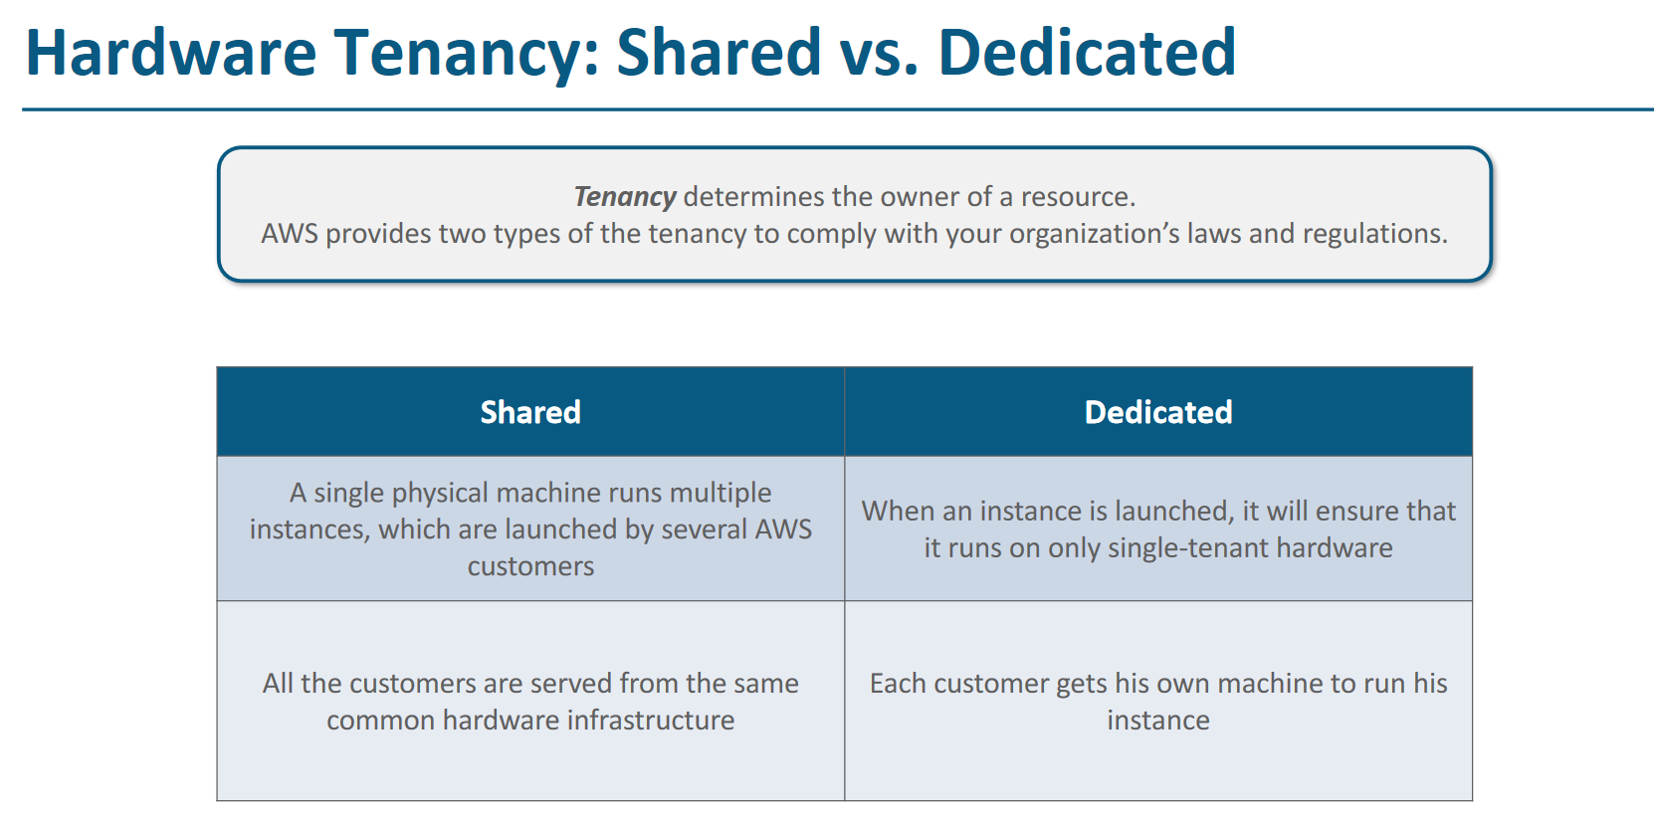

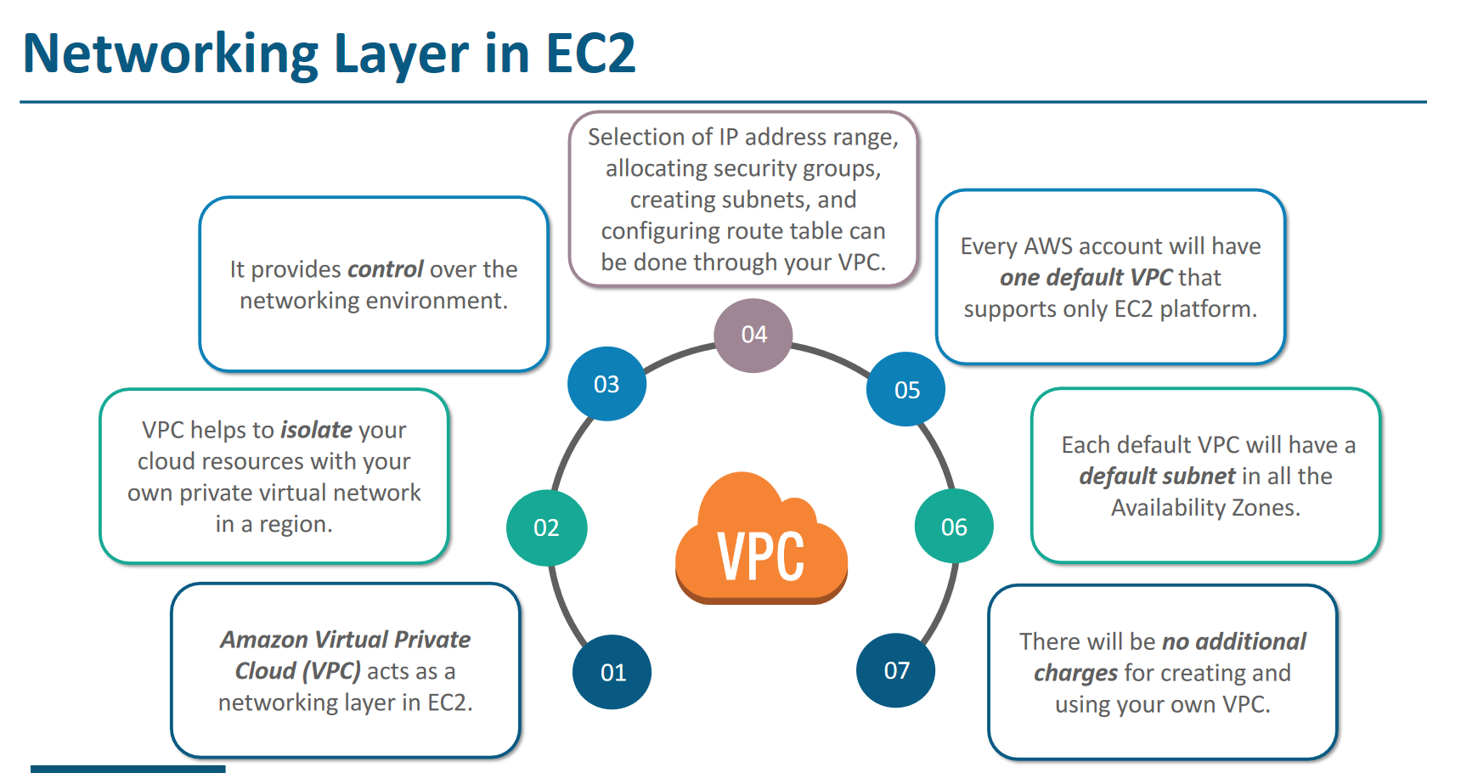

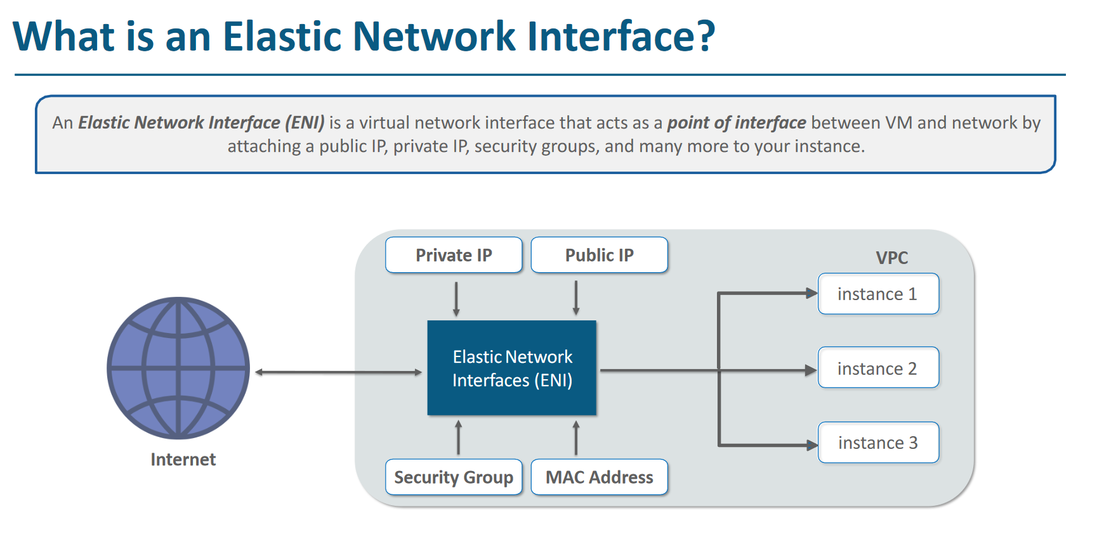

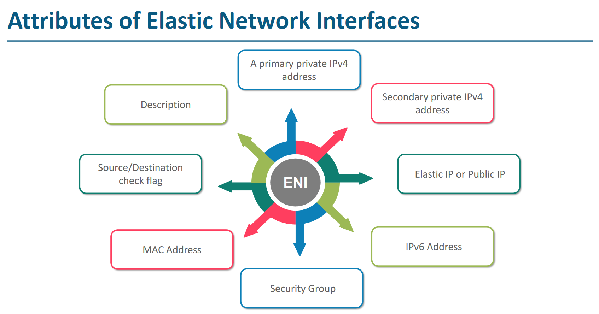

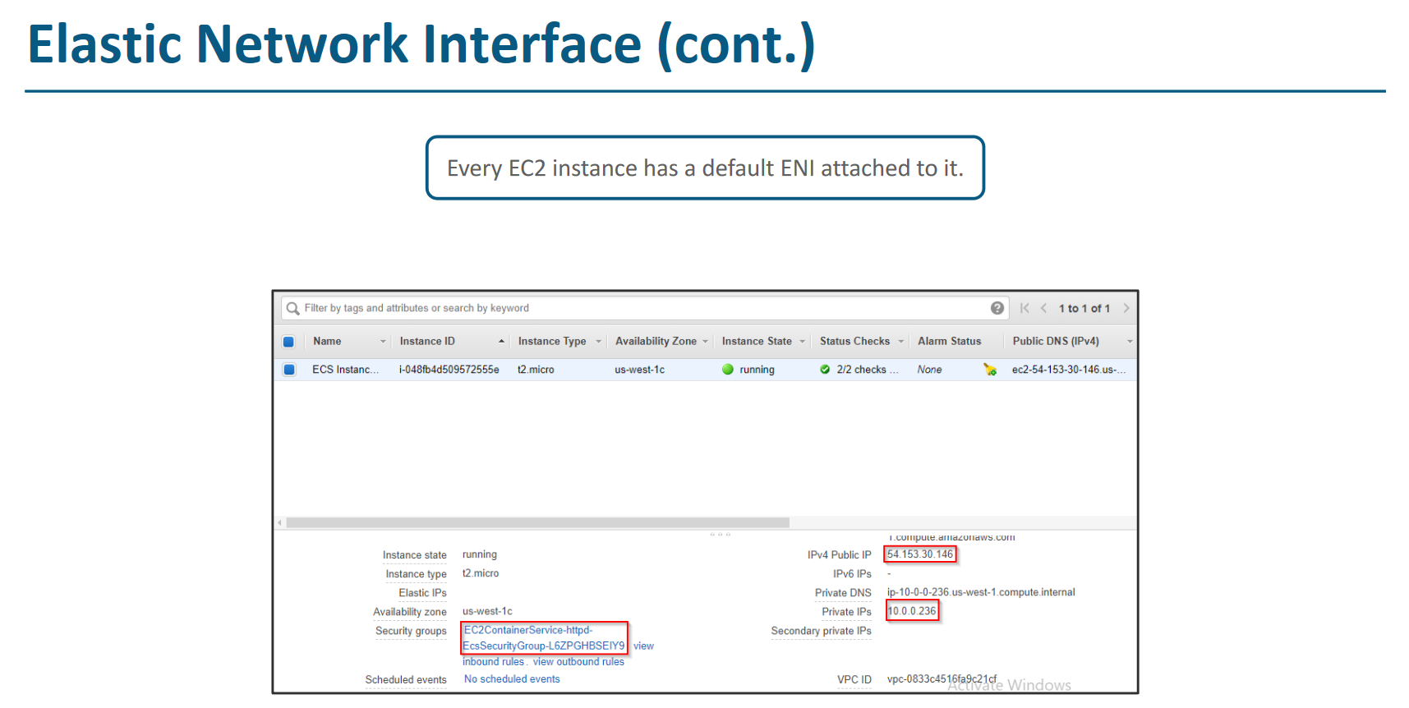

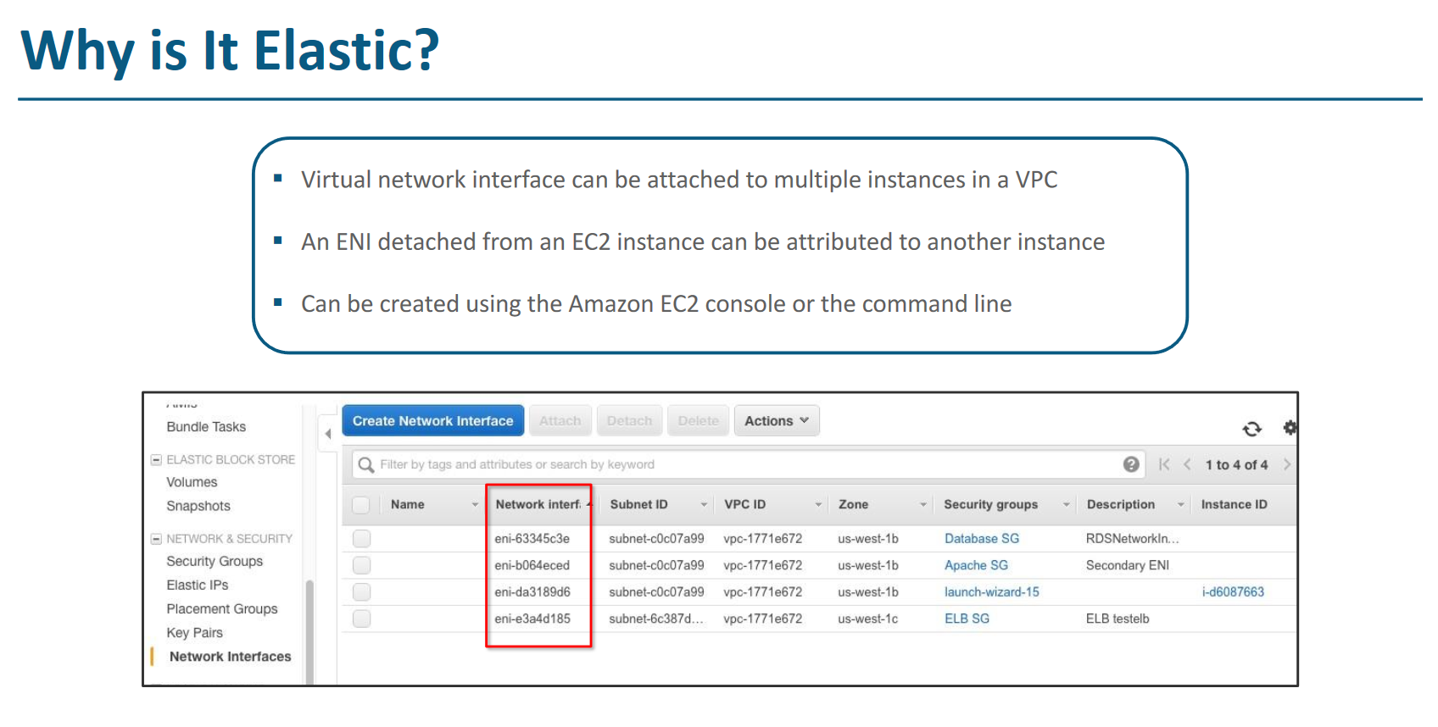

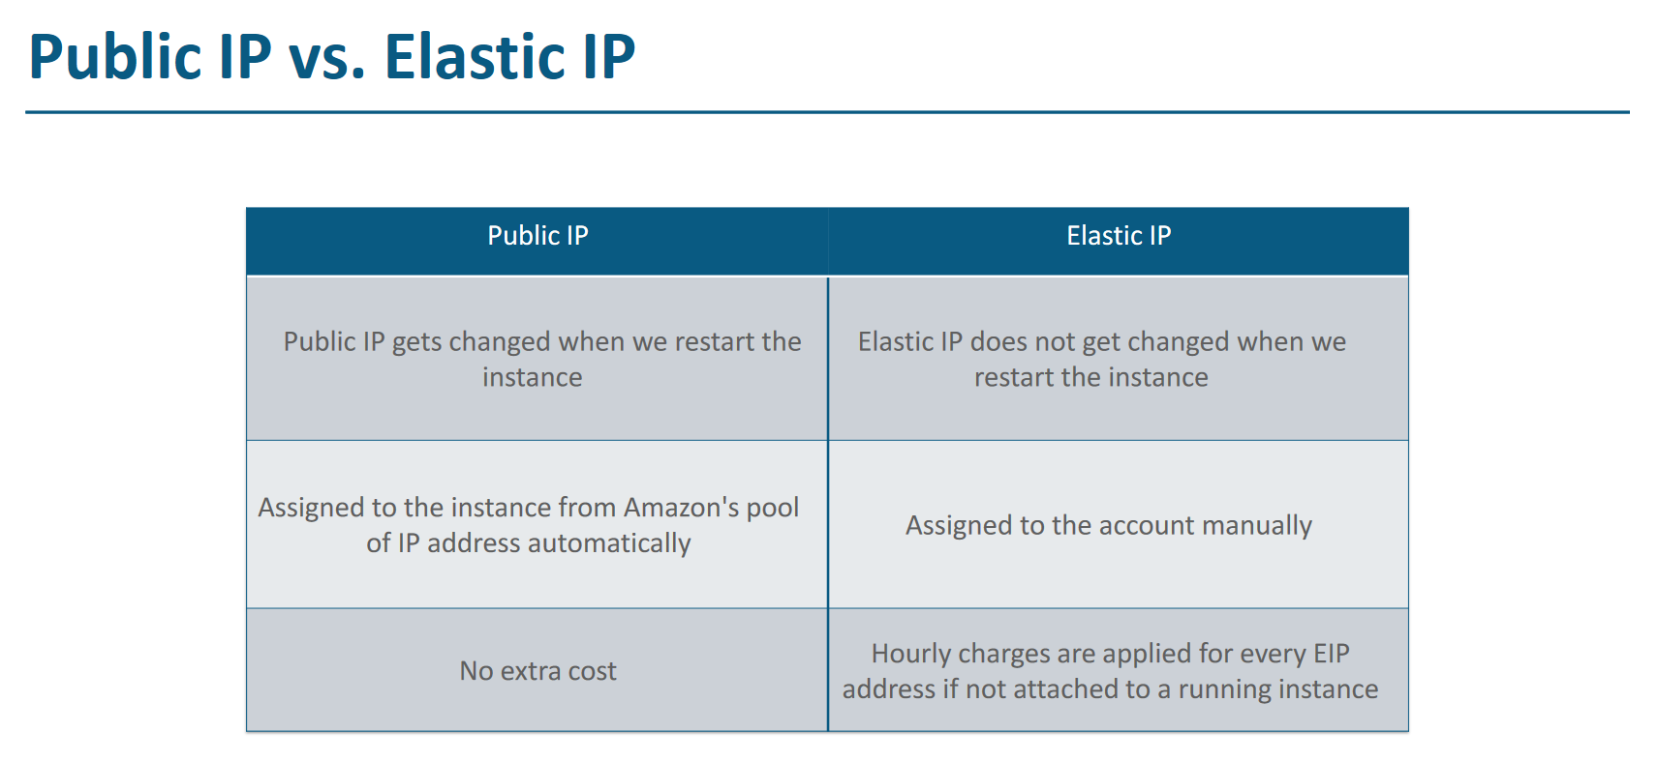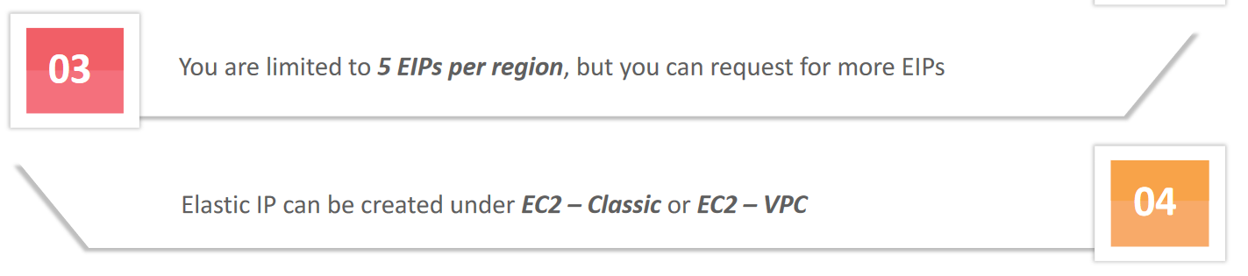

Types of EC2 instances

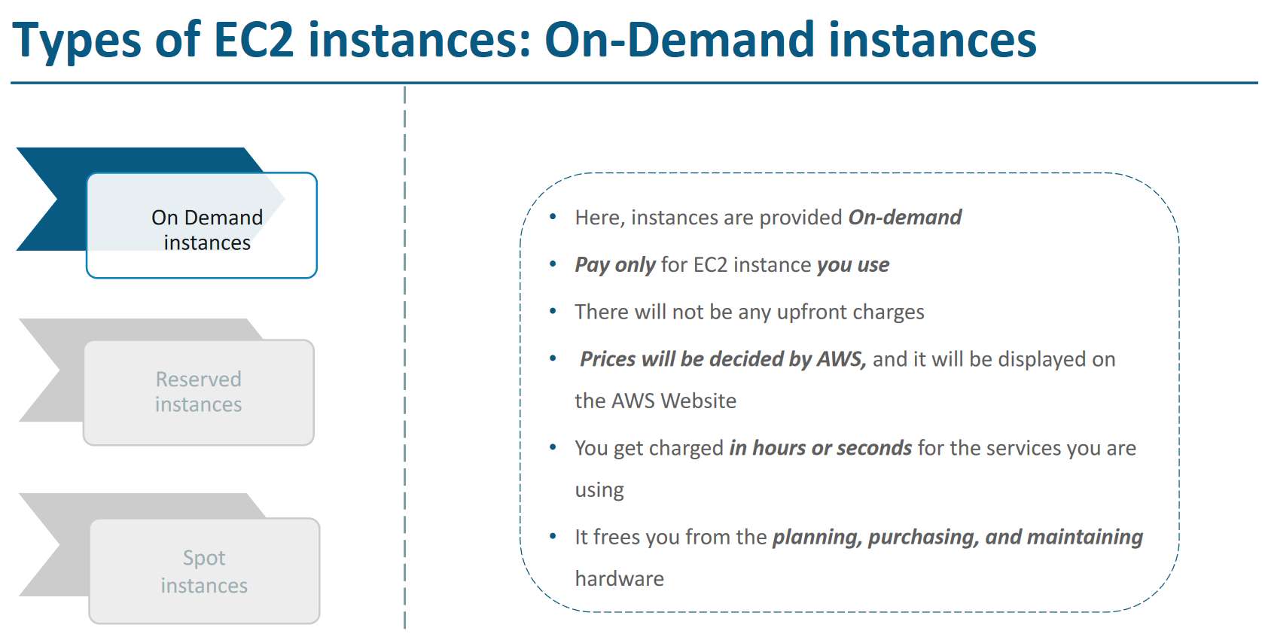

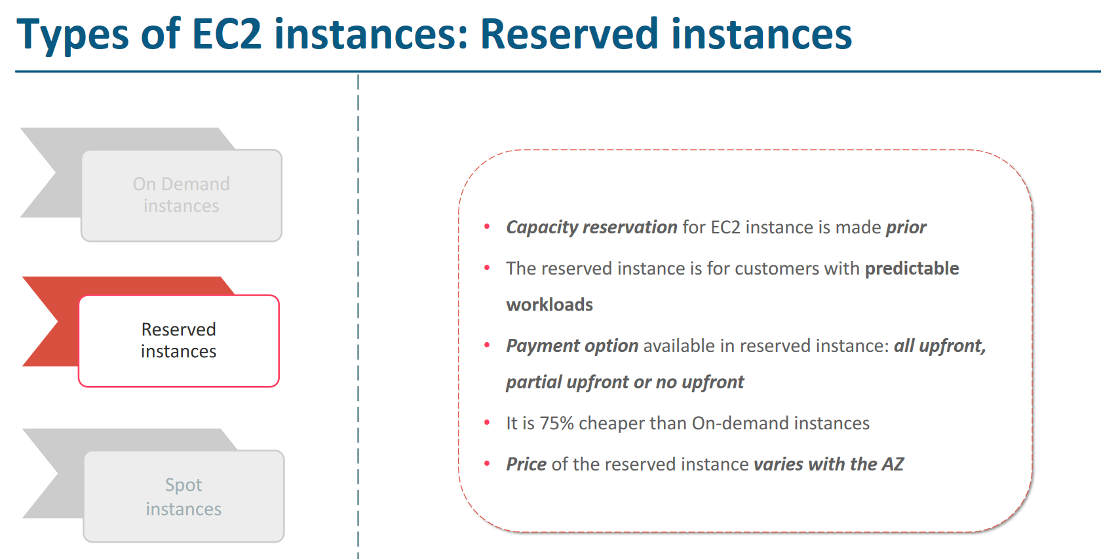

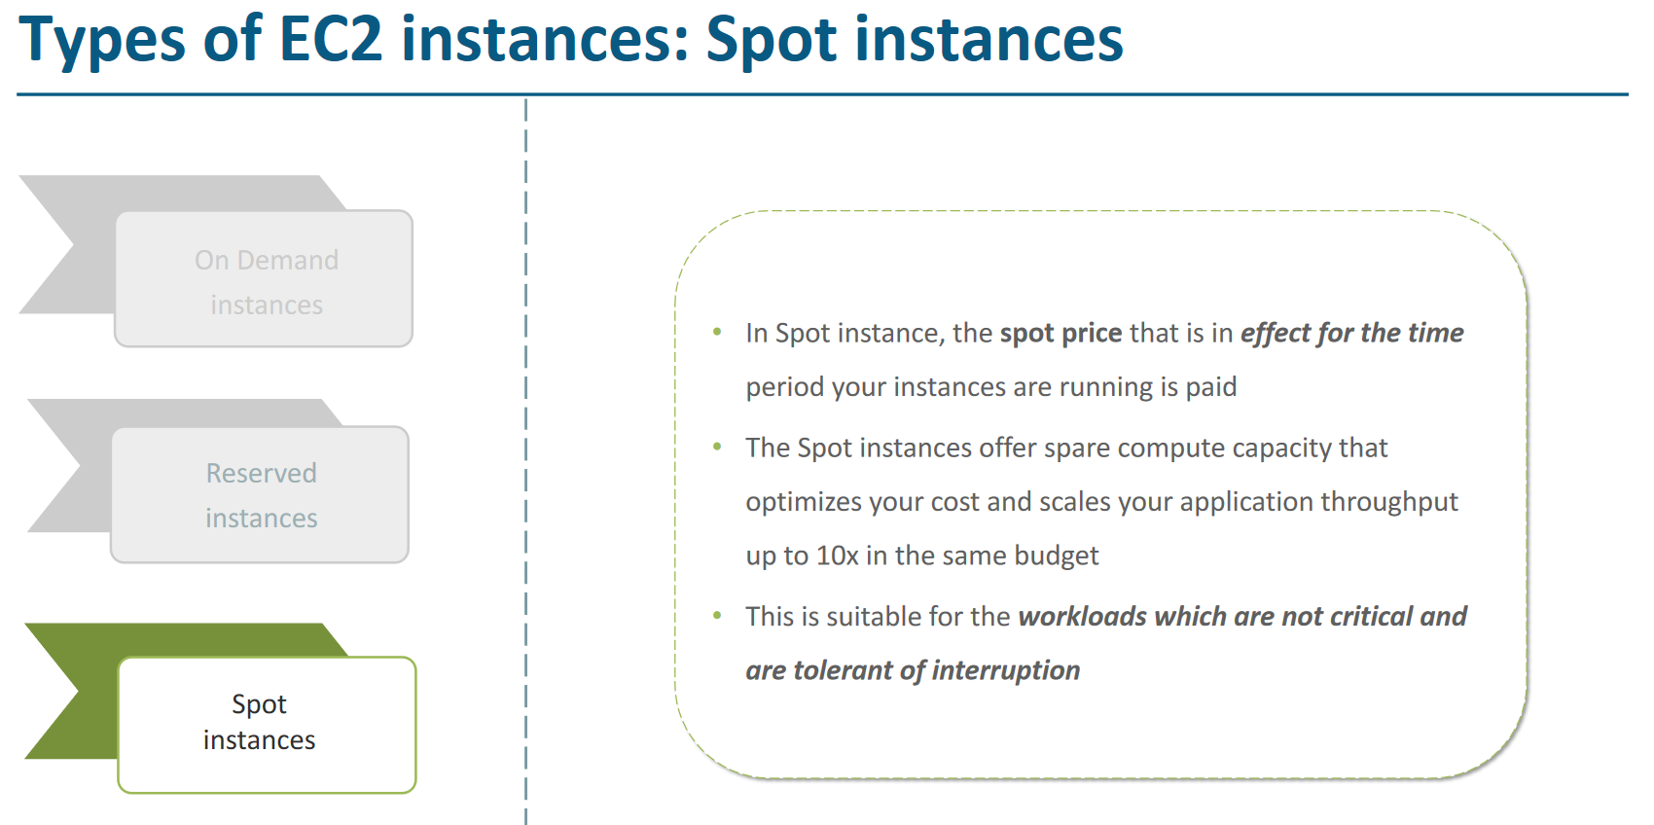

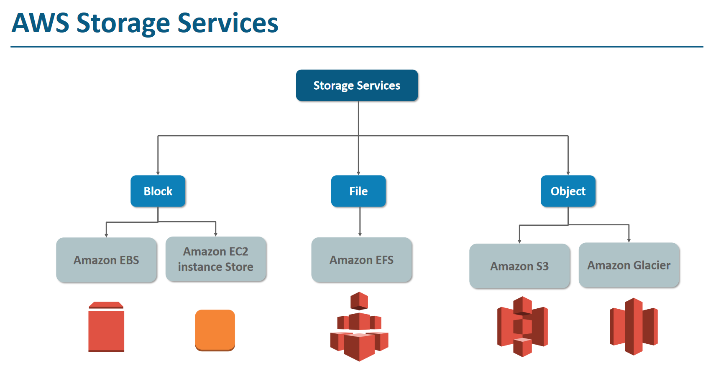

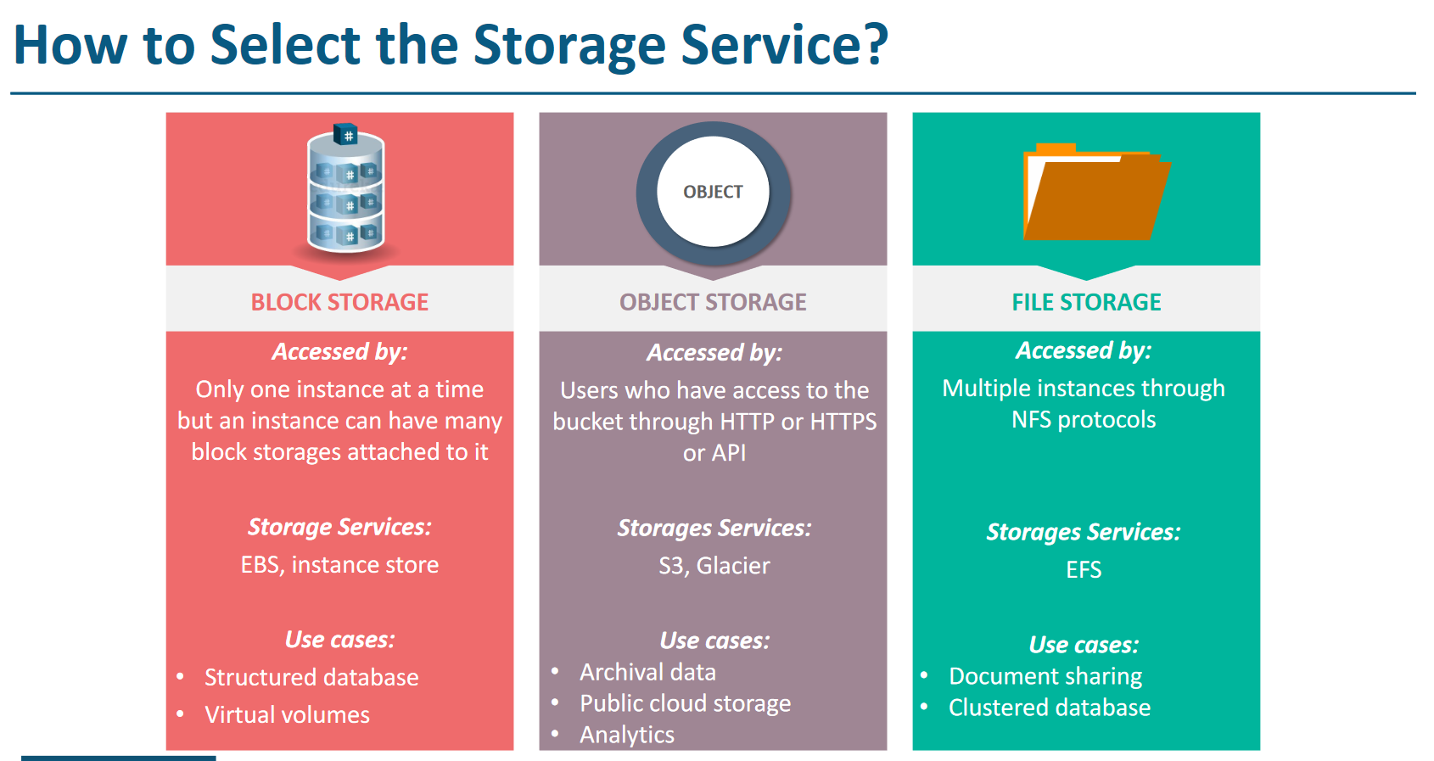

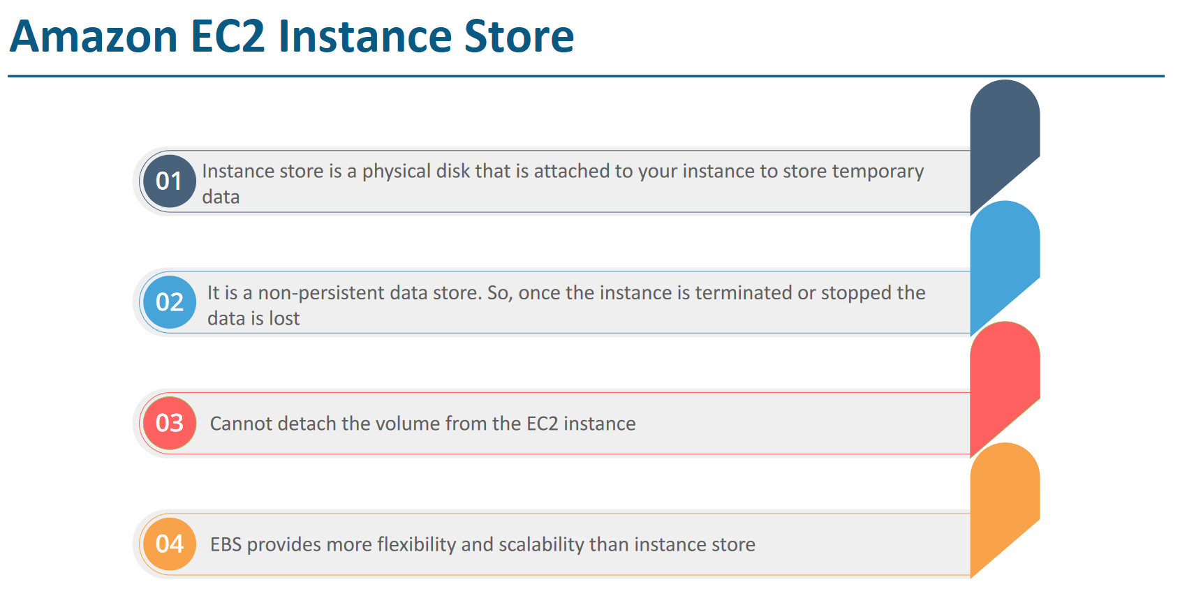

AWS Solution Architect Edureka notes

# Cloud IAAS, PAAS and SAAS Analogy

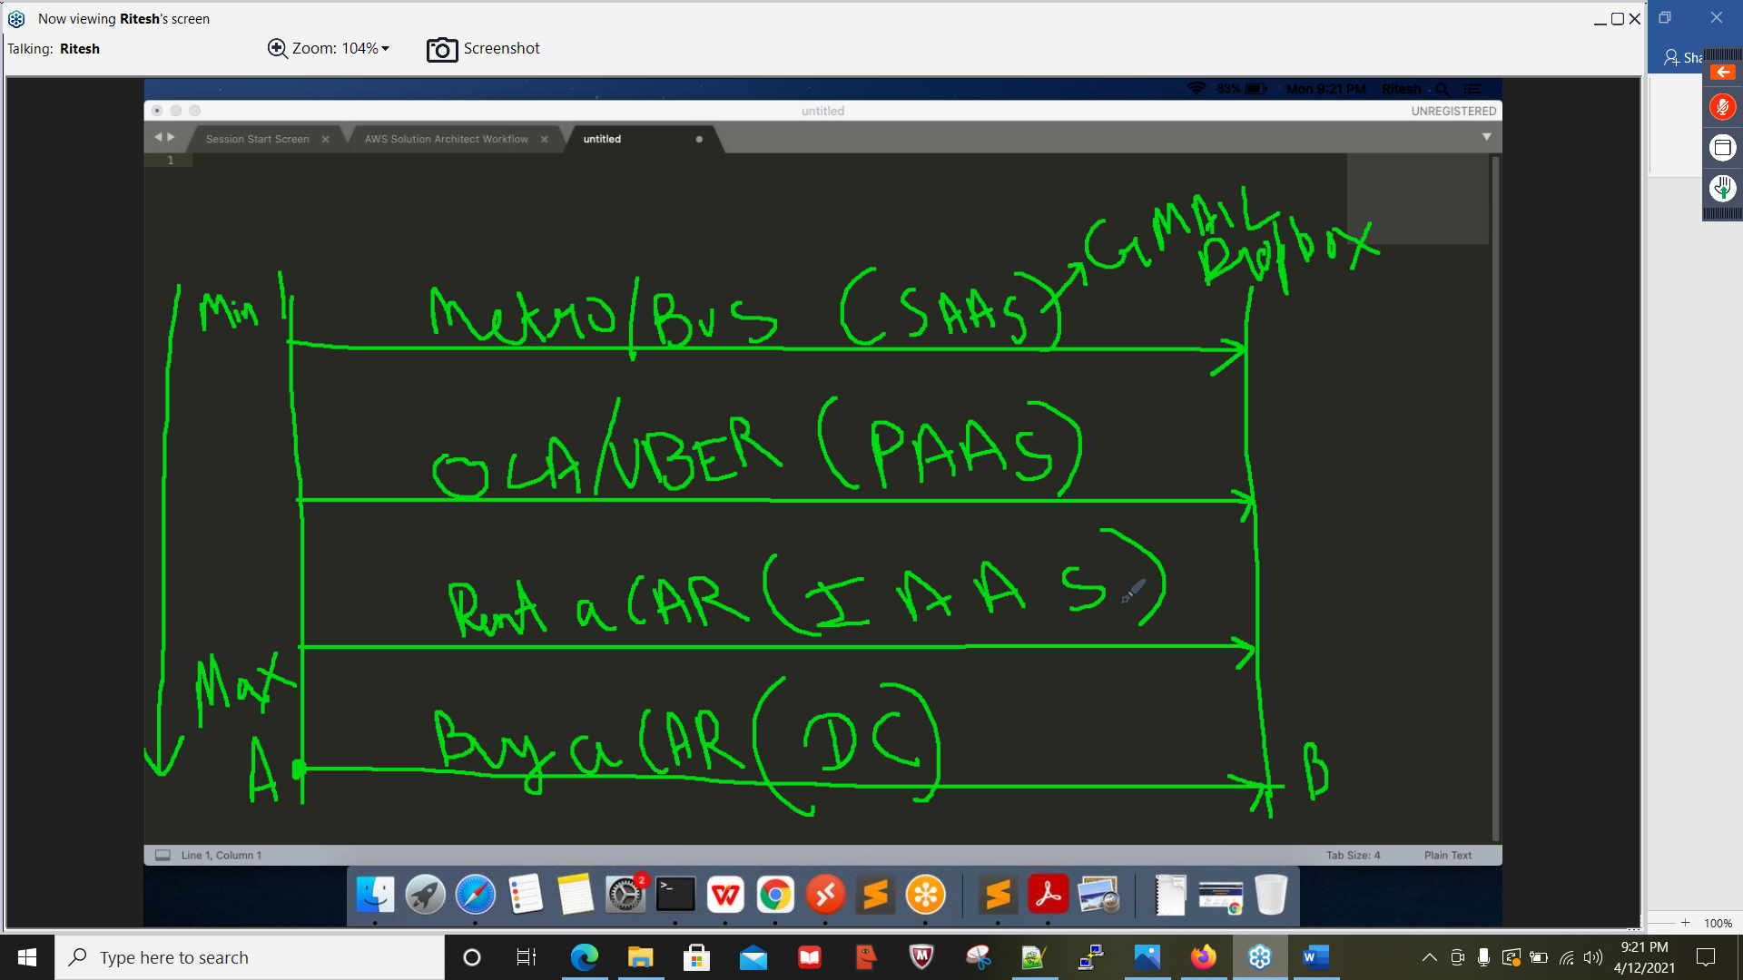

# **AWS Security**

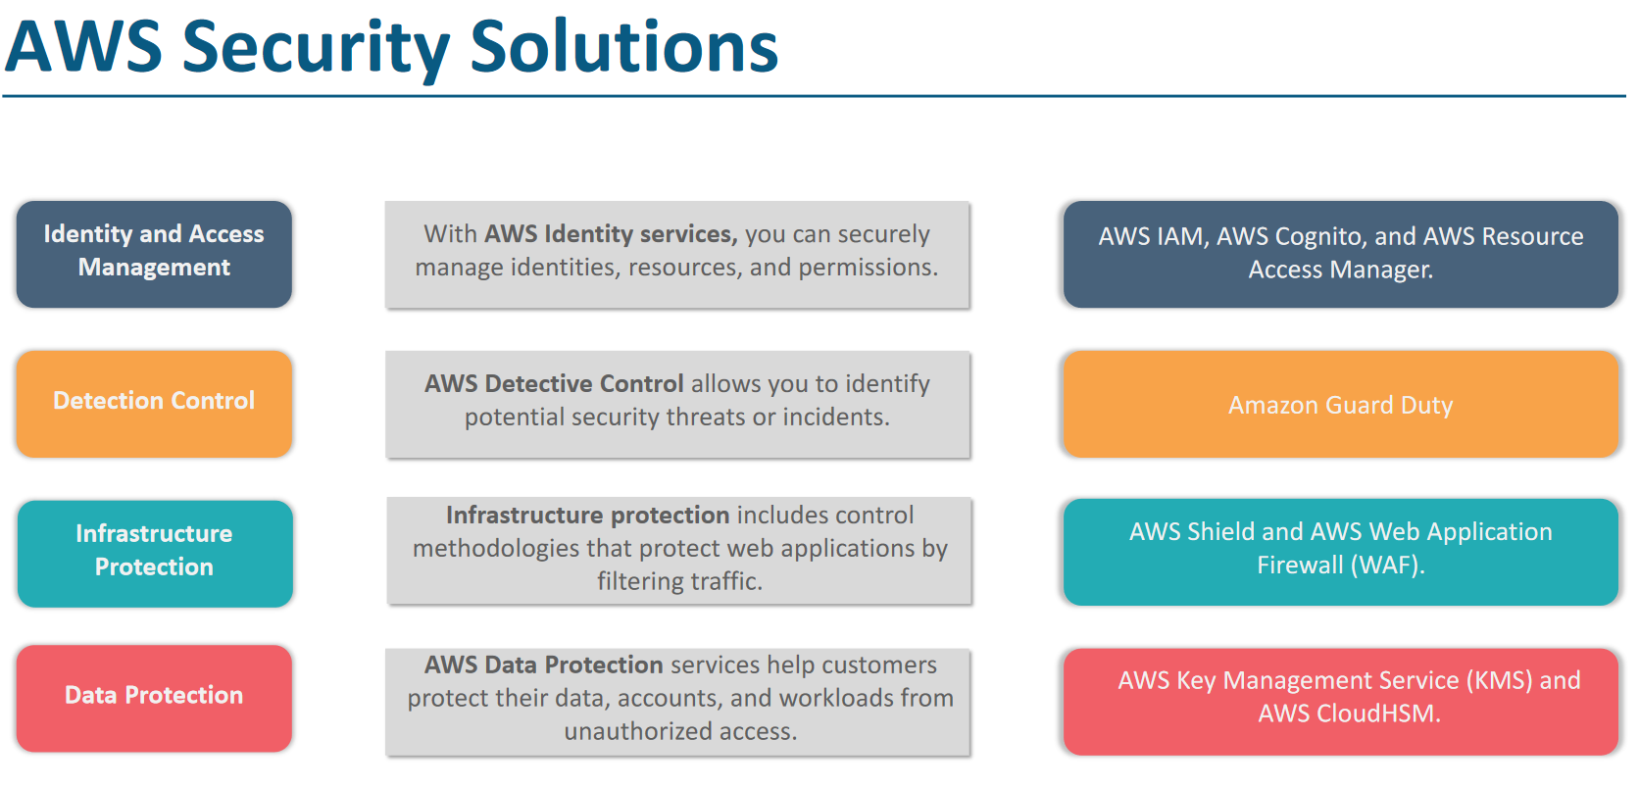

**Root** - can do anything

**Admin** - admin can do all but cannot change billing, change support plan or delete account

**Poweruser** - can access all service of AWS but not work on IAM service means it cant create IAM users

**End user** - can access individual service like s3, ec2 etc4

# IAM

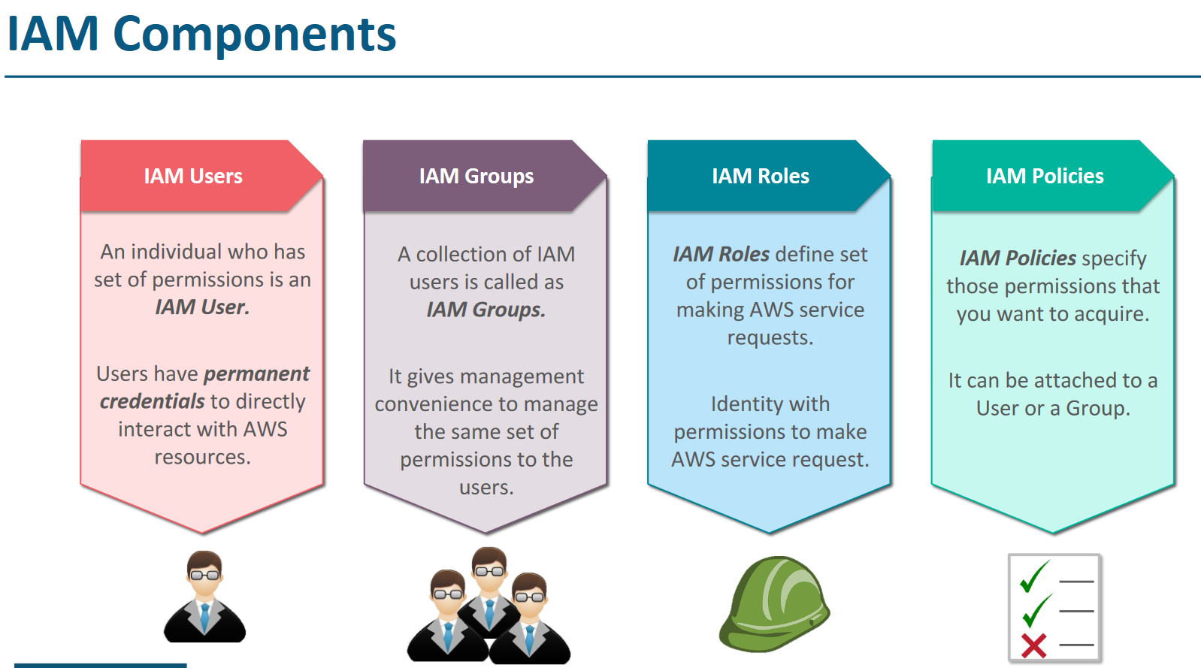

# IAM Policy

**IAM Managed Policy and Customer Managed Policy**

Policy can be created through Console (like to create S3 access with only read permission )

Policy generator tool <https://awspolicygen.s3.amazonaws.com/policygen.html>

Here you can create condition-based policy like S3 access with only read permission with in specific time and specific region.

Policy is a JSON document.

# IAM Groups

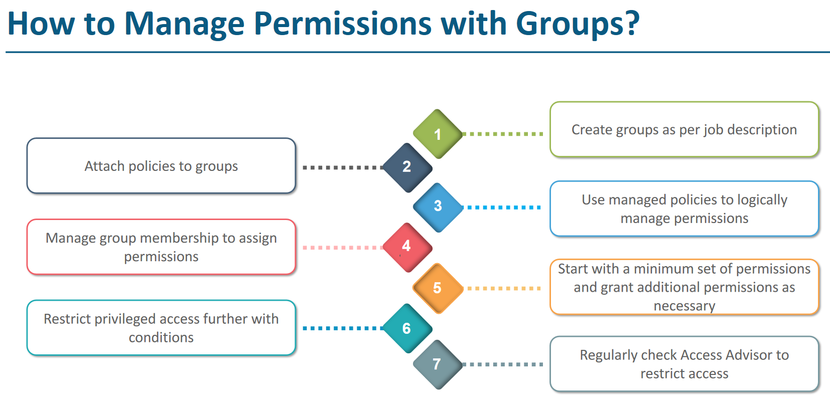

# IAM Policies

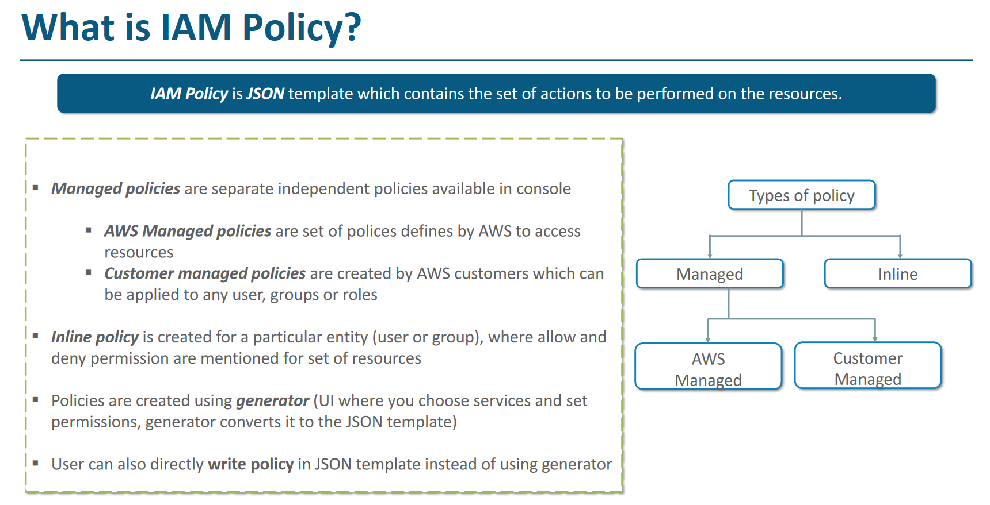

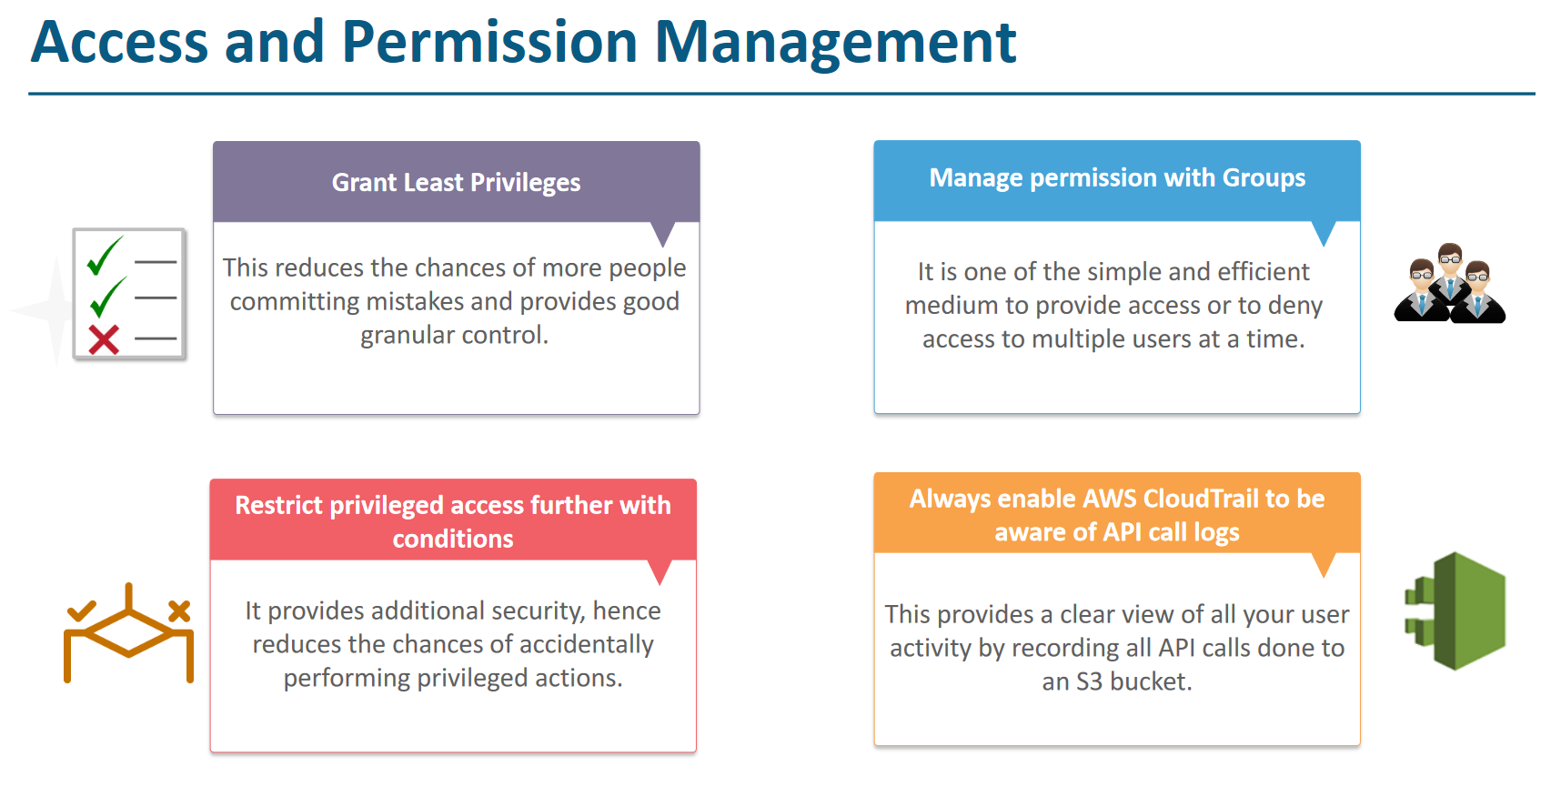

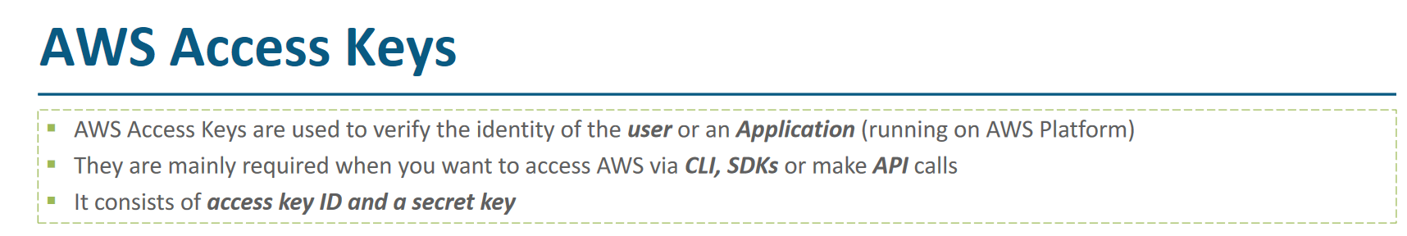

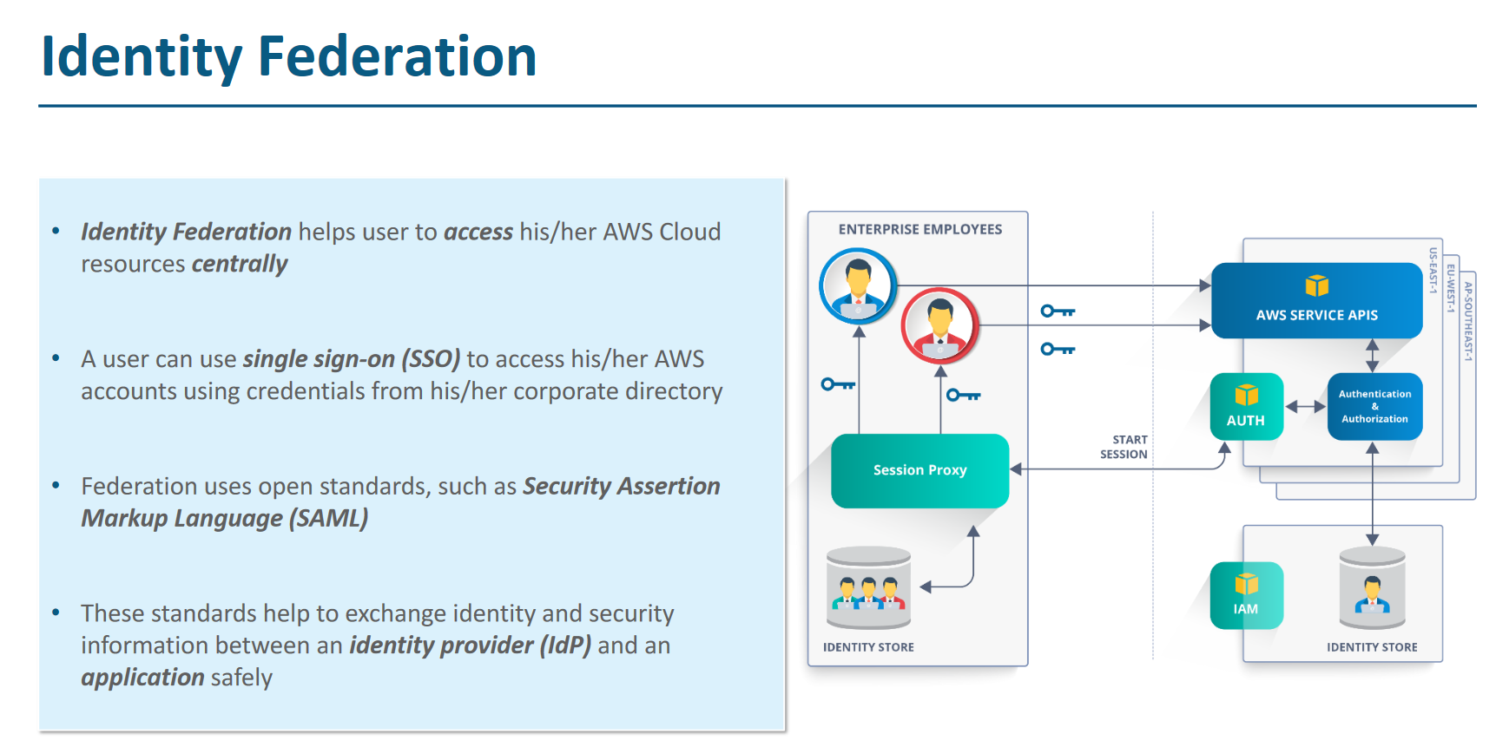

# AWS Guard Duty

It’s a Threat detection service which works to protect customer account.

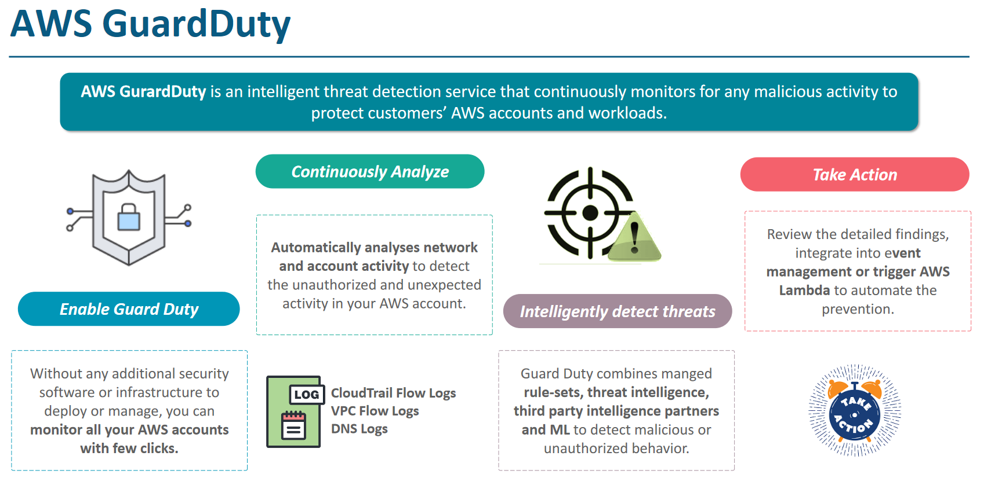

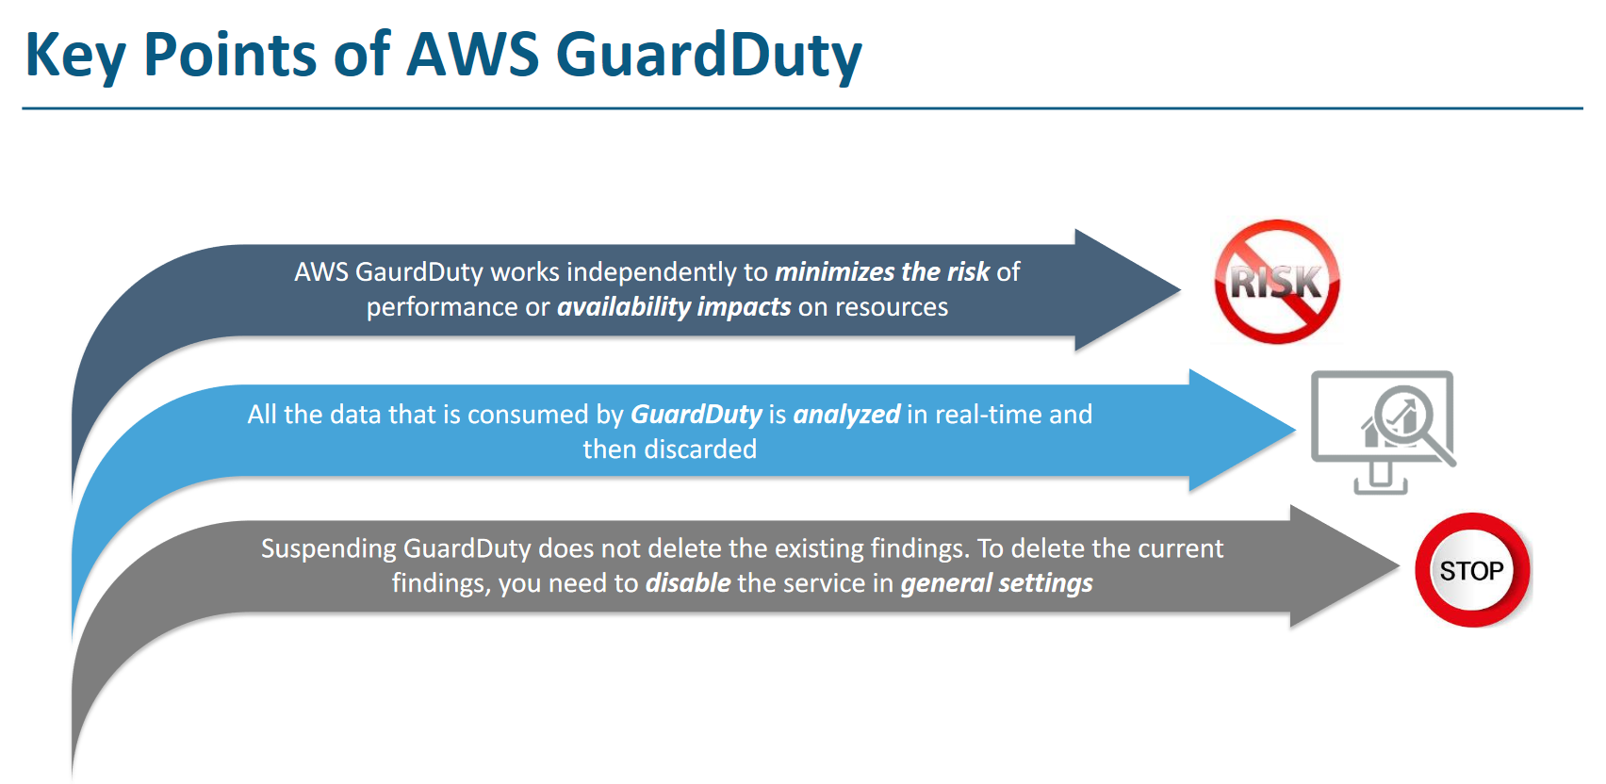

# **Infrastructure Protection – WAF (Web Application Firewall)**

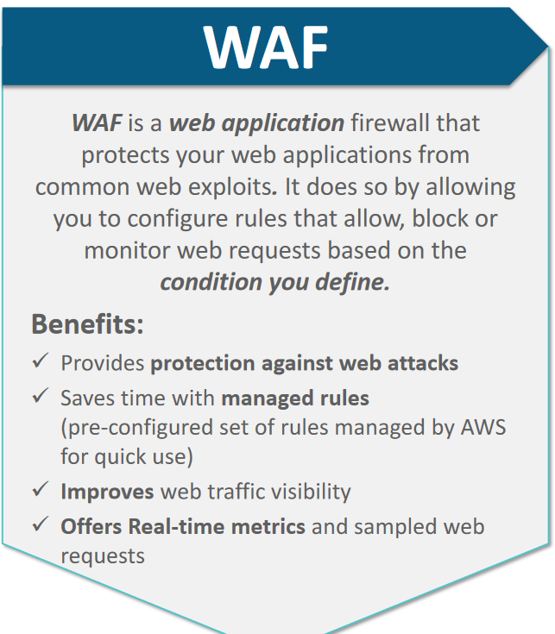

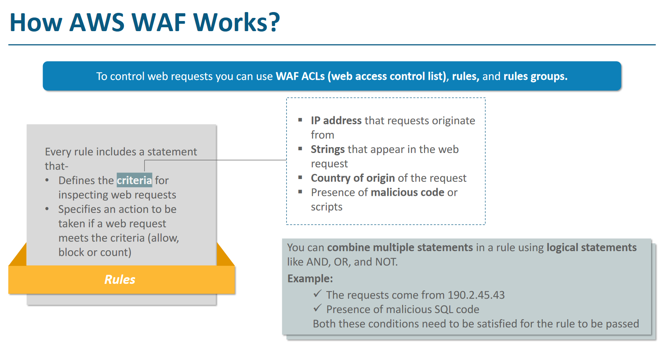

## AWS Shield

AWS Shield is additional layer for the Infra protection. The standard Shield is automatically enabled for all the AWS user. It’s the WAF that user need to pay for. WAF and Shield both works to mitigate the DDOS attacks (Distributed denial of service)

**DDOS Example** – Hacker can send sql injection scripts or heavy packets to the Username and Password fields, in that case Server need to process this rubbish request before discarding them. But this keeps the server busy doing rubbish things and ultimately server dies and application suffer downtime.

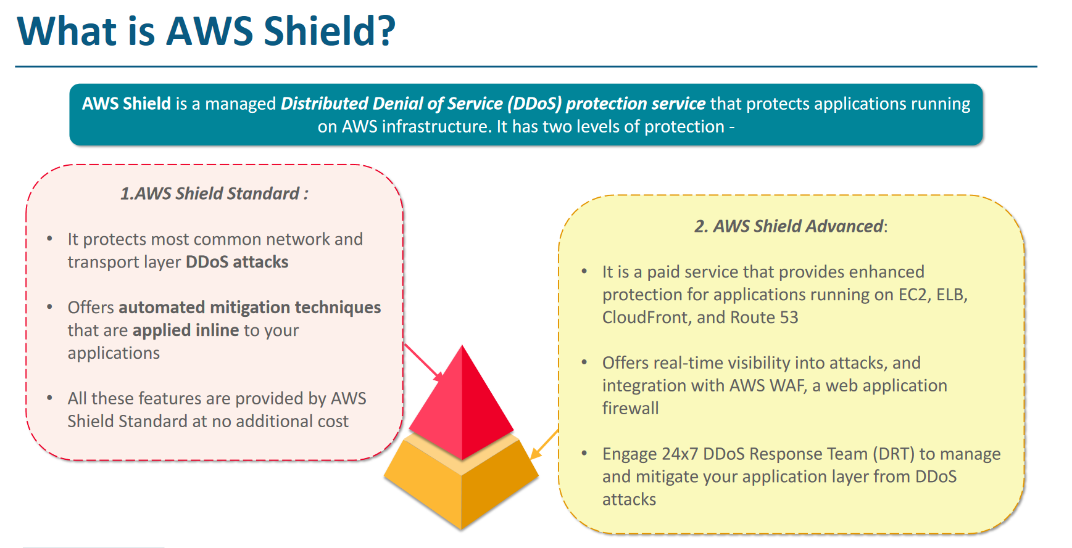

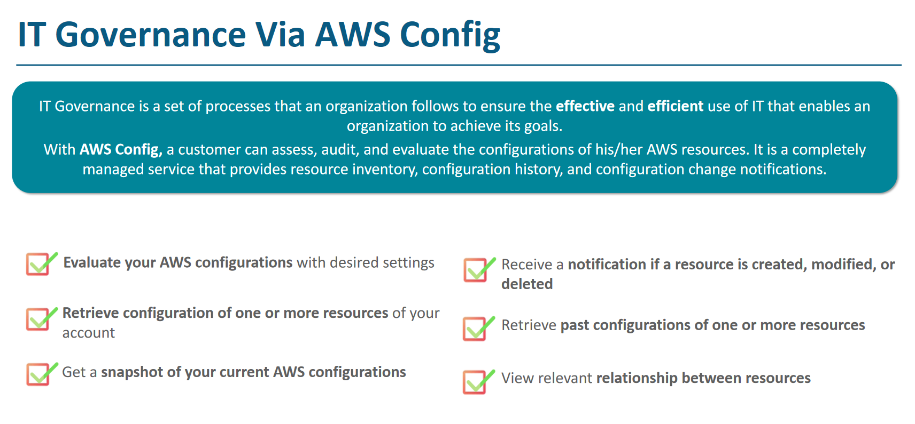

# **Data Protection – KMS (Key Management System) and Cloud HSM**

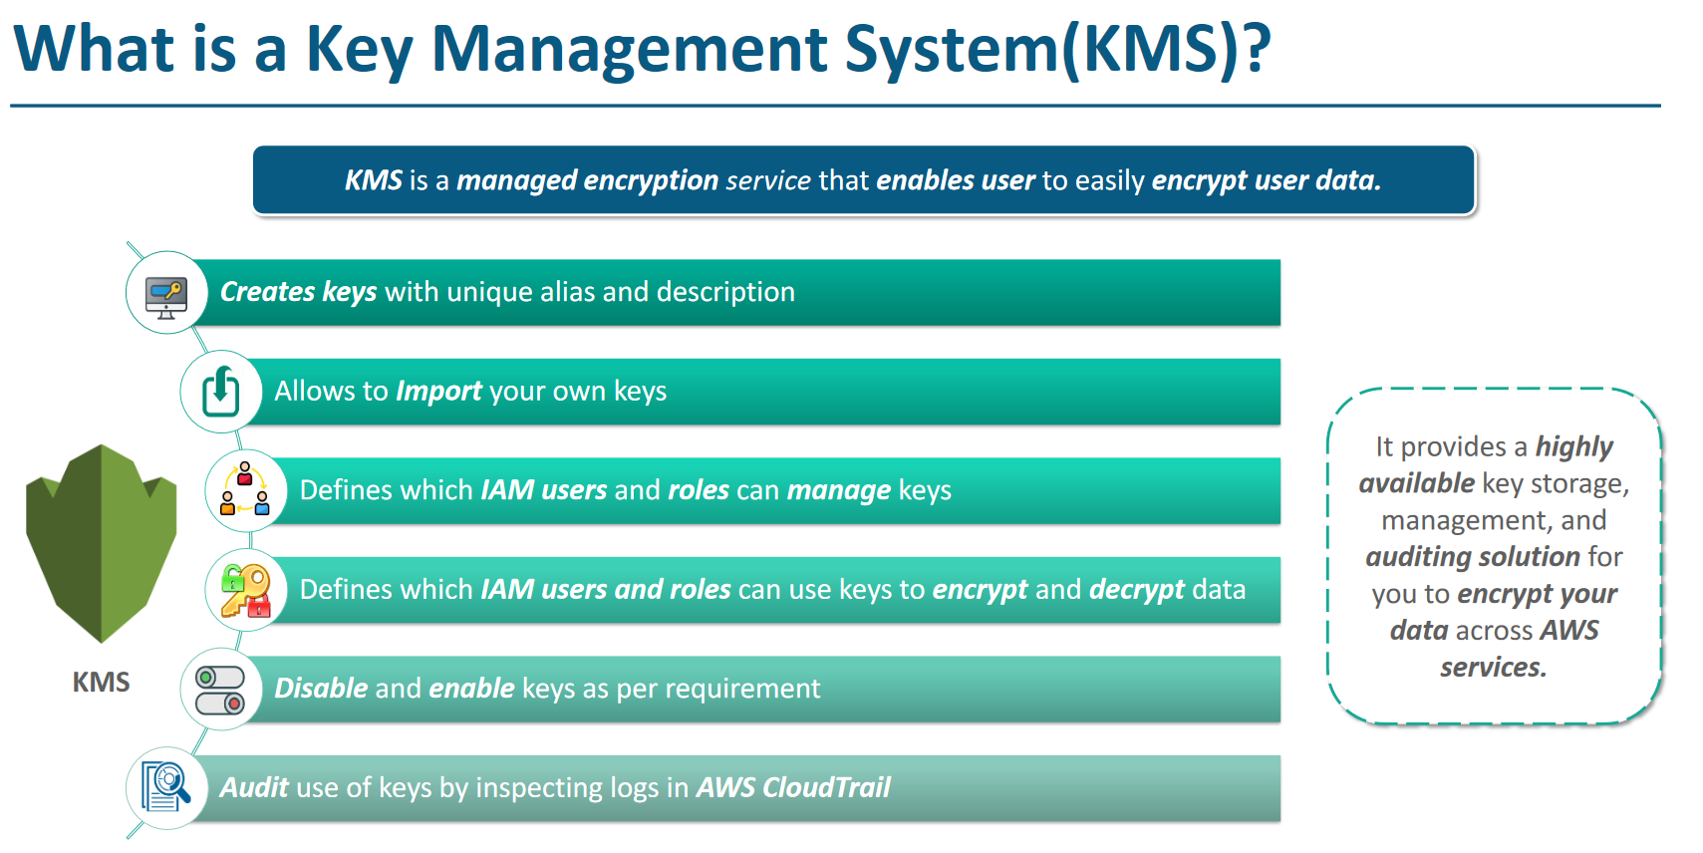

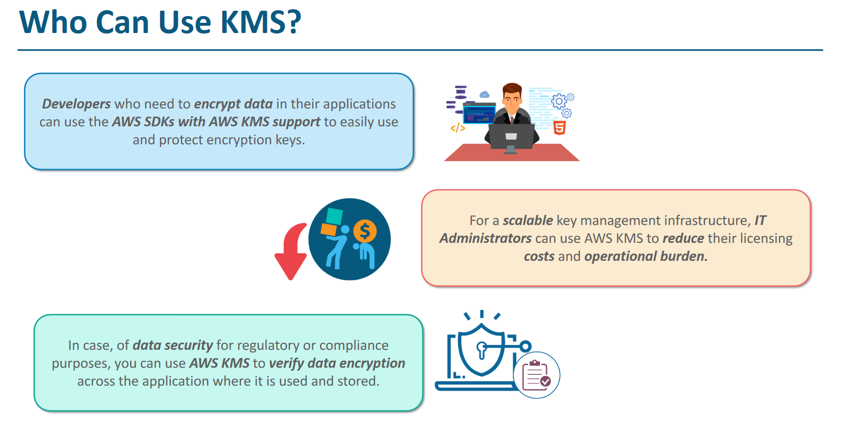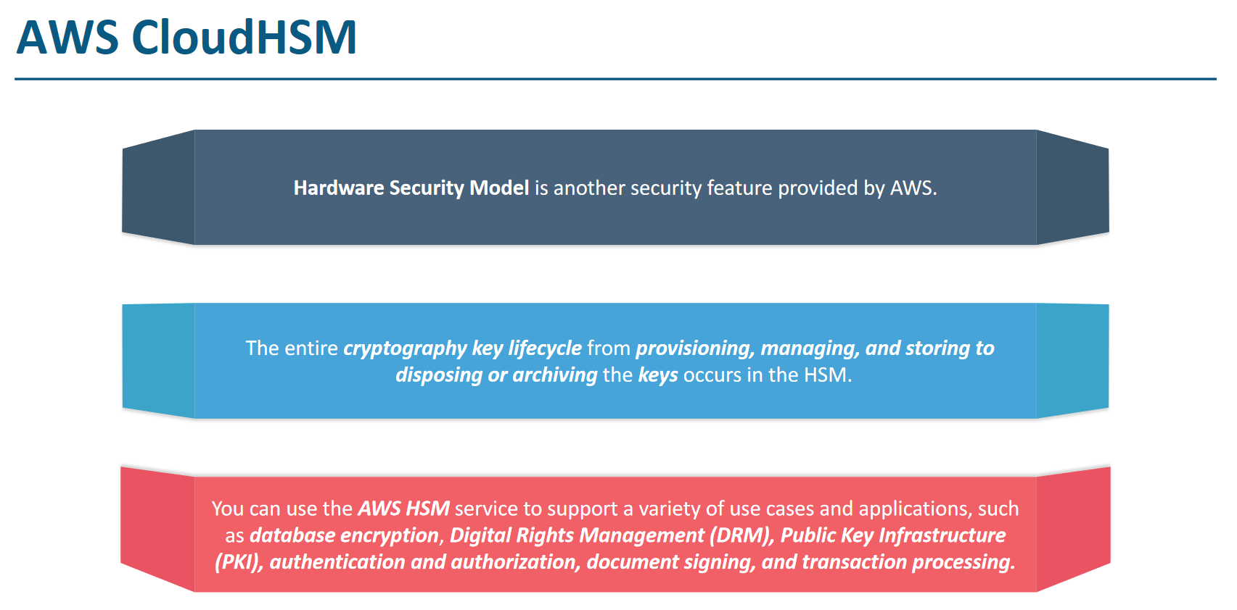

List of all AWS services with Use case examples

<https://www.parkmycloud.com/aws-services-list/>

# **Amazon Cognito**

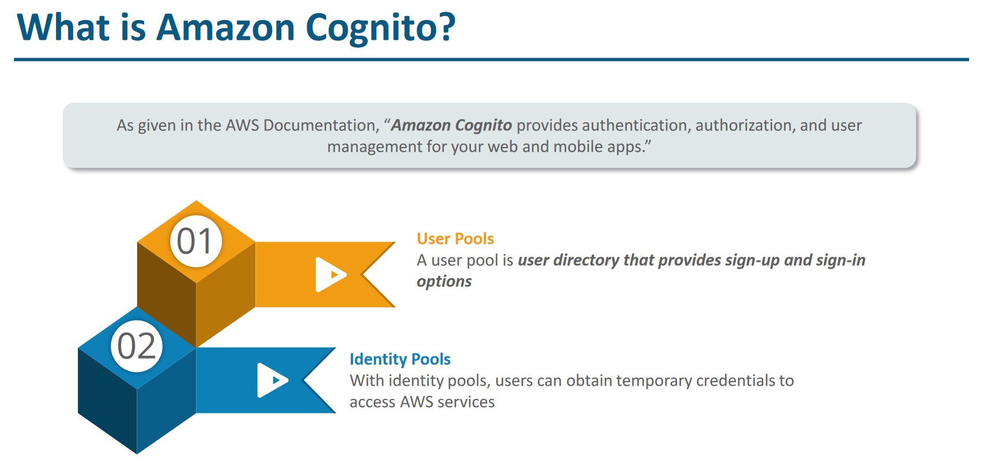

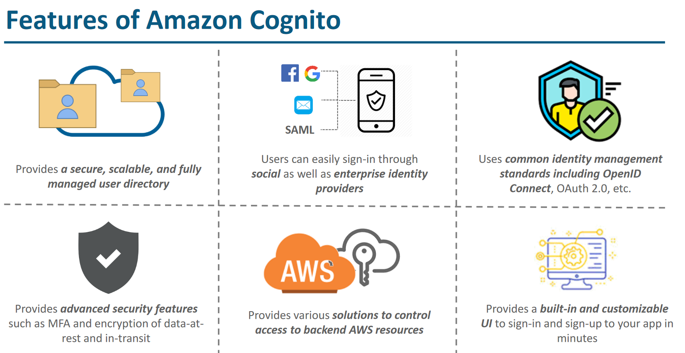

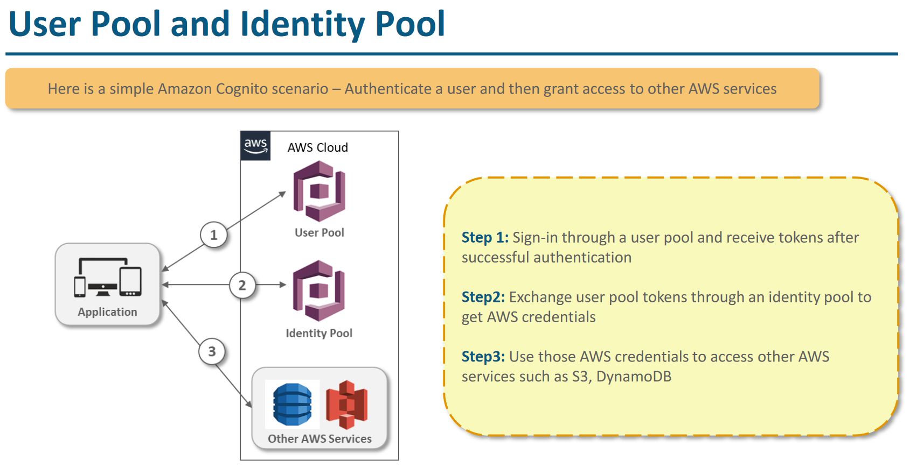

AWS Storage

Demo - Static website hosting in S3, Versioning, Replicating Data Across Regions

1. **S3** – Simple Storage Service – Used to save unstructured data, internet data, mostly used service
2. **EFS** – Elastic File System – Like network drive. Can be accessed from many location (like if some application is running from different location across globe ( used for application data), work only with linux
3. **EBS** - Elastic Block Storage – Attached with EC2 instance and can only be access by EC2.
4. **Glacier** – Cheap Storage, used for big data storage for many years, used for non-frequently used data
5. **Snowball** – It’s a portable storage used to data migration. If company have petabyte date then it is like big box storage (big like trucks which aws send to company data centers there it is plugged there to store the data and then this truck is sent to aws where it is copied otherwise it will take weeks even on ultra-high speed network if we want to migrate data.

# **Block (EBS) vs Object Storage (S3, G drive, Dropbox)**

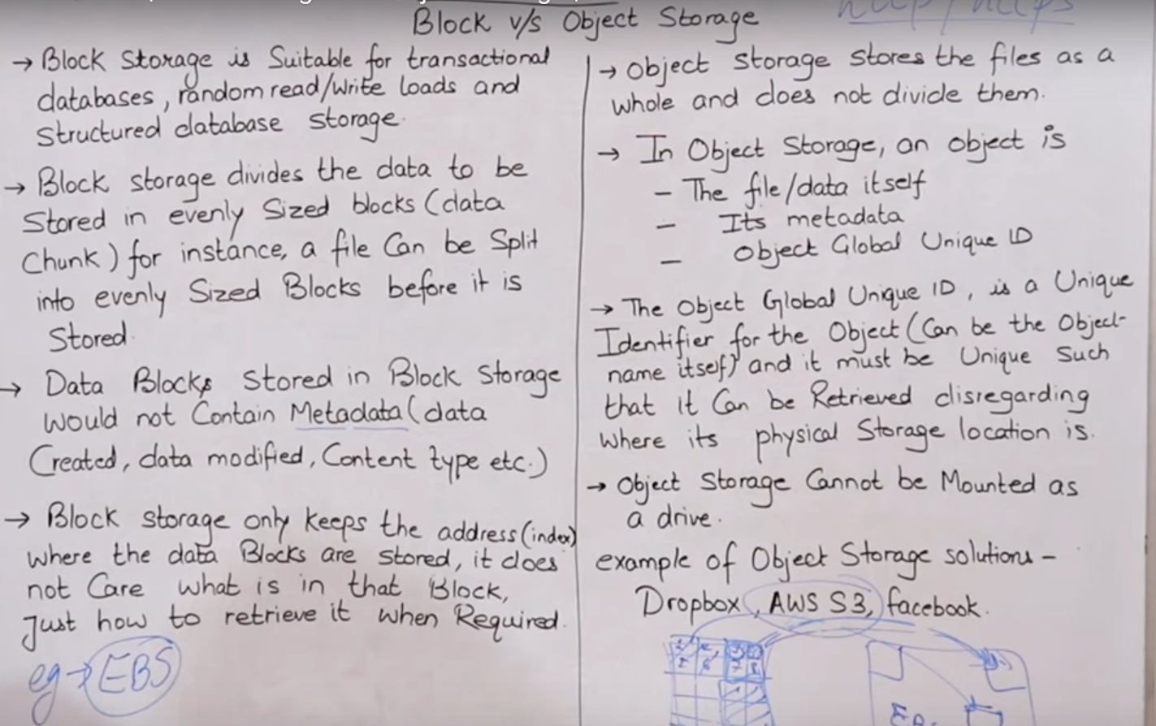

# **S3 in Details**

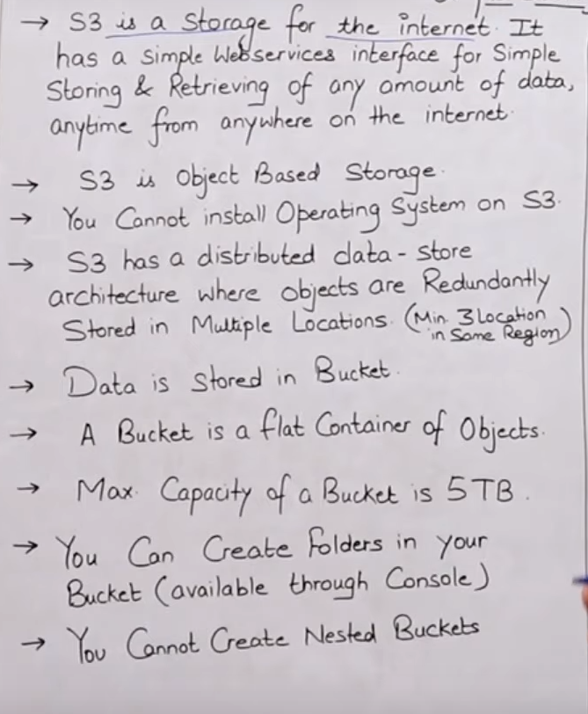

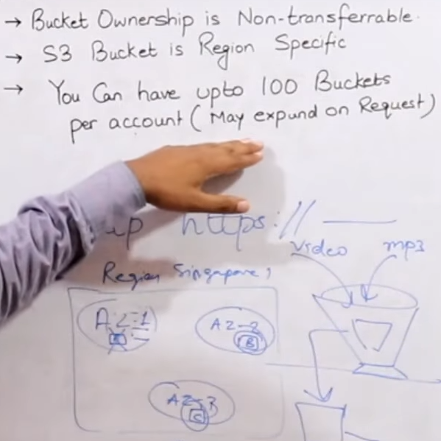

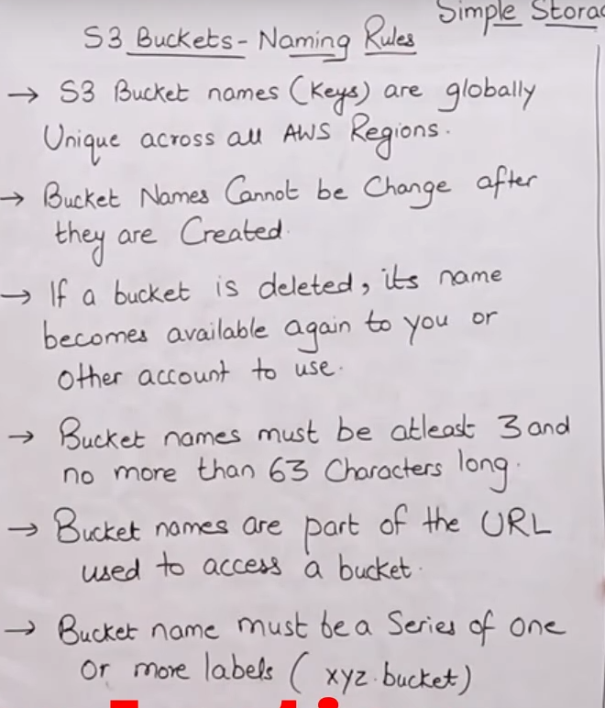

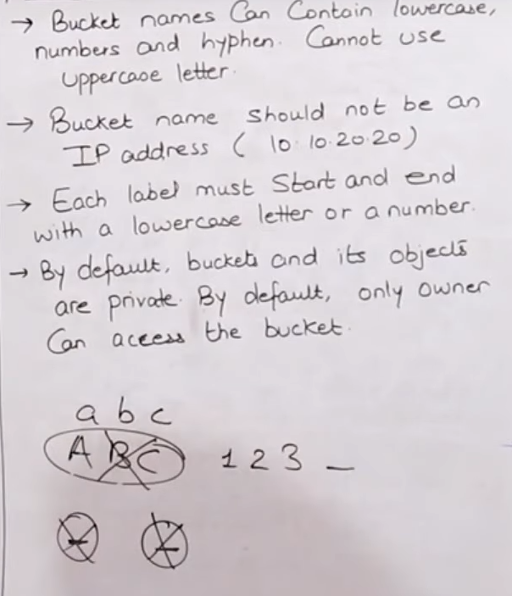

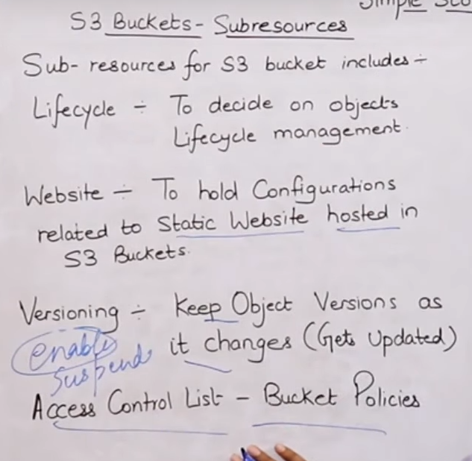

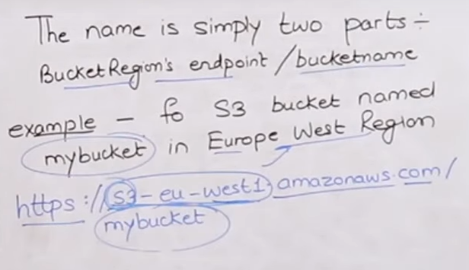

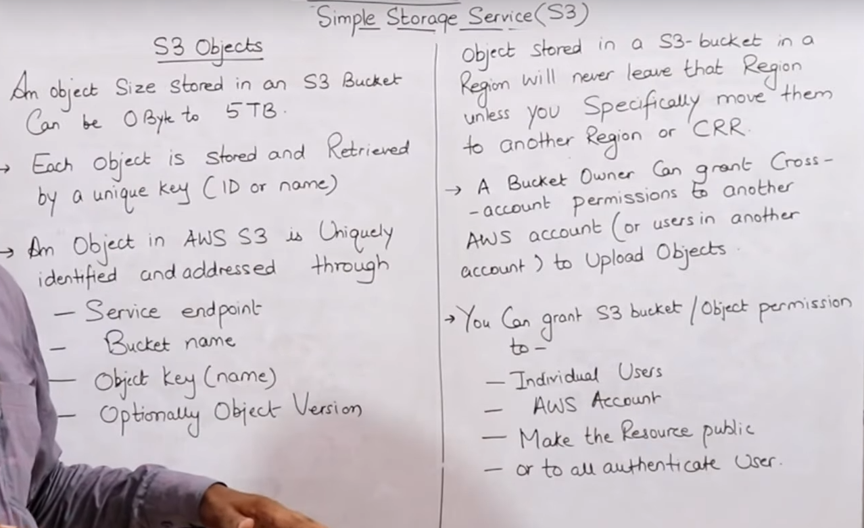

# **Amazon S3 Storage Classes**

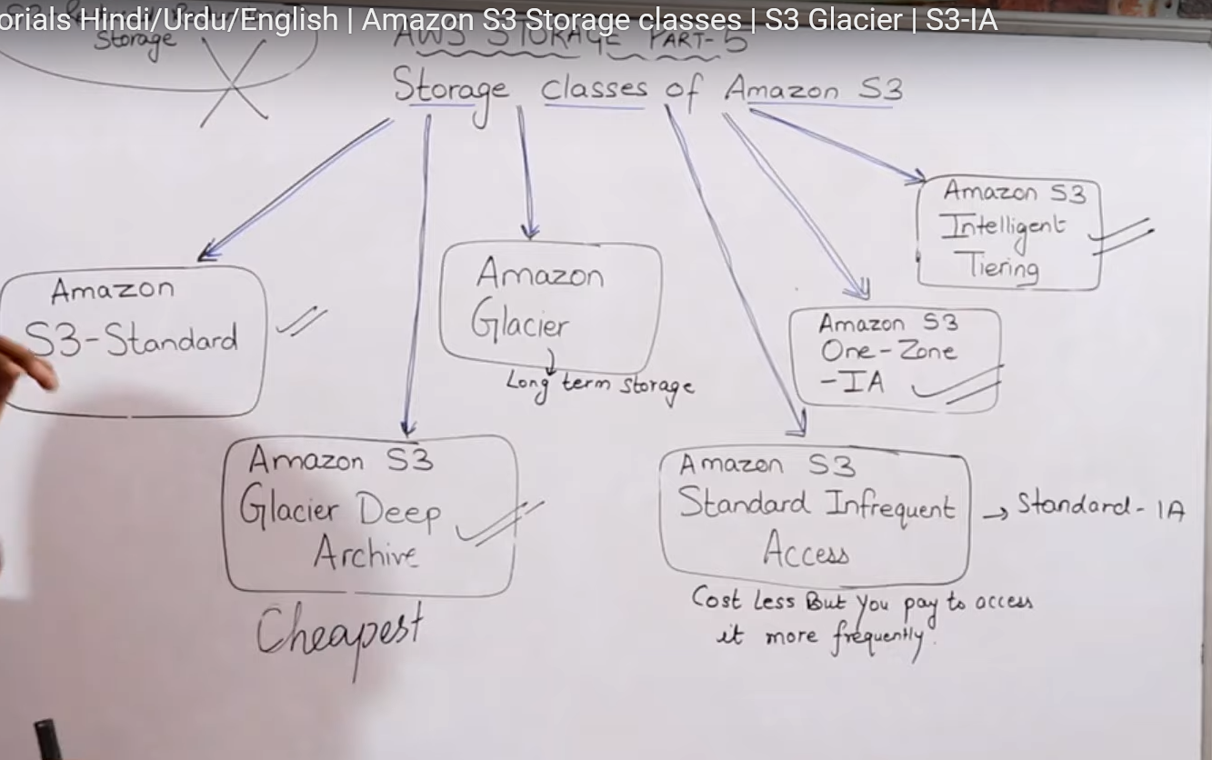

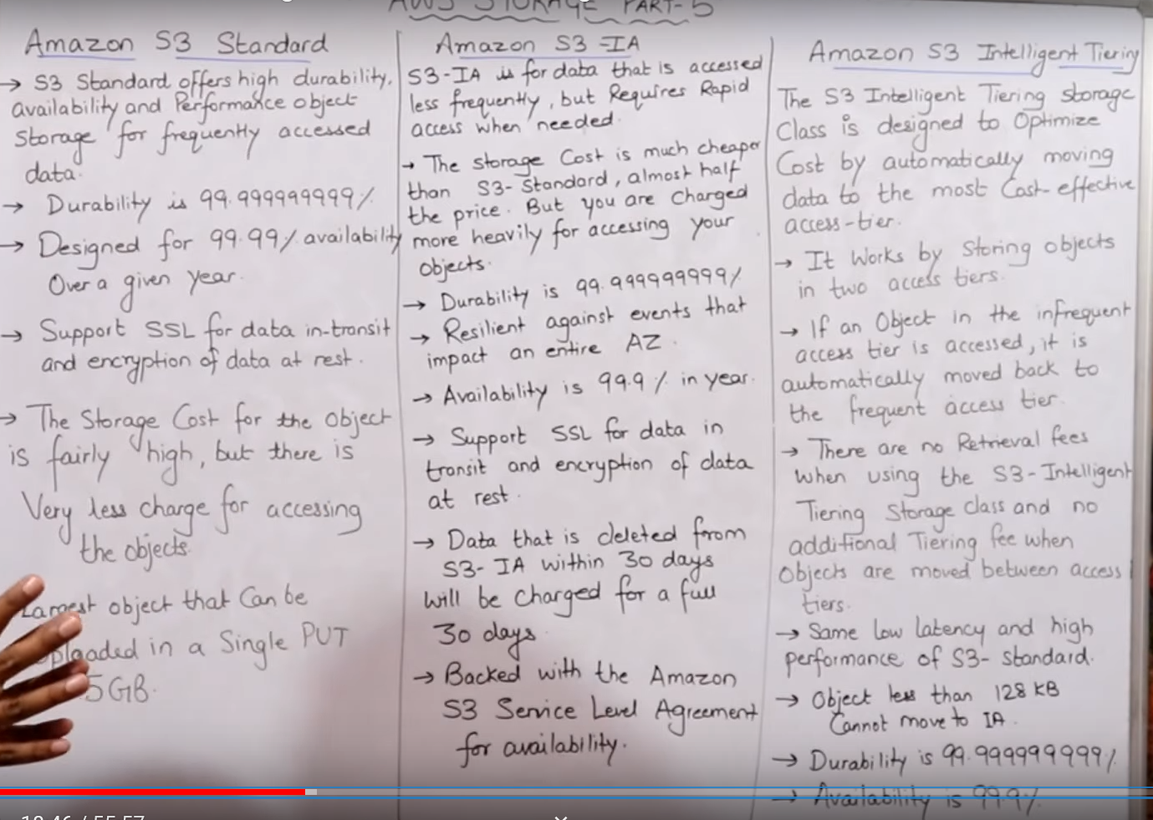

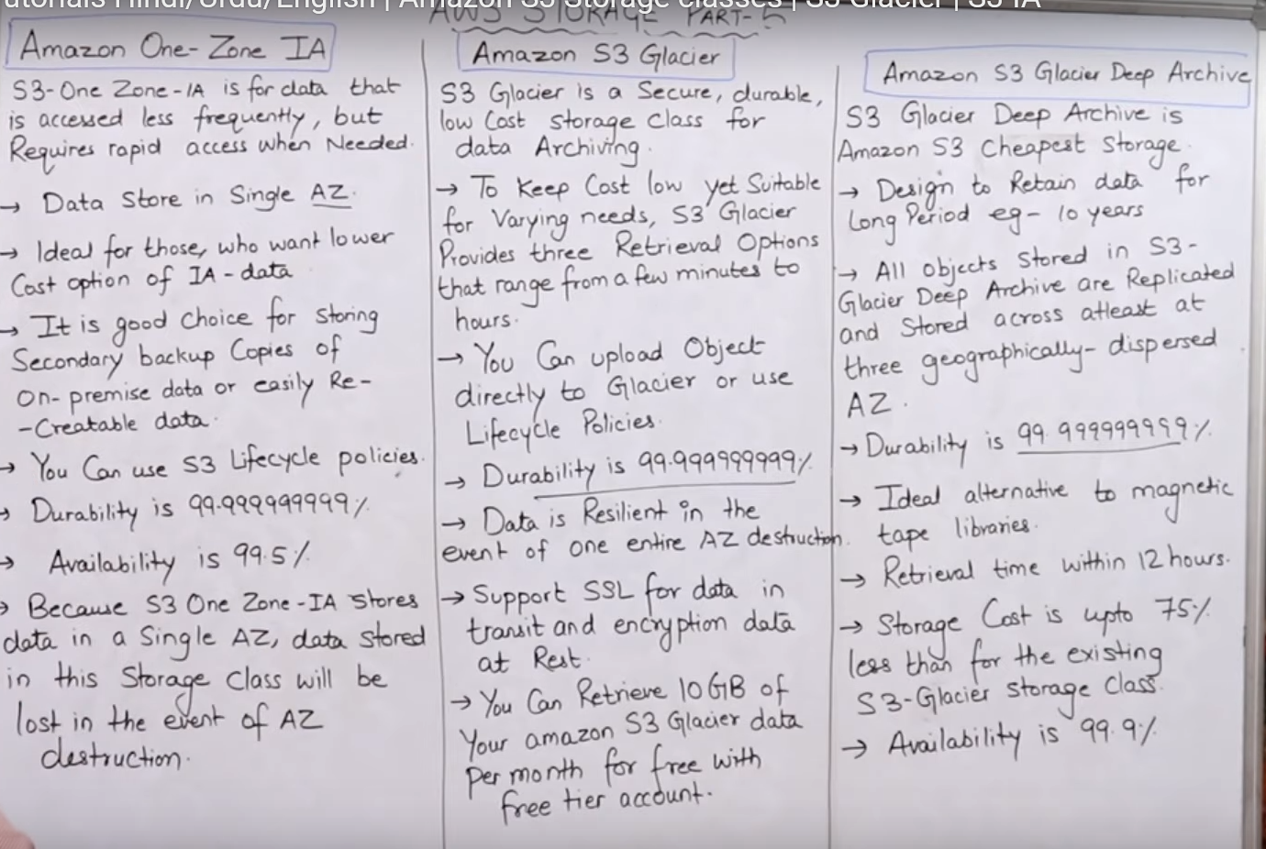

# S3 Bucket CLI commands

*To make bucket aws s3 mb s3://dagadu*

*To delete aws s3 rb s3://dagadu*

*To empty bucket aws s3 rm s3://dagadu/ --recursive*

*To sync a local folder with a bucket*

*For uploading from laptop to bucket , go to folder and aws s3 sync . s3://dagadu*

*For downloading from bucket to laptop , go to folder and aws s3 sync s3://dagadu .*

# EBS - Elastic Block Storage

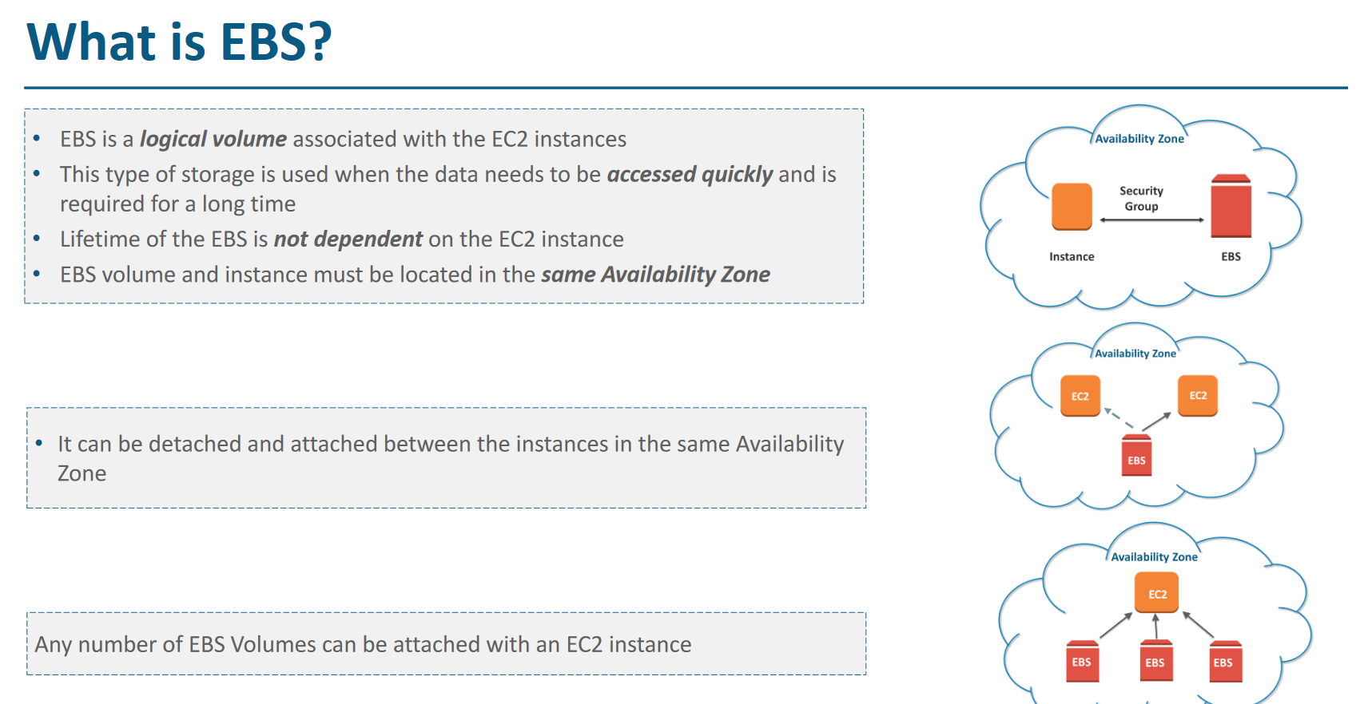

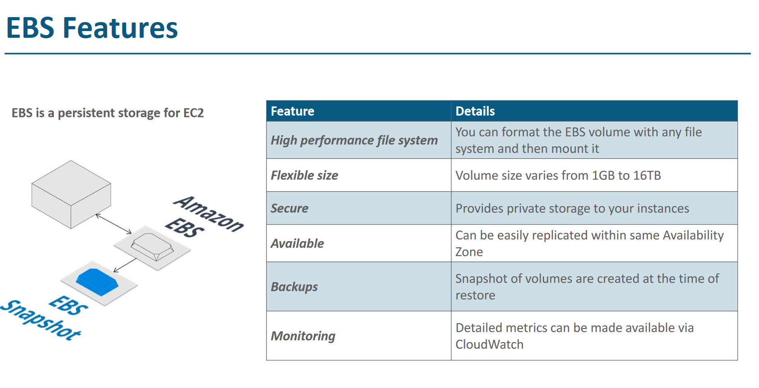

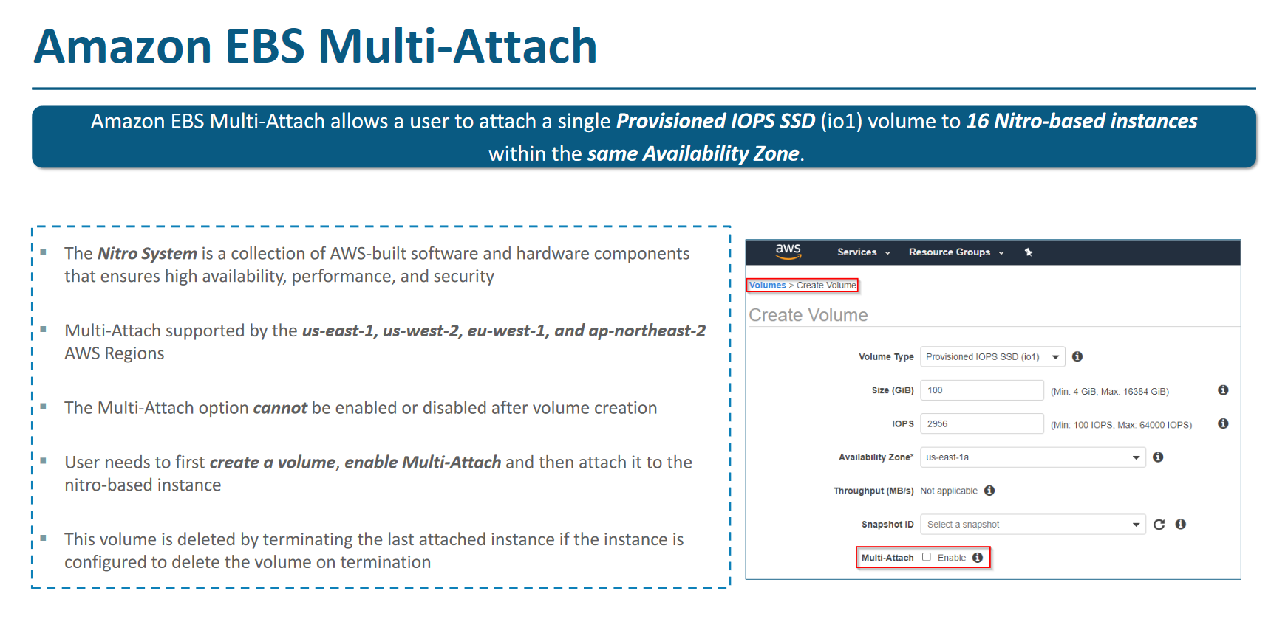

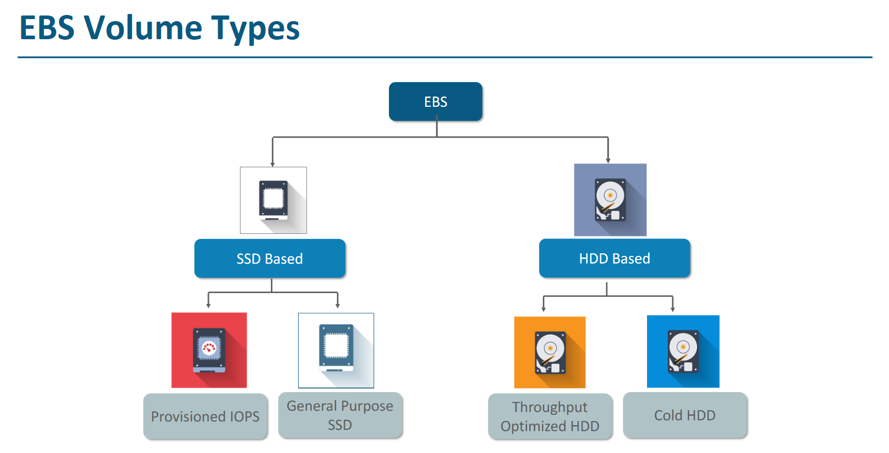

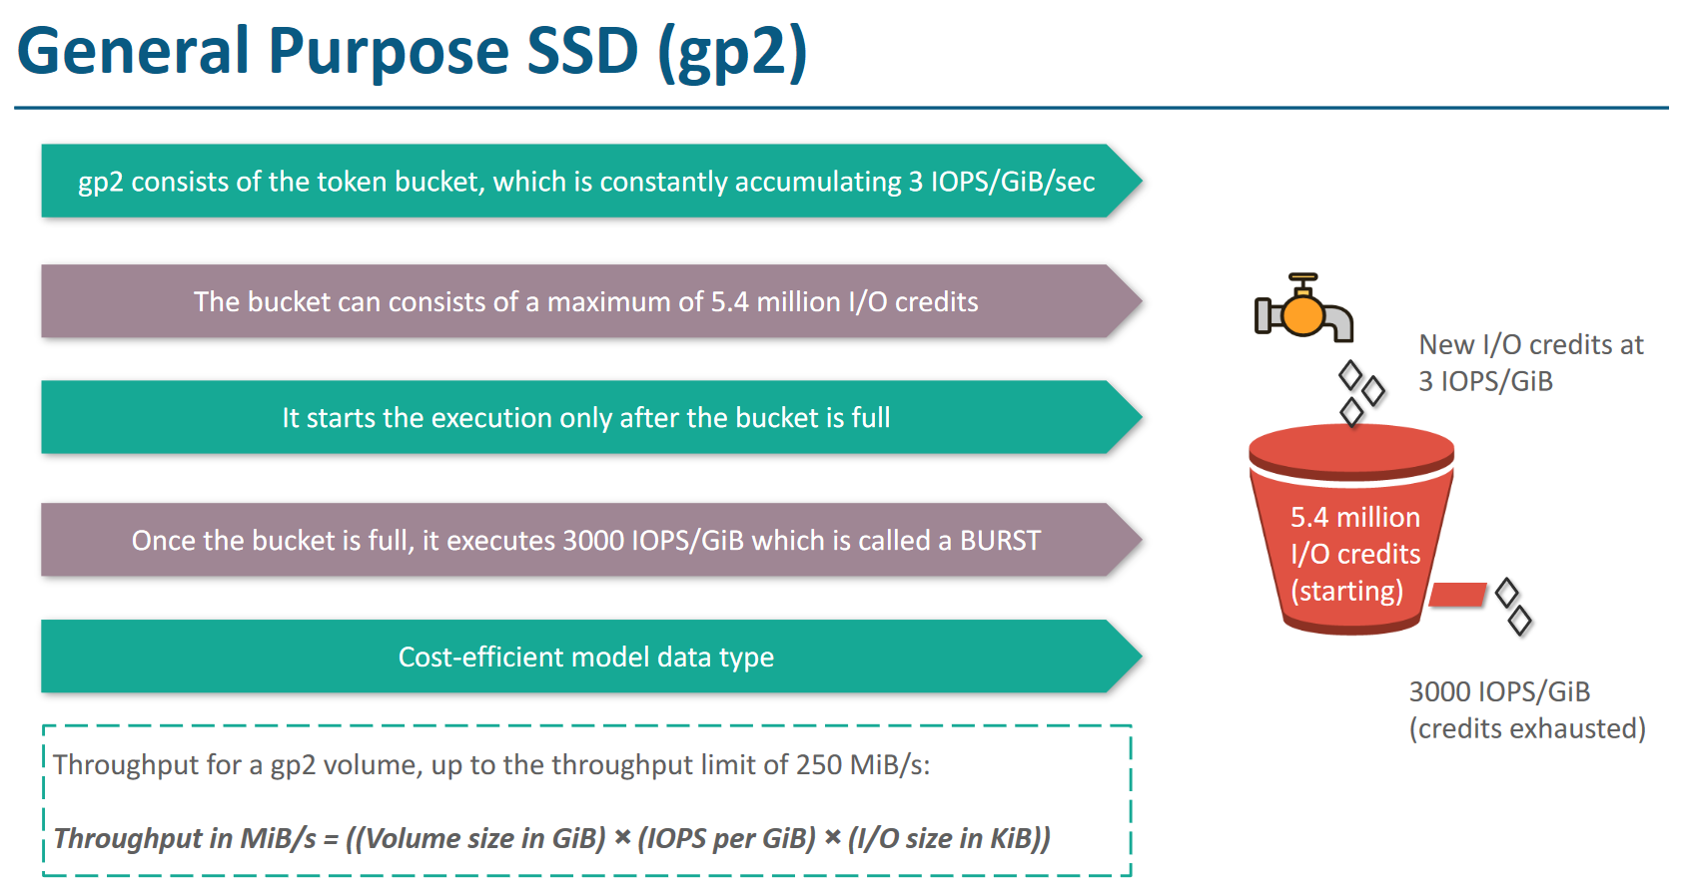

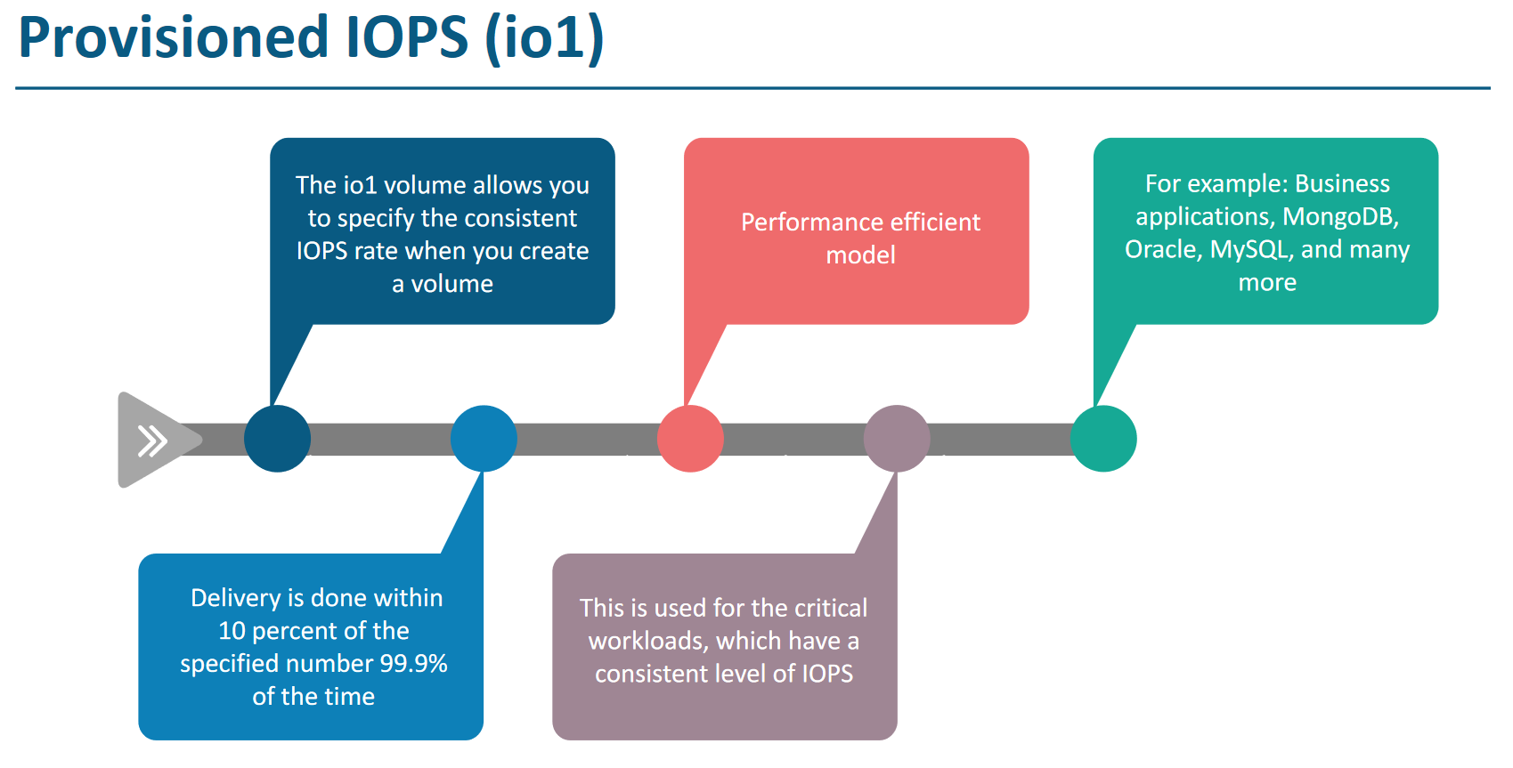

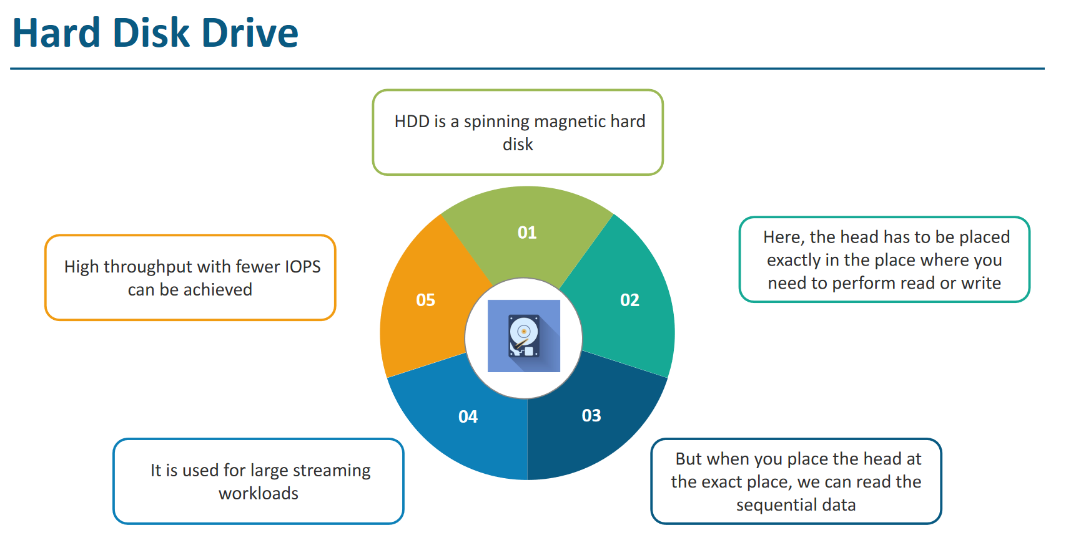

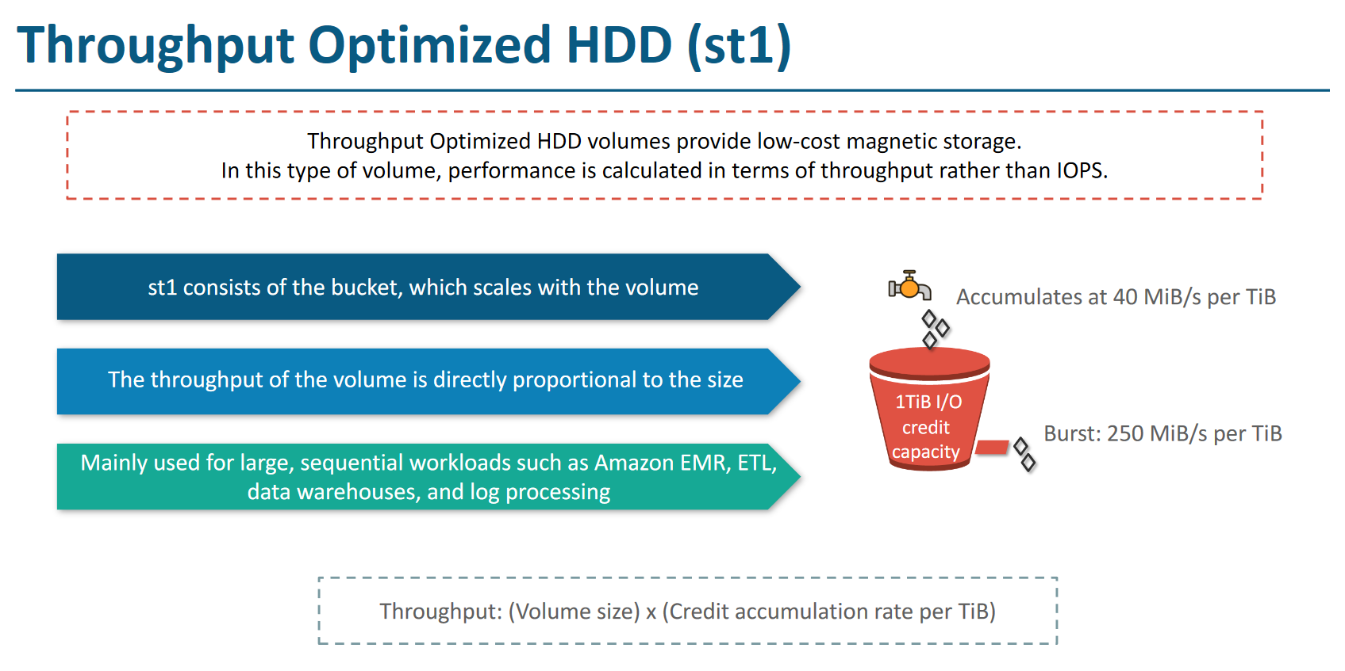

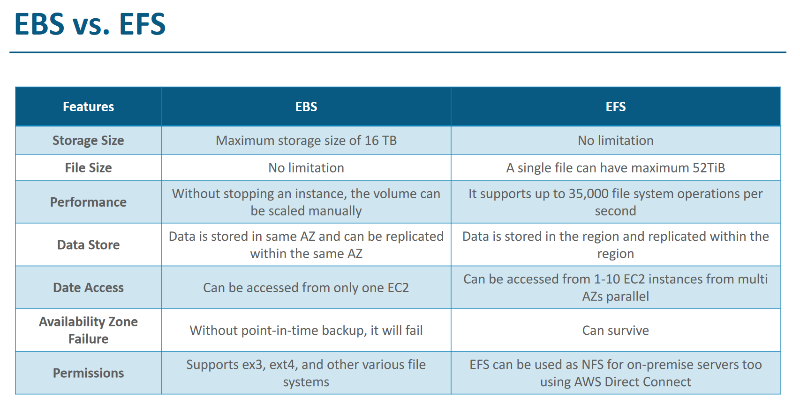

# USE CASE 1 - How to add volume block to an EC2 instance ( apart from default root) through command

1. Create EC2 instance in AMI linux with default setting
2. Create Volume from EC2 dashboard ( volume should be in same AZ as instance)
3. Now attach this volume to instance through volume console.
4. Now connect to server and run fdisk -l to see if the newly created file system is visible
5. Format the file system using mkfs.ext4 /dev/xvdf
6. Make a directory to which you want to mount it
7. Run the mount command mount /dev/xvdf /devwork
8. Check with df -h

# USE CASE 2 – Increase the volume from snapshot through command prompt (we do this if disk is getting filled)

1. Create the snapshot of the existing volume
2. Use this snap shot to create a bigger volume than before ( say 100 gig)
3. Attach this volume to ec2 instance through console
4. Now don’t FORMAT just mount and flush because if you format it , will erase all the data
5. Mount /filesystem folder-name
6. To come this change into effect either you restart the instance or flush the filesystem using resize2fs /dev/xvdg
7. Done. Same volume increase can also be done through console

# EFS – Elastic File System

1. It’s a regional service. Means it does not work in multiple region. Only work with different ec2 in different AZ with in same region
2. We don’t define size. It increases dynamically
3. Most important - If you want to mount servers to EFS then don’t forget to put all servers in default security group from console otherwise EFS mounting command will not work.
4. Step to create first create the ec2 instances and create the /efs folder on them.
5. The create the EFS from console and attach this EFS to servers using the mount command taken from efs console

Elastic Load Balancer

ELB is a AWS managed service

AWS does not provide global load balancer. It is only for 1 region ( can be on multiple AZ in that region)

It is auto scaled

Its support SSL termination. If https encrypted requests comes to it…then it can decrypt it and send the http data to targets (this avoids target server of decrypting the ssl overhead)

It supports the health check of targets and don’t send traffic to unhealthy targets

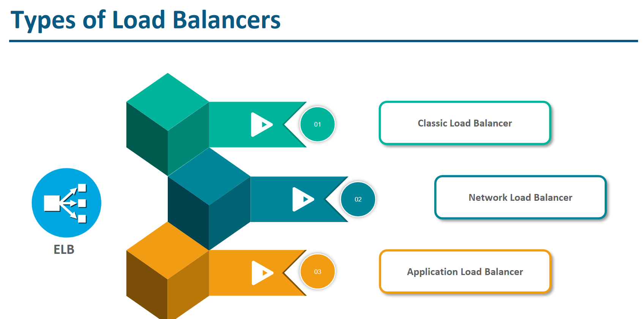

There is 4th latest LB which is Gateway Loadbalancer

# Classic load balancer - It is deprecated. No one is using it (only the old applications are using it)

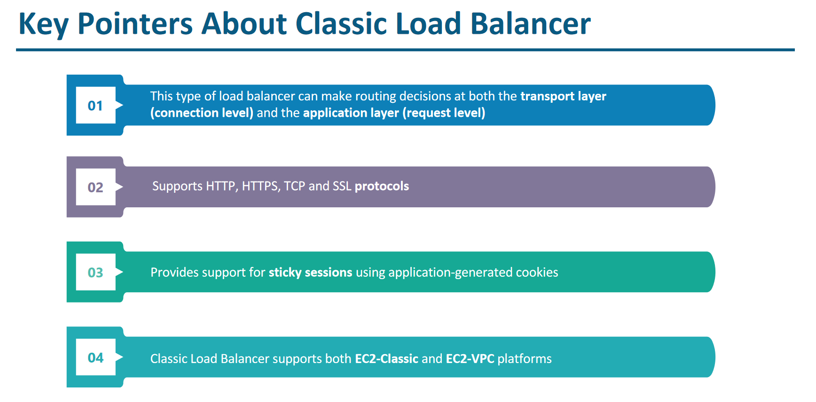

# Application load balancer

It supports path-based routing as describe below

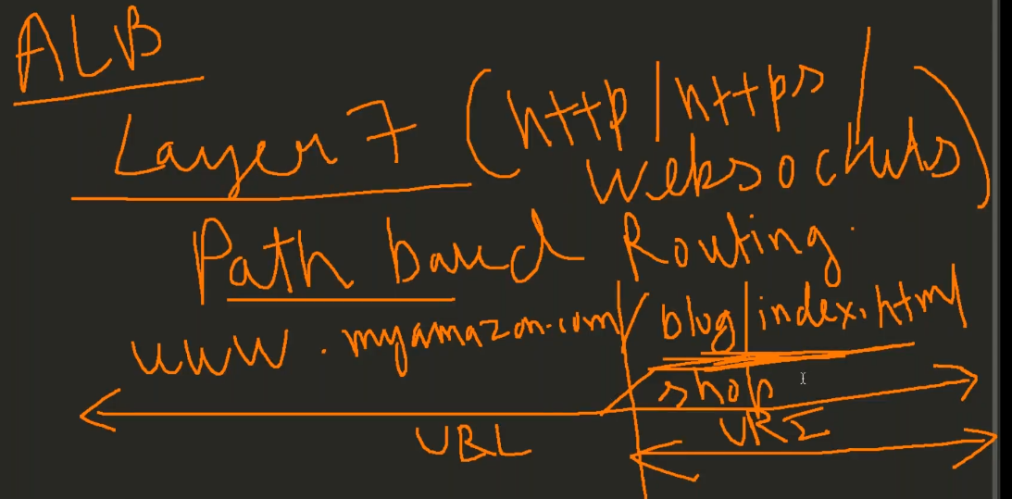

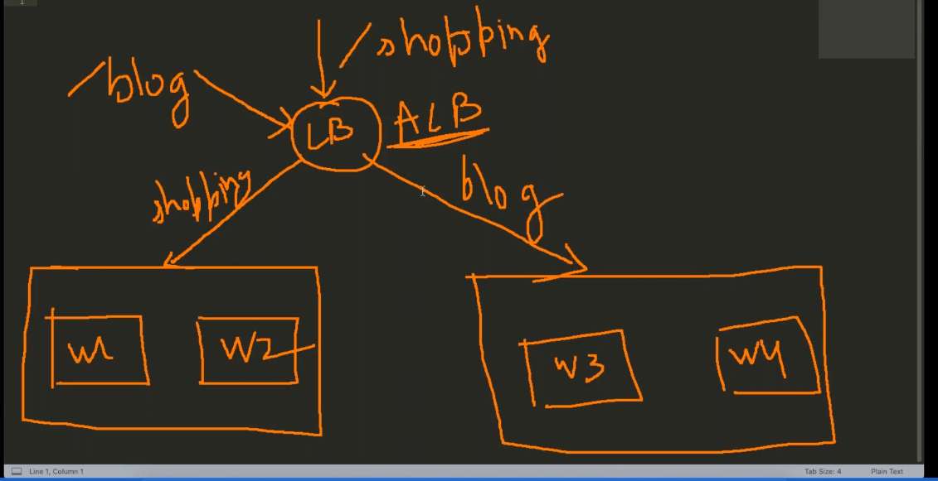

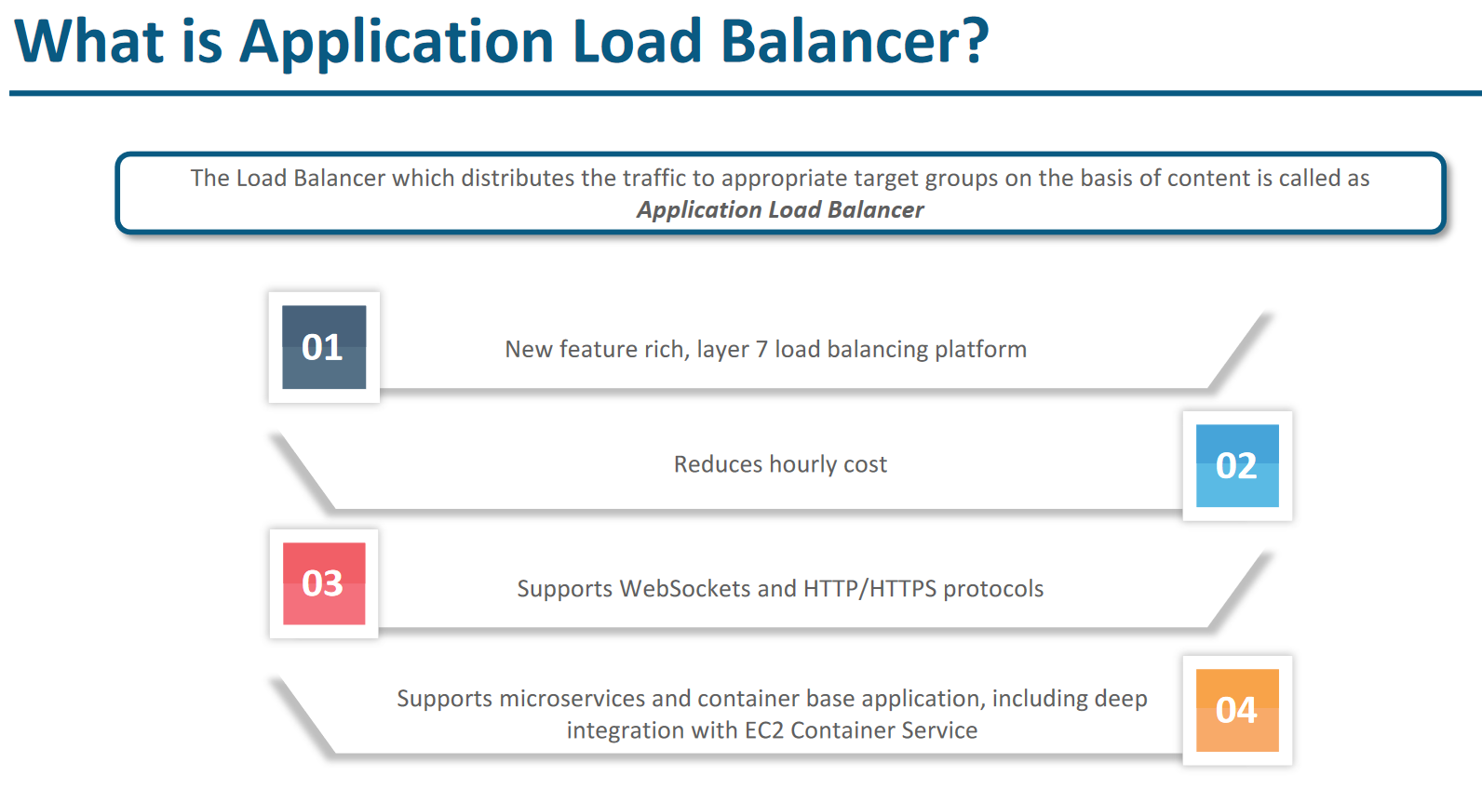

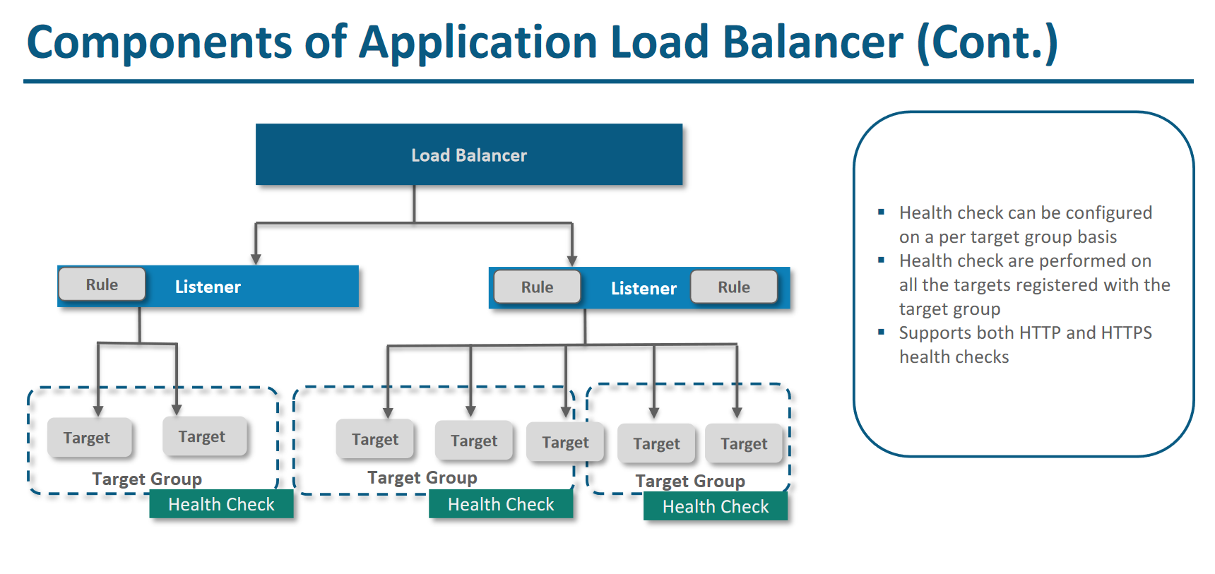

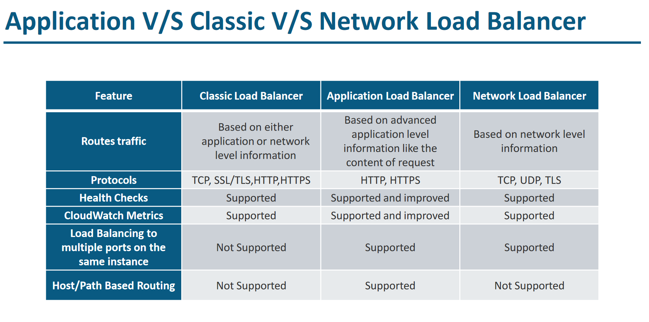

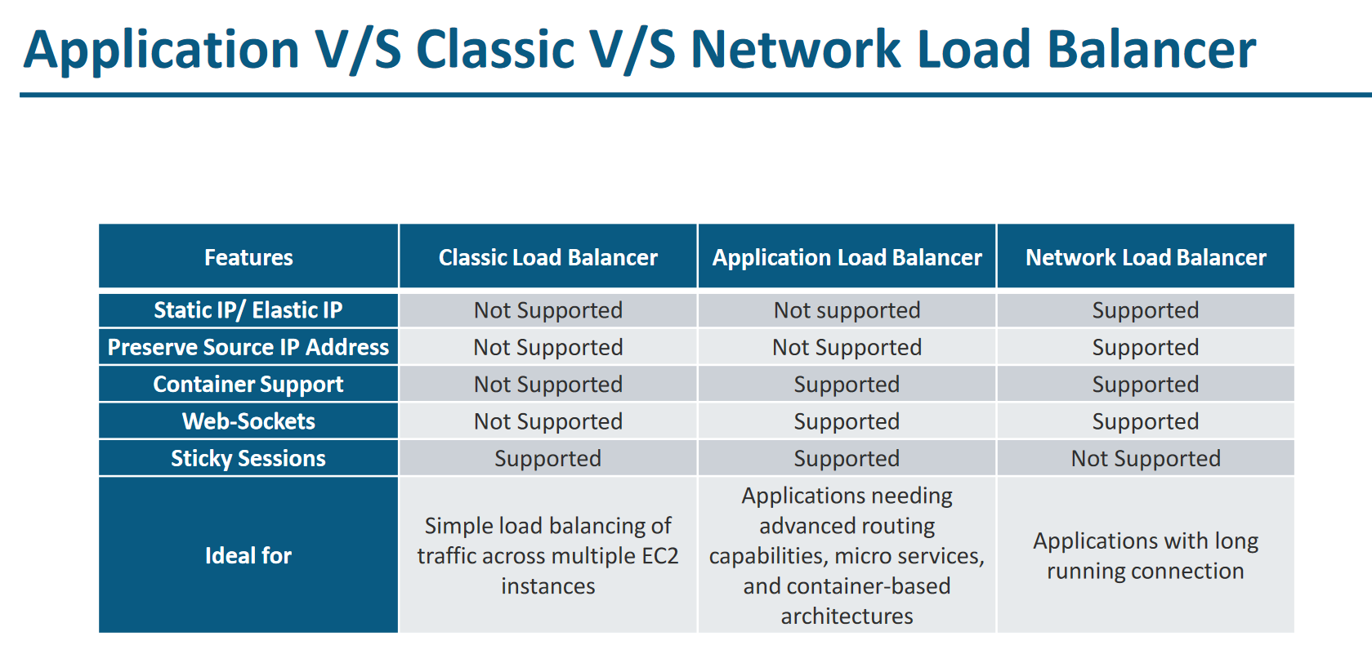

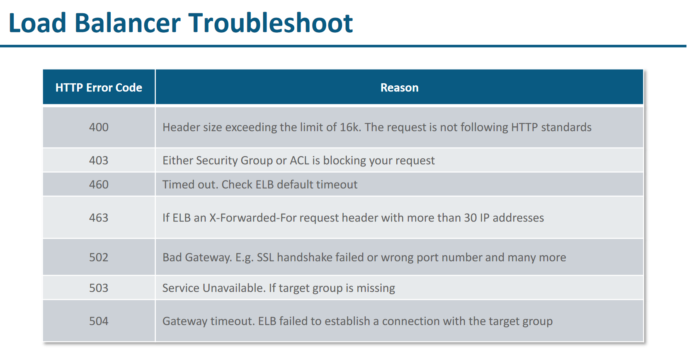

# Auto Scaling

Scaling is of 2 types as describe below. Vertical and Horizontal scaling

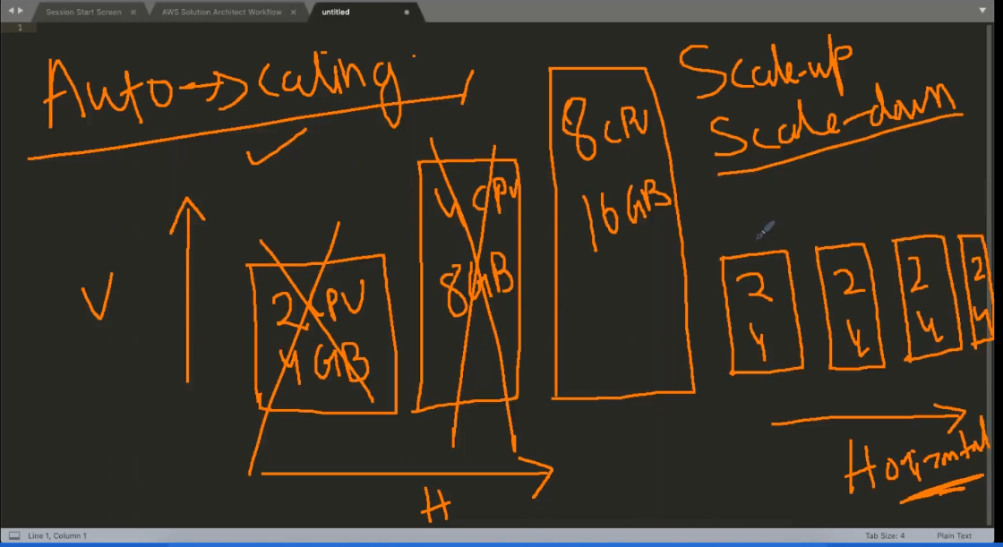

Few Prerequisite of auto scaling

Only horizonal scaling is supported

Application should be stateless. If it is stateful then after auto scaling it might go in bad state

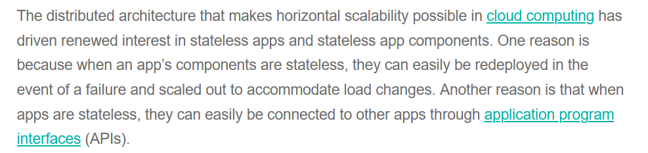

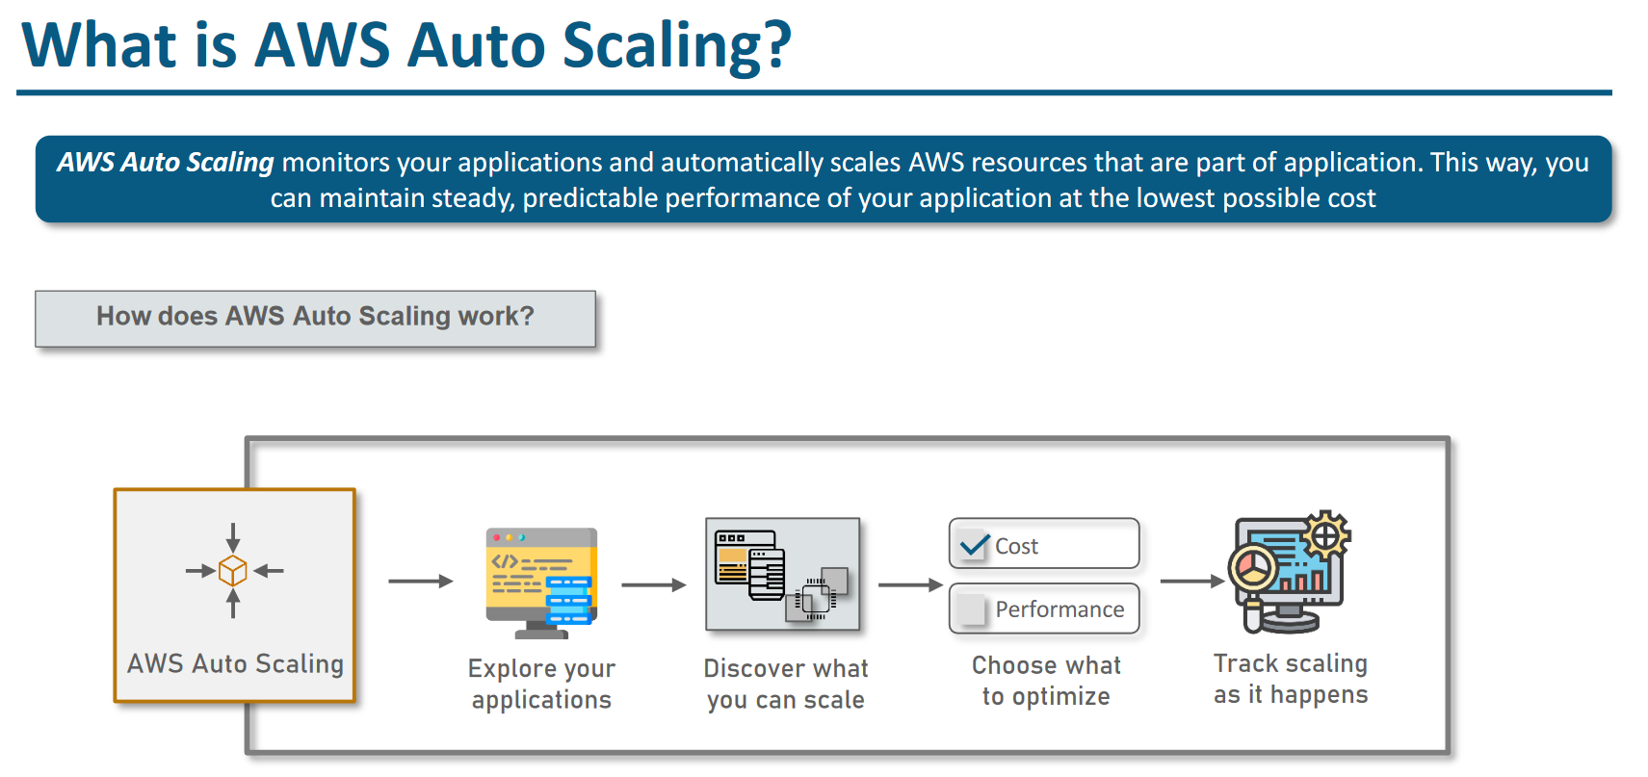

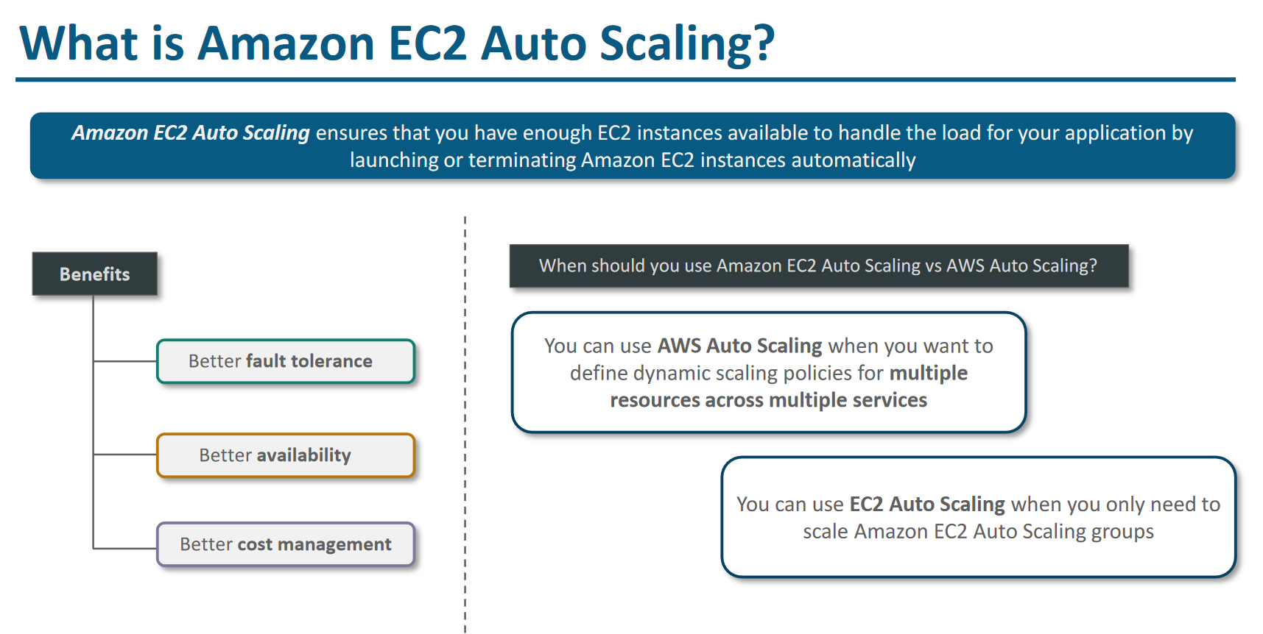

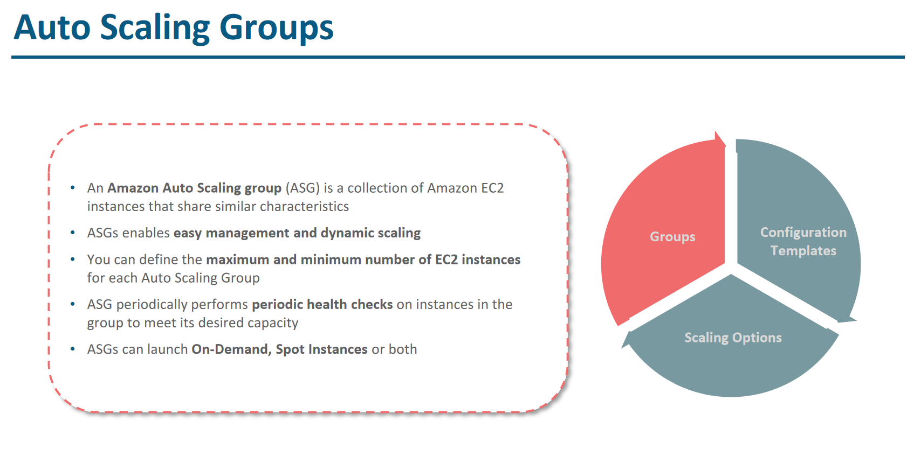

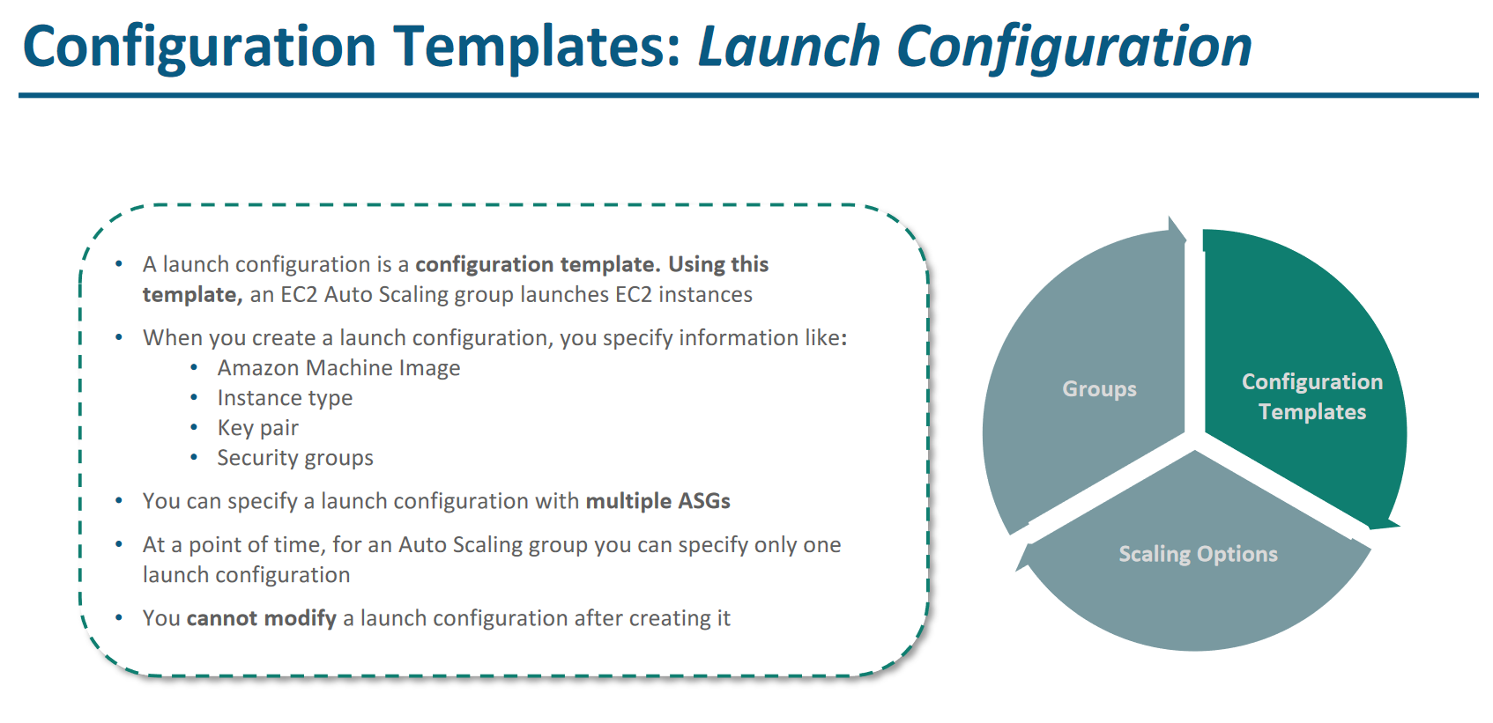

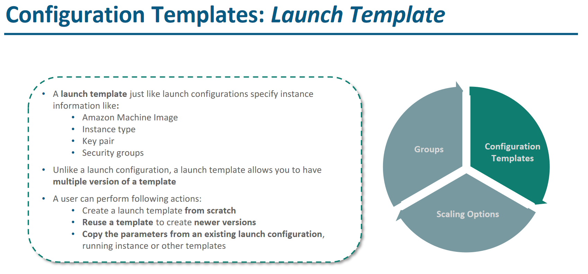

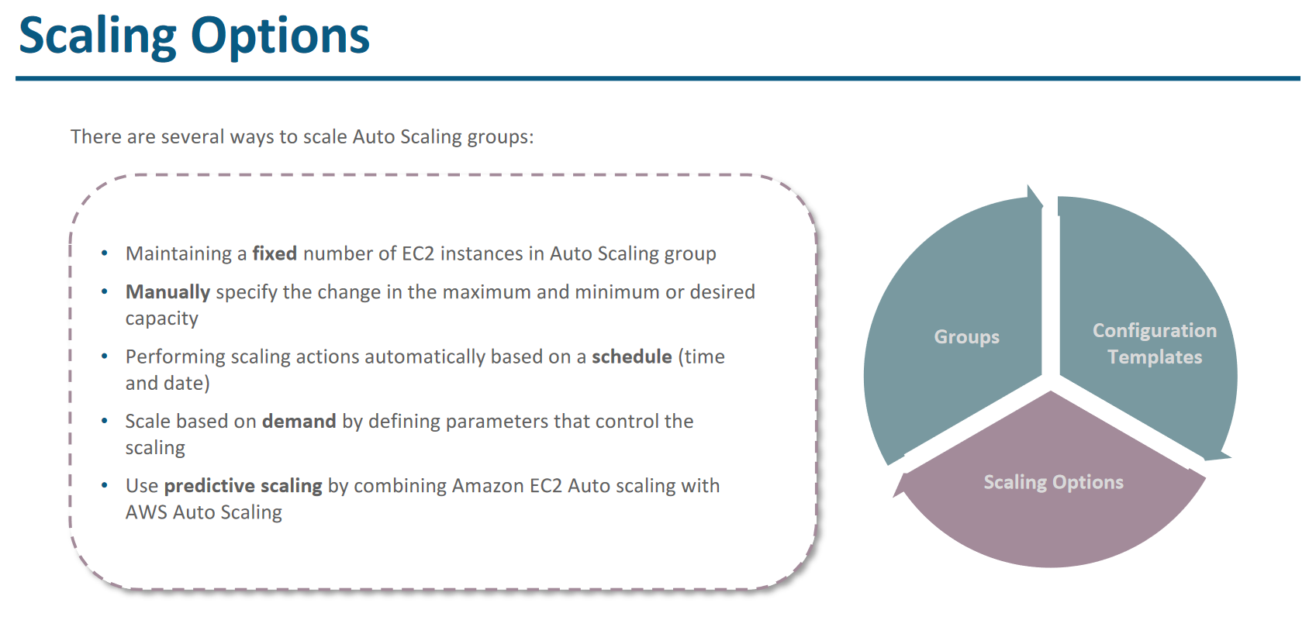

# **Life Cycle of Autoscaling (Difficult- learn from some you tube video)**

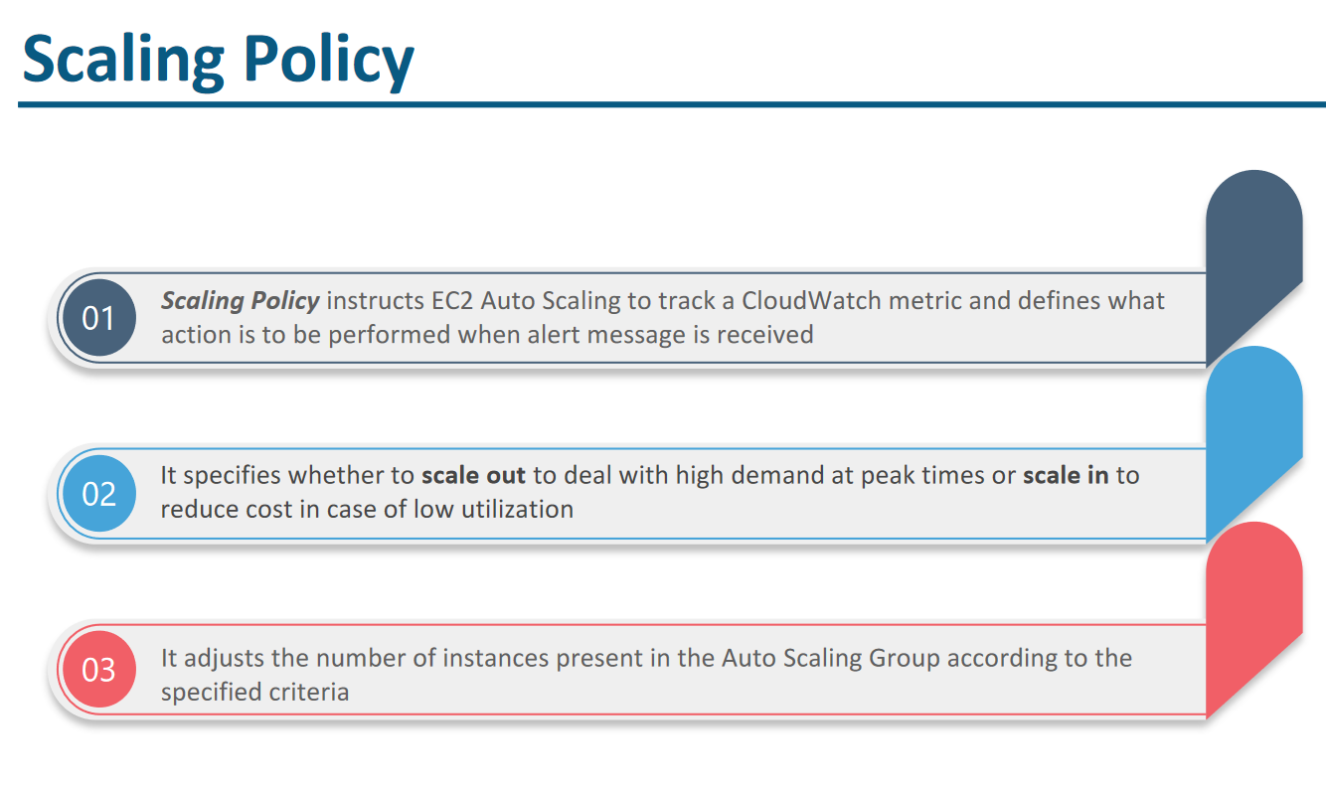

Ideally LB should be connected to ASL and we should have ASL for each layer. Like for web servers ASL group then for App server ASL group.

Route 53

Route 53 is a DNS service (Domain name server) and DNS runs on port 53 that’s why it is called Route 53.

Route 53 is a global service.

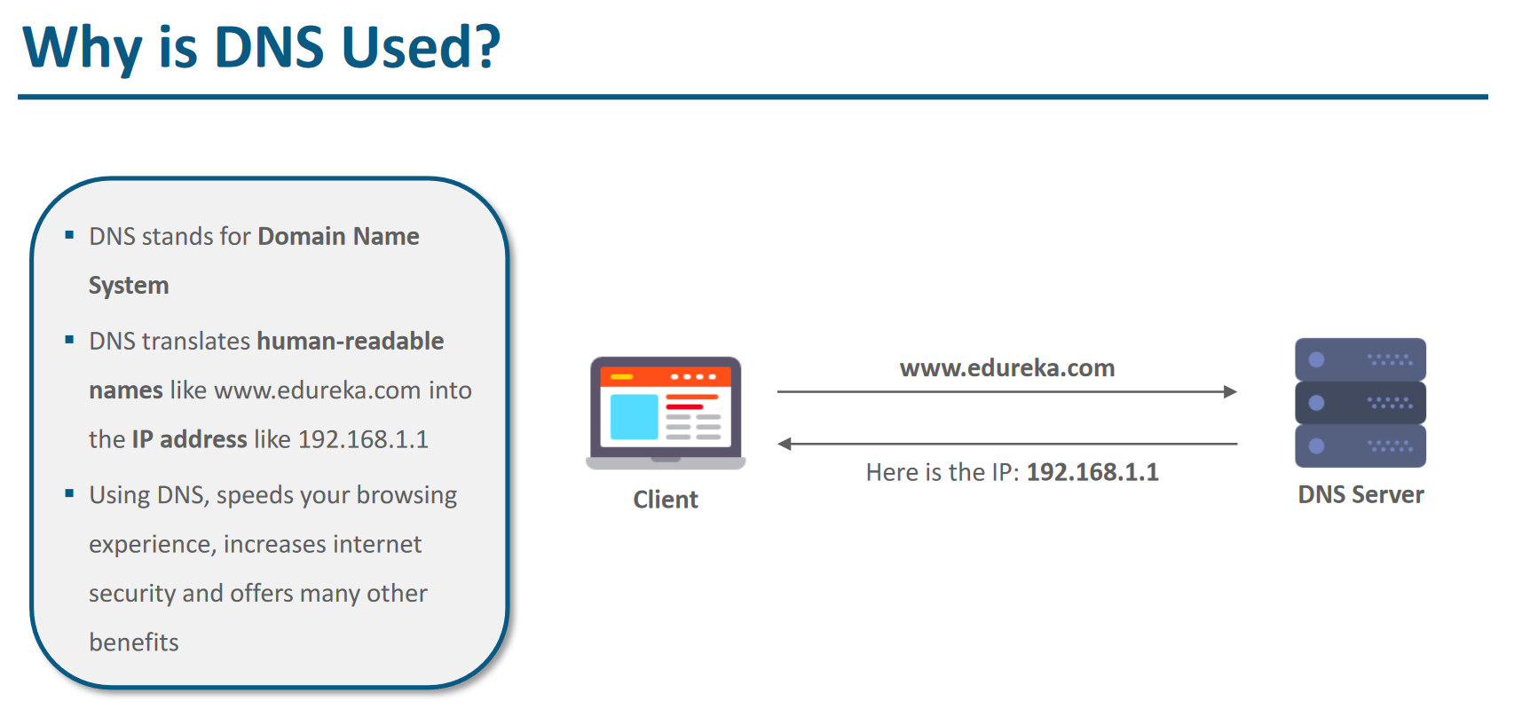

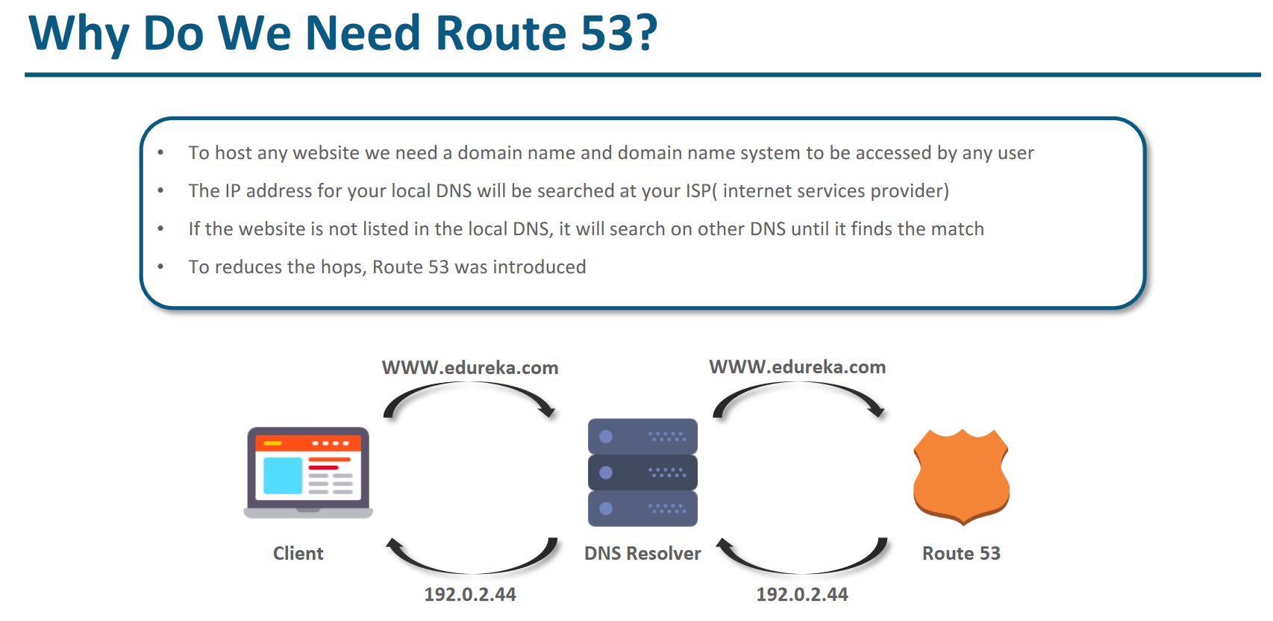

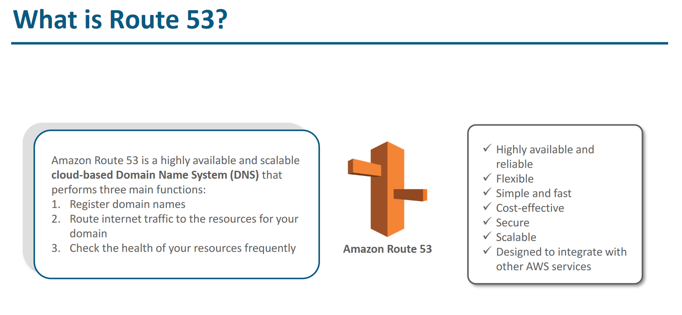

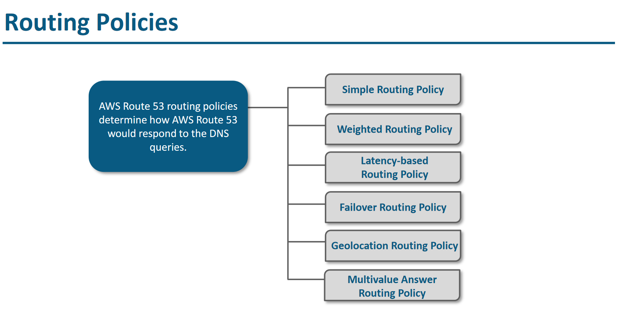

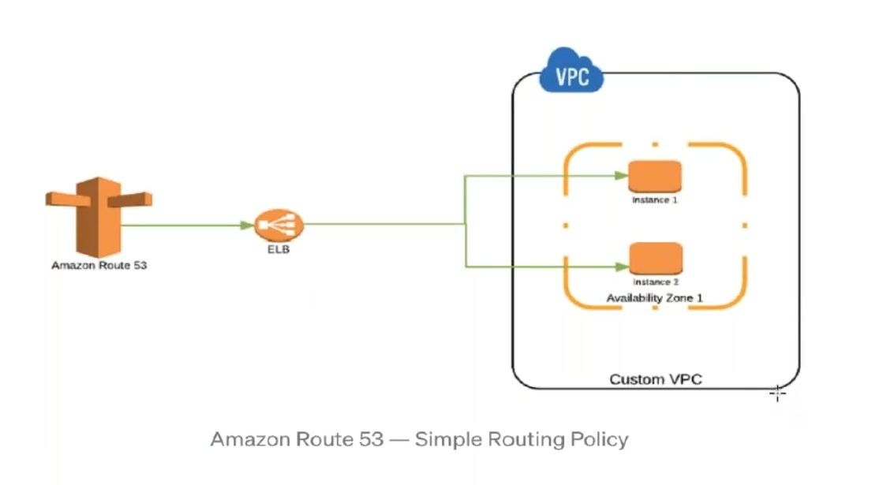

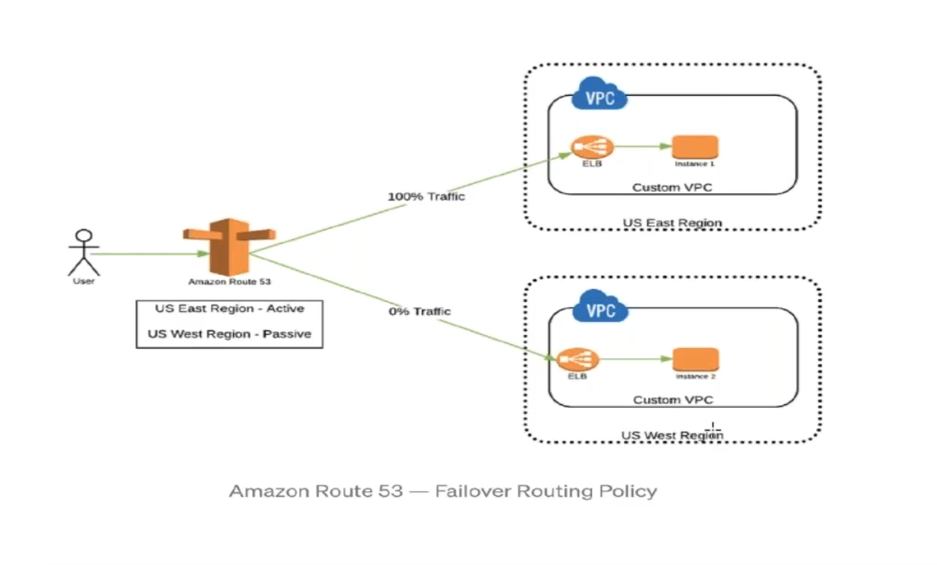

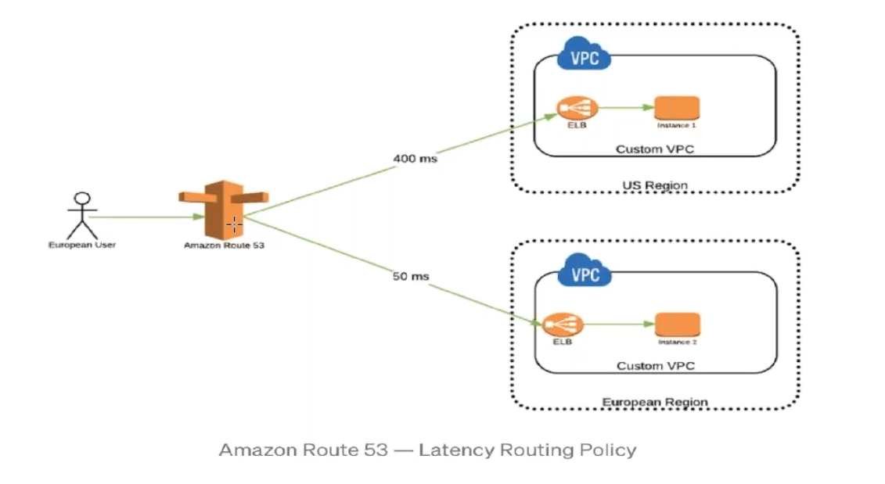

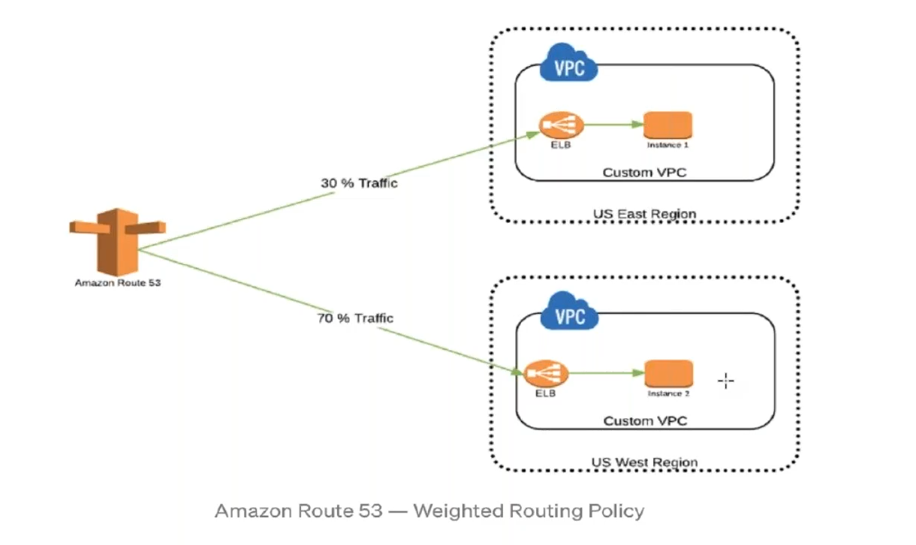

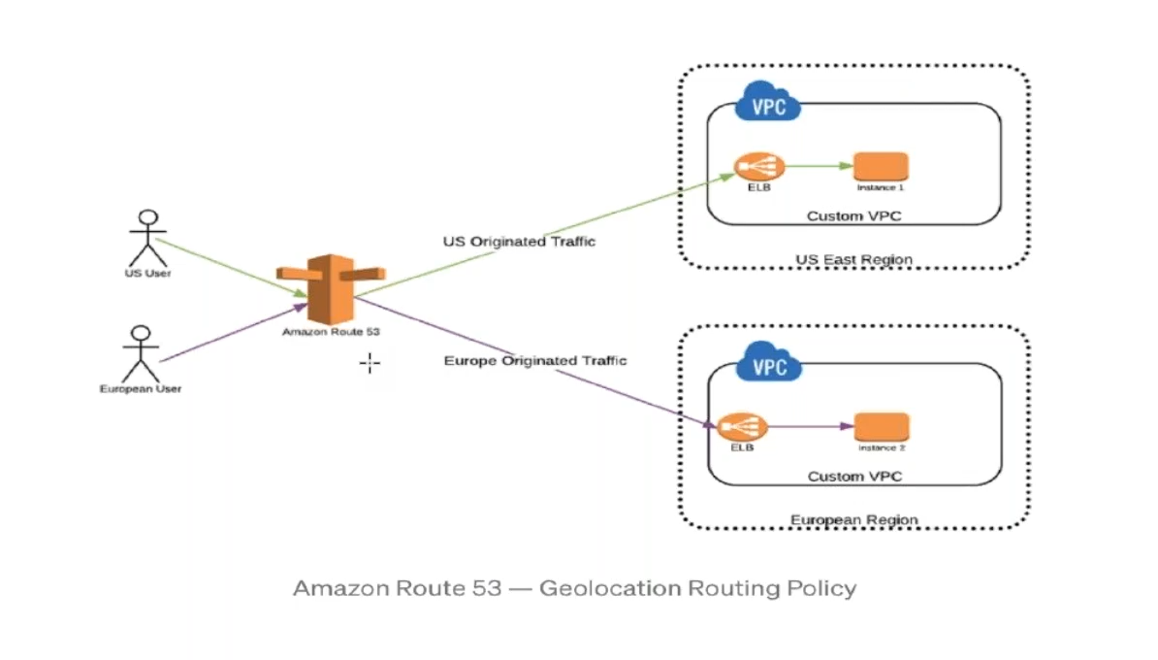

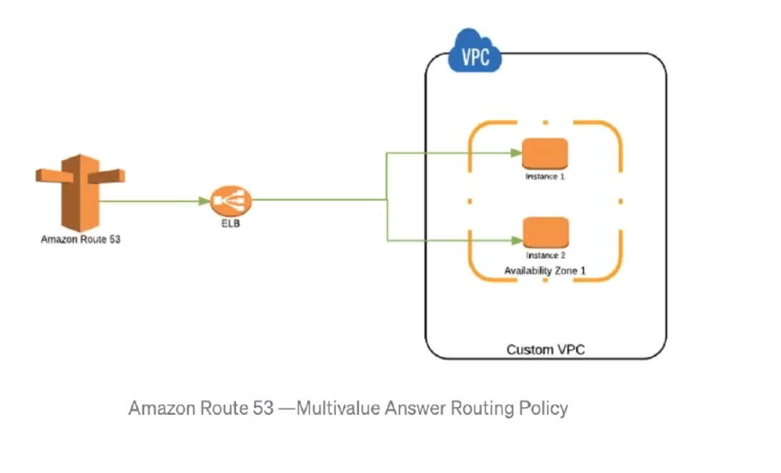

VPC – Virtual Private Cloud

Special Note - Project Omega from Linux Academy - [https://lucid.app/lucidchart/703f6119-4838-4bbb-bc7e-be2fb75e89e5/view?page=eNbqbEM6f5NI#](https://lucid.app/lucidchart/703f6119-4838-4bbb-bc7e-be2fb75e89e5/view?page=eNbqbEM6f5NI)

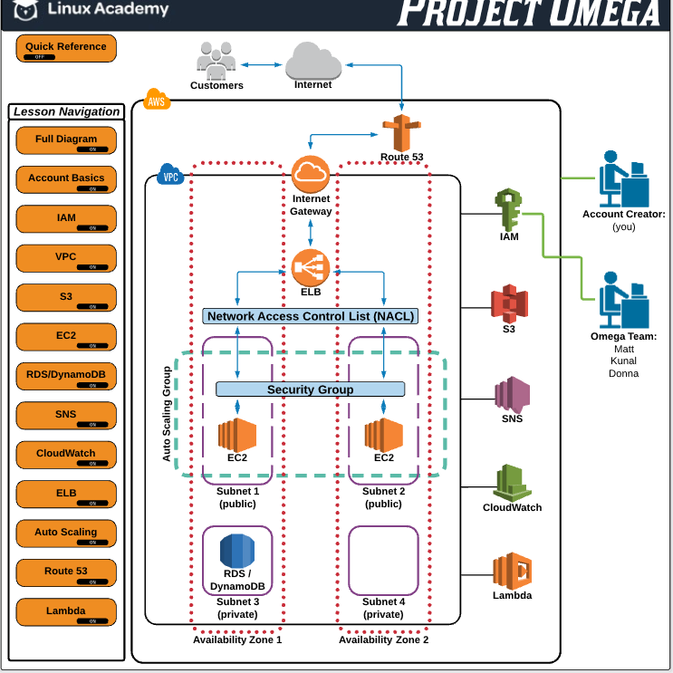

<https://www.youtube.com/playlist?list=PLv2a_5pNAko0Mijc6mnv04xeOut443Wnk>

Below URL can be practice for creating AWS architecture

**VPC Analogy with home network**

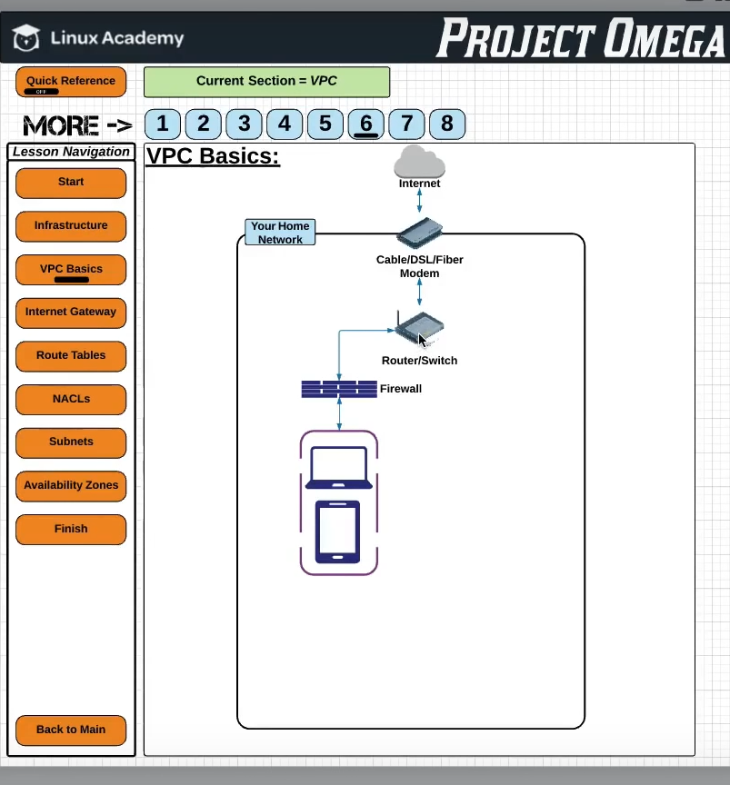

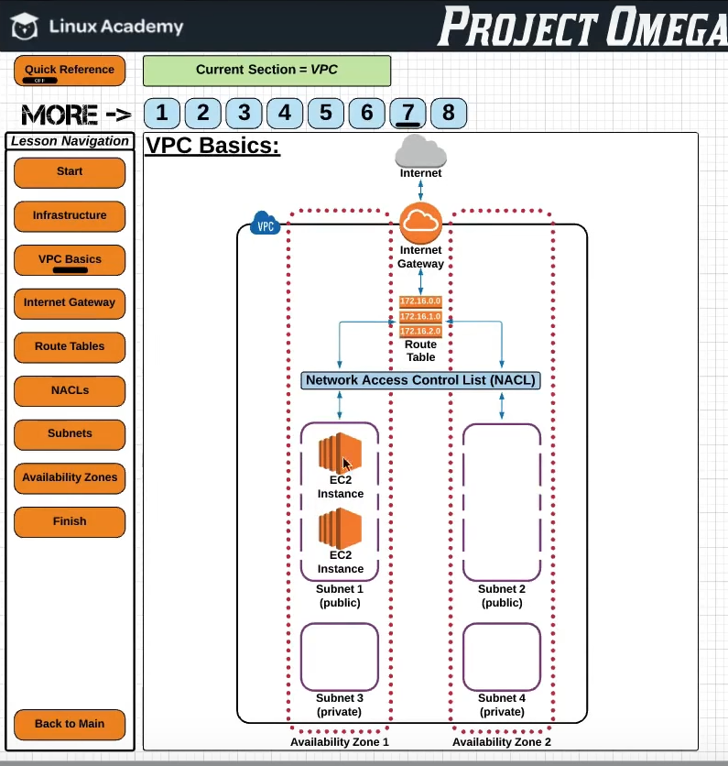

Below list of components are required to make VPC work

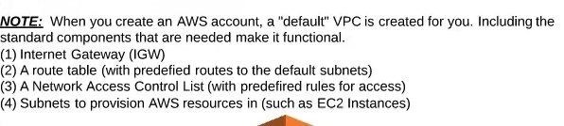

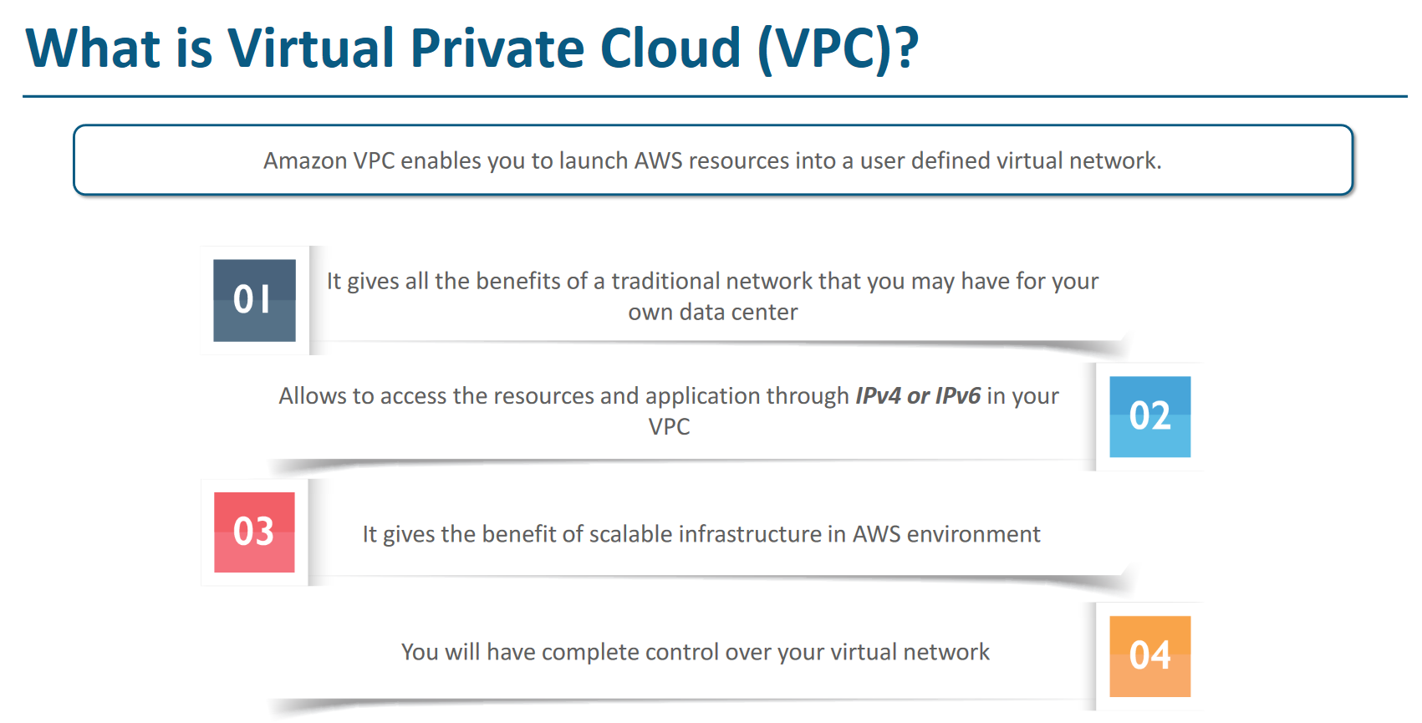

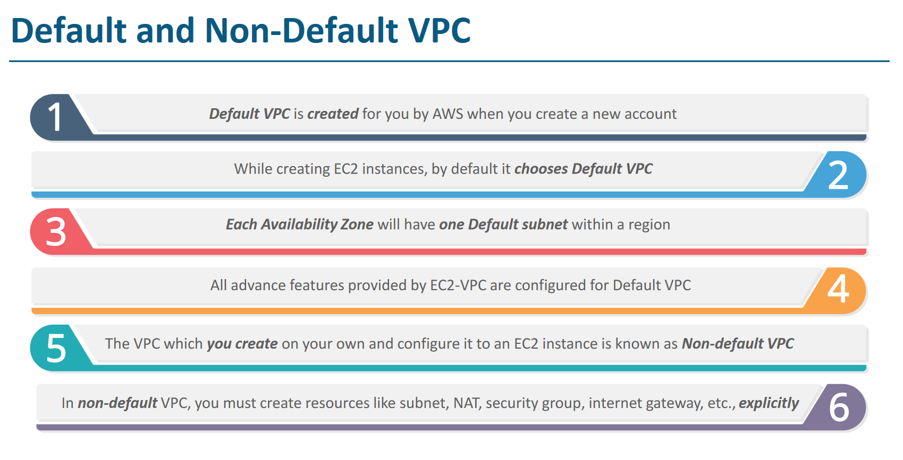

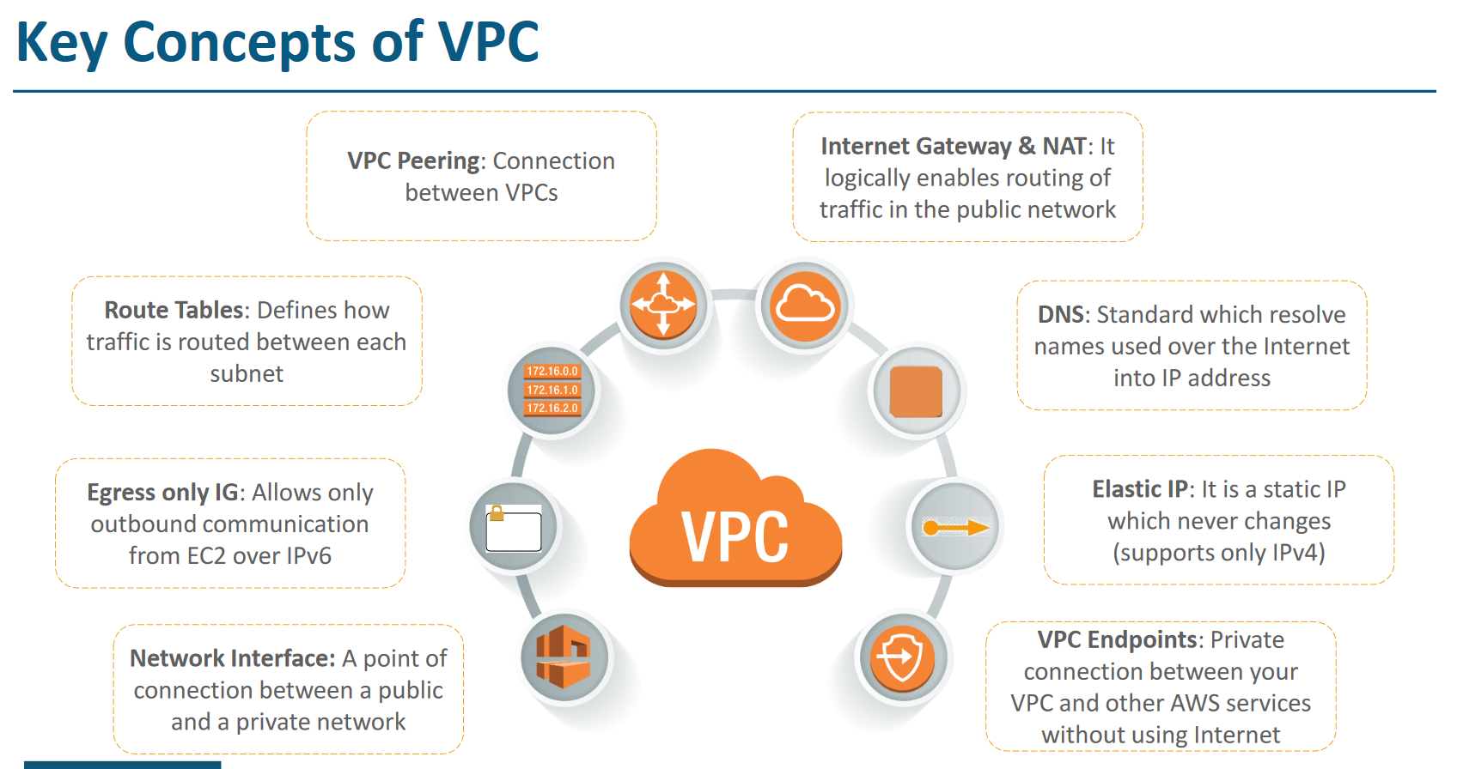

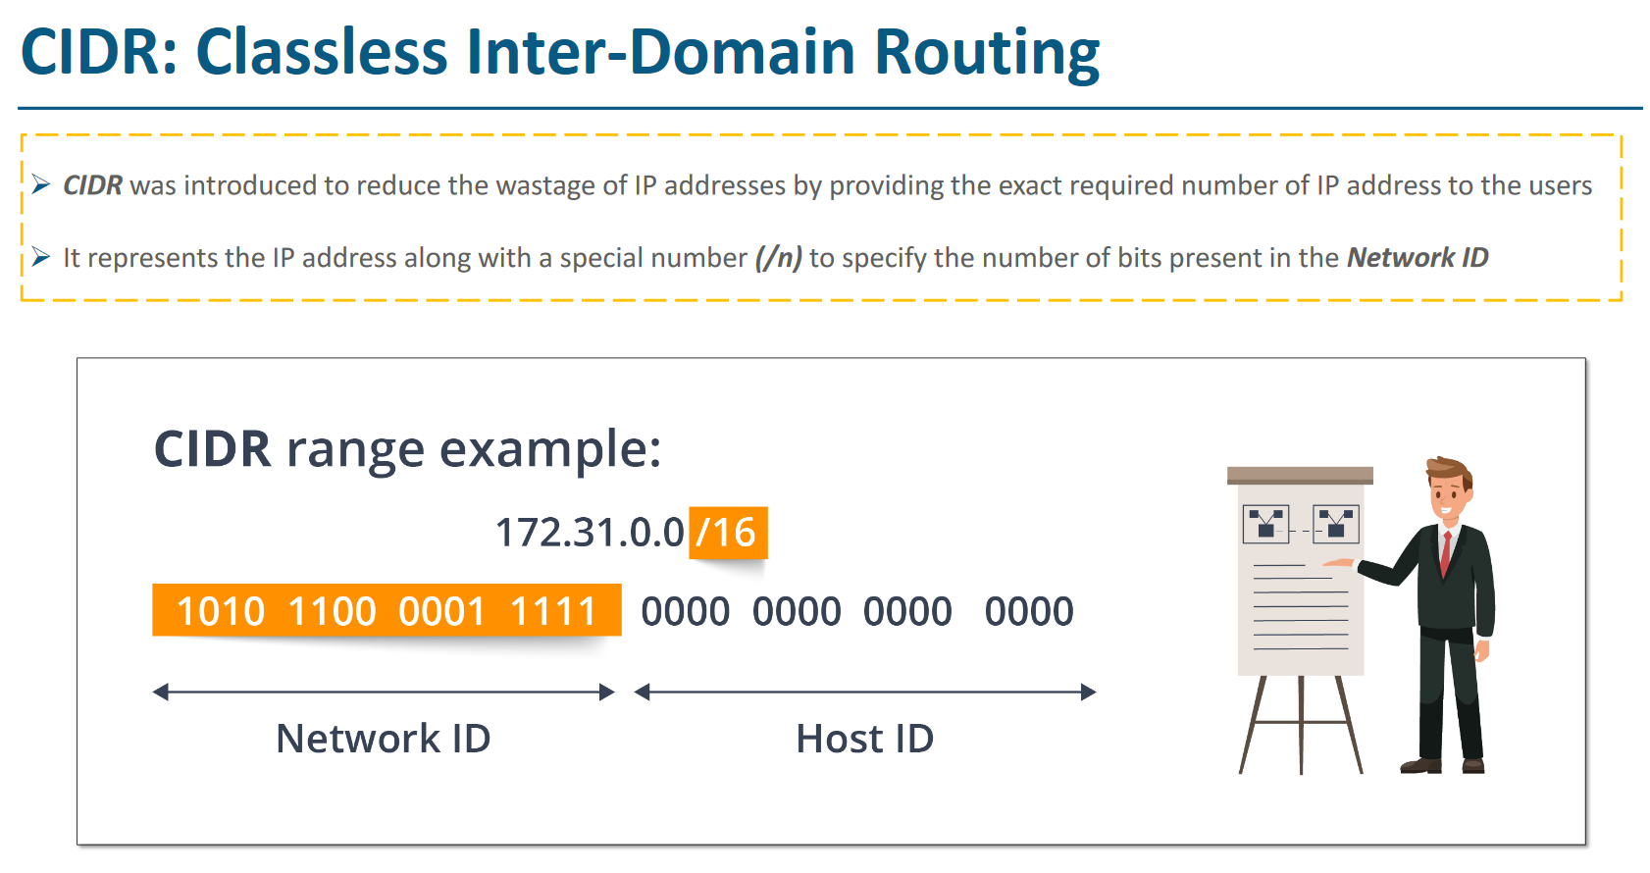

Here /16 denotes the network ID

Full ip address in IPv4 is of 32 bit

8 bit.8bit.8bit.8bit

It means first 16 bits are reservered and only later 16 bits are available for host IP

So , 16 bit = 2^8 x 2^8 = 2^16 = 65k IP address available (approx)

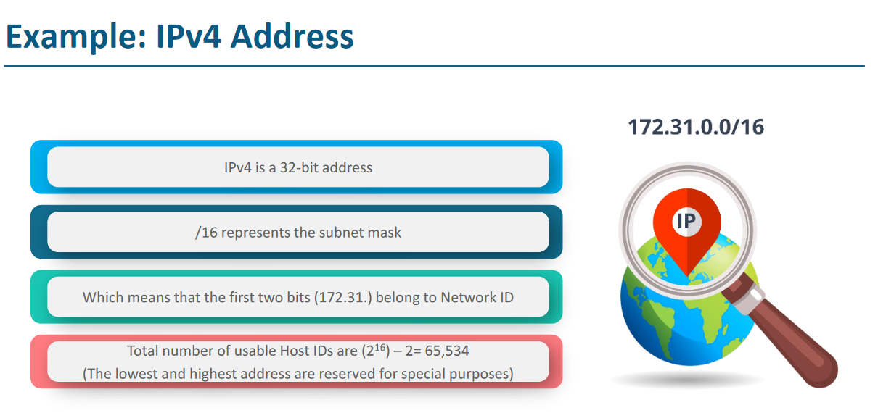

# **SubNet**

When VPC is creates then it expands to all AZ of a region. Subnets are the small networks in side a AZ. Each subnet entirely reside with in one AZ and cannot span other zone.

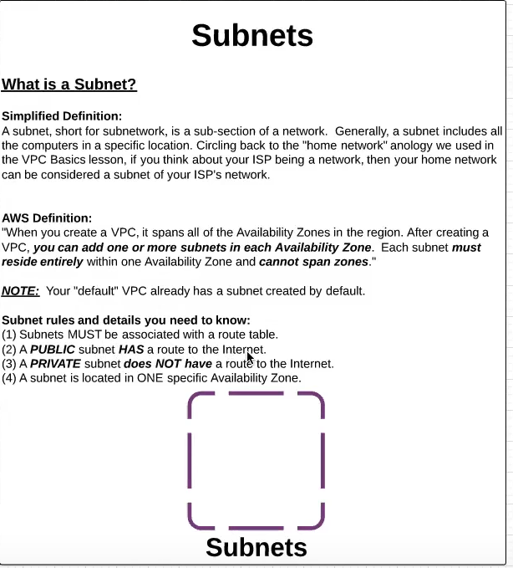

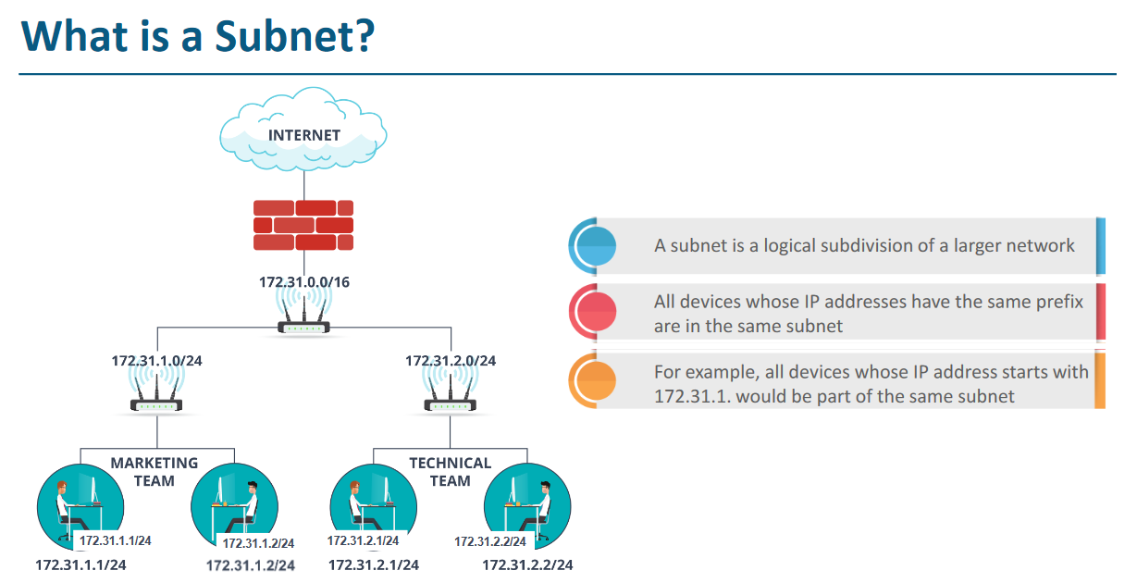

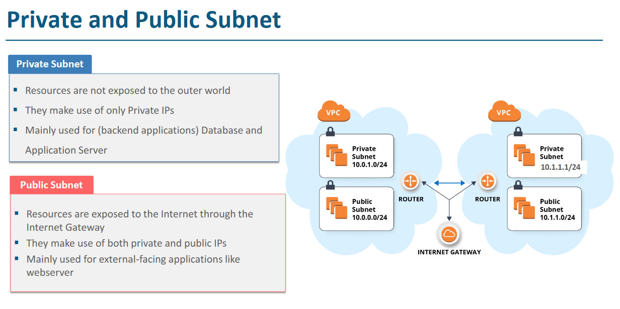

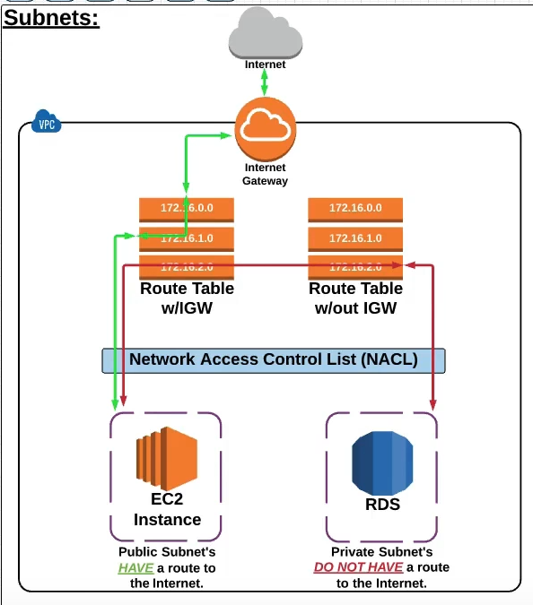

Subnets which are attached to a route table which is attached to IGW is called **public subnets**.( due to internet connectivity)

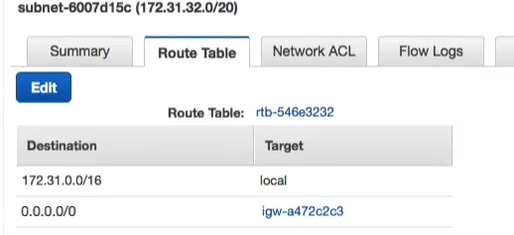

And Subnets which are attached to a route table which is NOT attached to IGW is called **private subnets**.( due to NO internet connectivity)

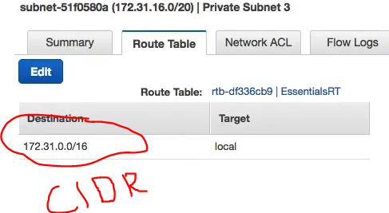

But in both the cases both the subnet will be able to talk to each other as route table has a default CIDR level entry which is responsible for internal communication of subnets.

# Internet Gateway (IGW)

IGW is to enable the internet connection to vpc ( only if it is attached to vpc)

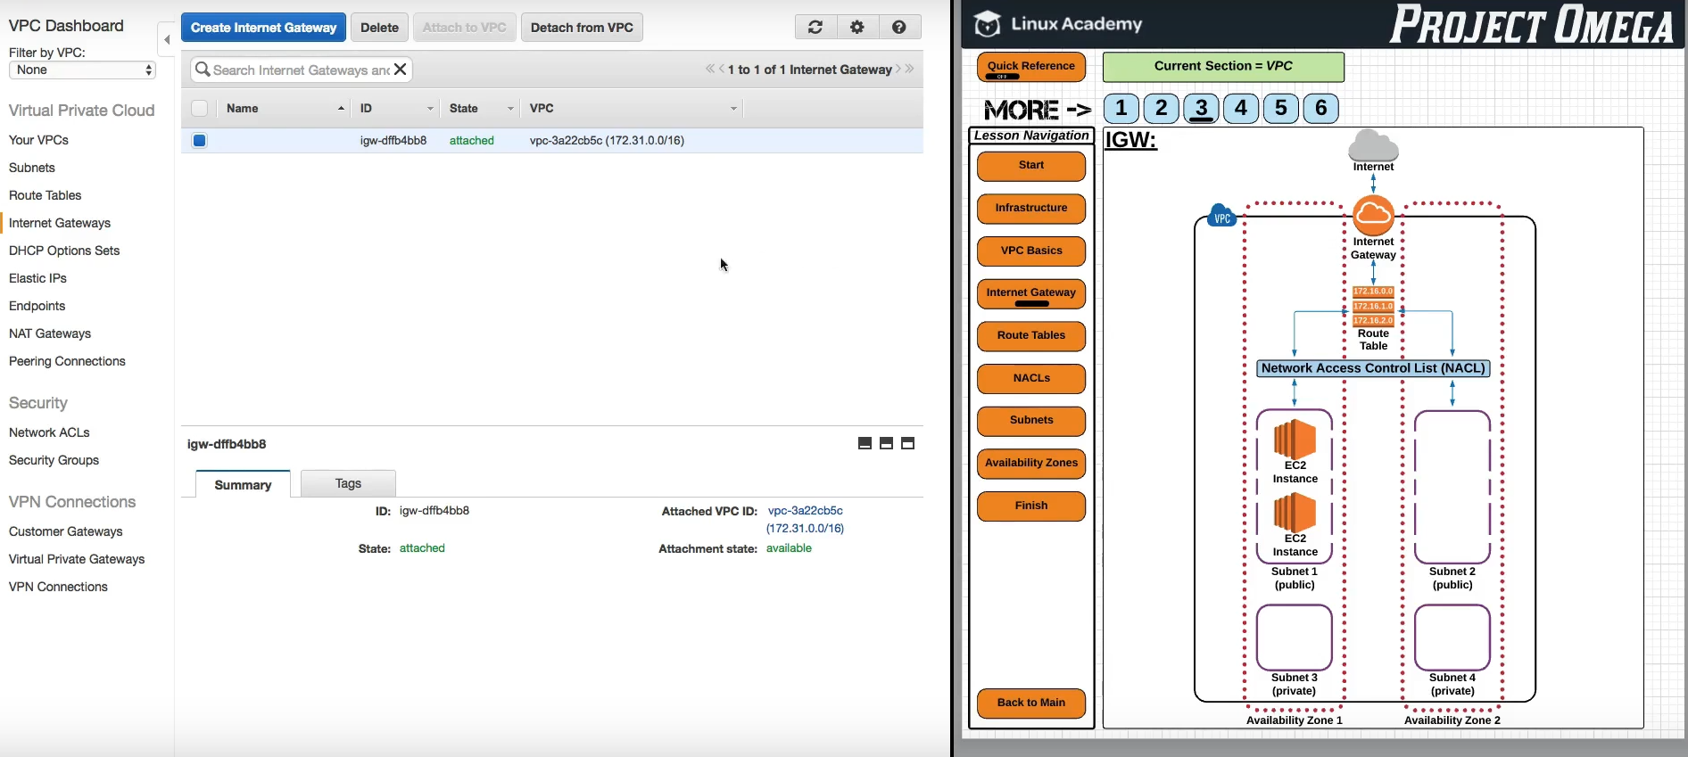

IF we detach it, then there will be no internet access to vpc

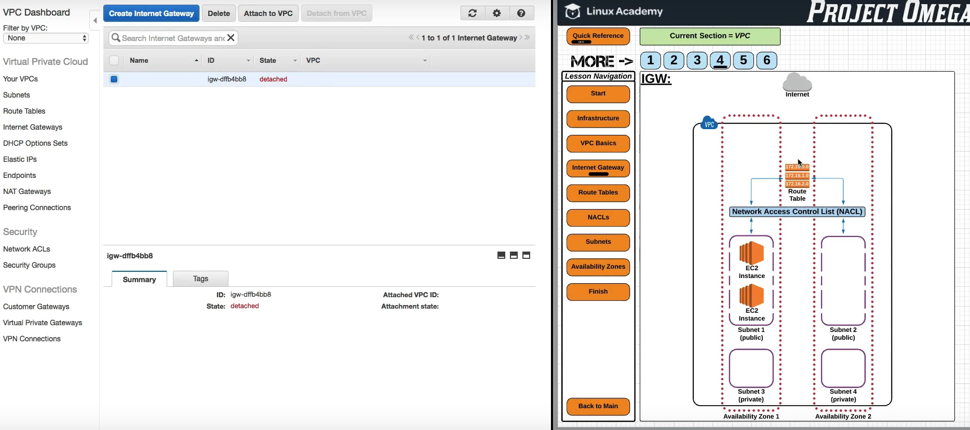

Some Rules about internet gateway

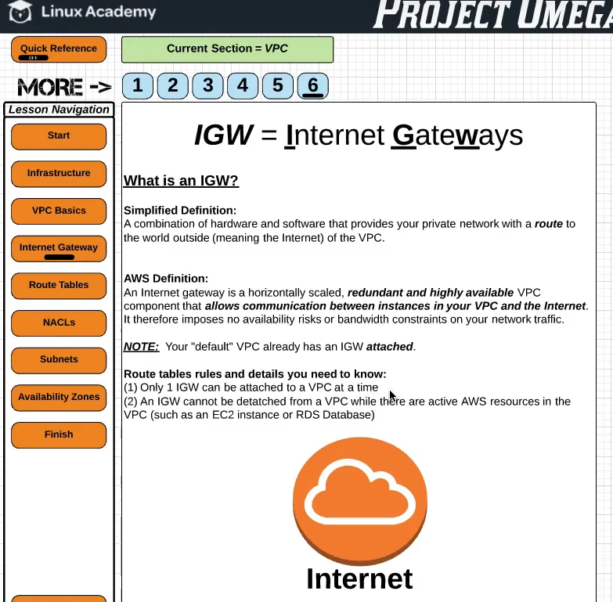

# **Route Table**

Route table if the bridge between IGW and Subnets and this tells the data ( coming and going from internet) to which ec2 instance it has to go.

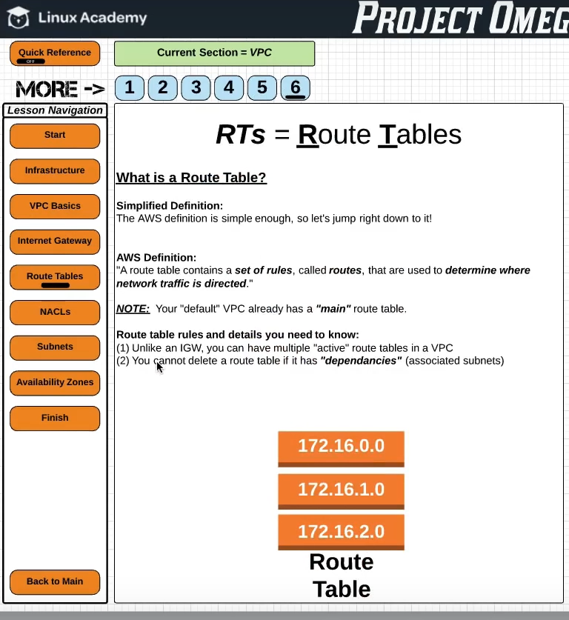

If Route table is attached with IGW and local CIDR it will work fine

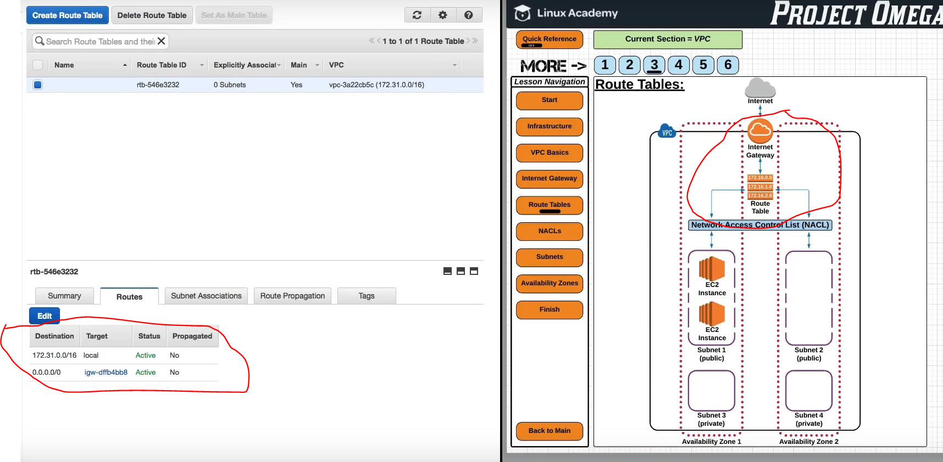

If we detach the IGW then RT will still point to it but the traffic will go to black hole means nothing

So either we will have to again attach the IGW or create new IGW and attach it to VPC and route table

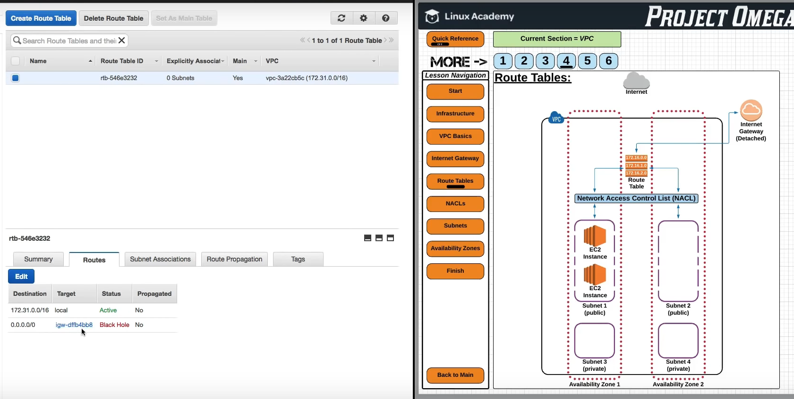

The below route table shows, it is attached to CIDR range ( mean local devices like ec2 in this CIDR can talk to each other through it ) and the second row shows it is attached to IGW so all device of CIDR can also talk to internet. These 2 entries are must for a route table to work correctly.

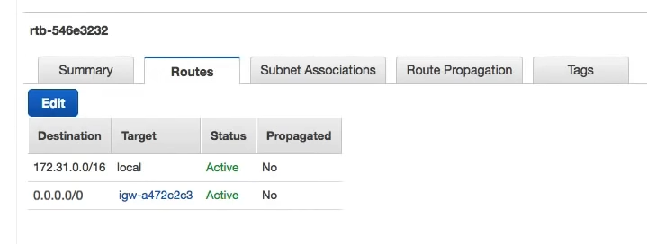

# NACL – Network Access Control list

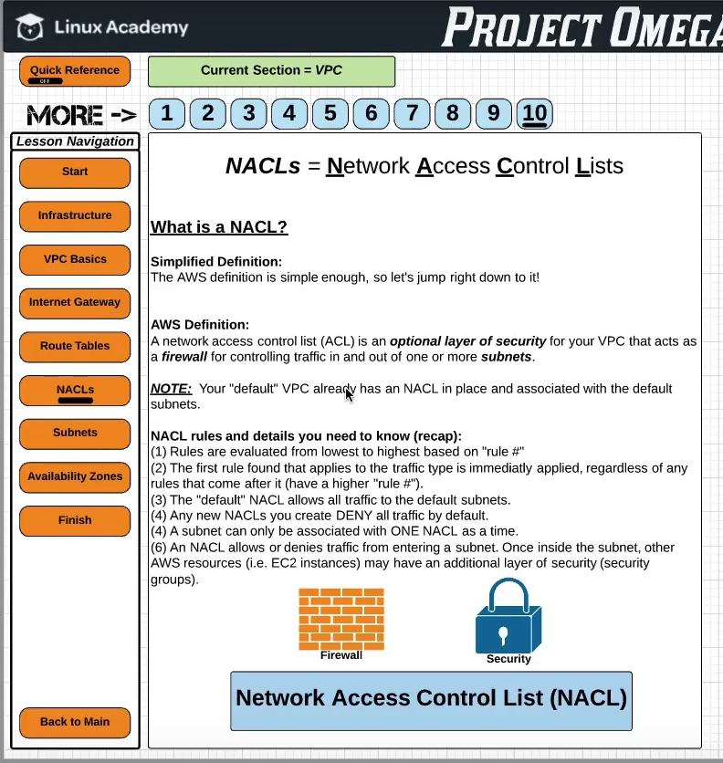

NACL is the security layer between Route table and Subnet. It acts as security layer for subnets with the inbound and out bound rules. Mean it can restrict what type of traffic (http, ssh etc) will come to subnet from route table of vice versa

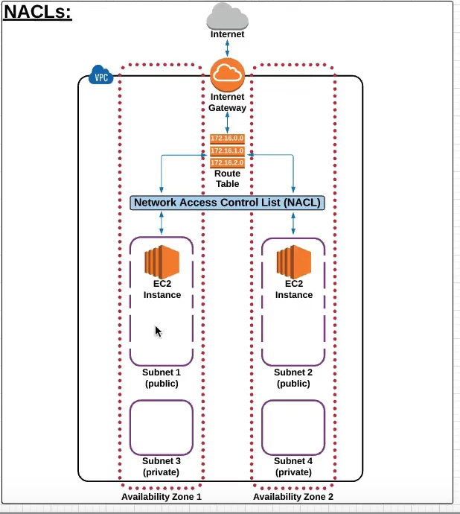

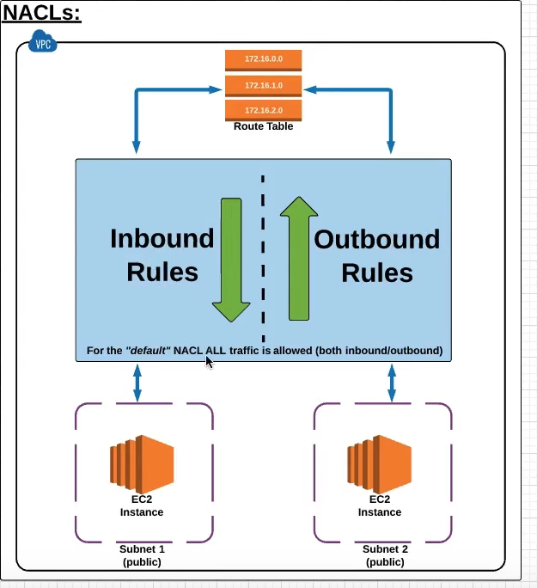

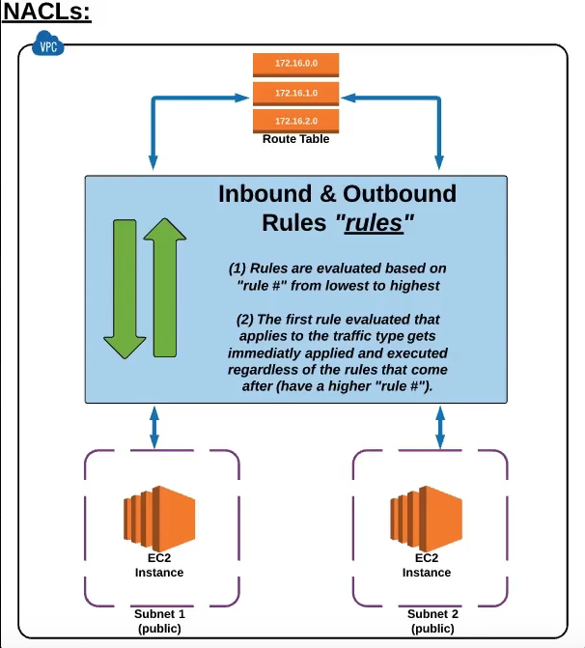

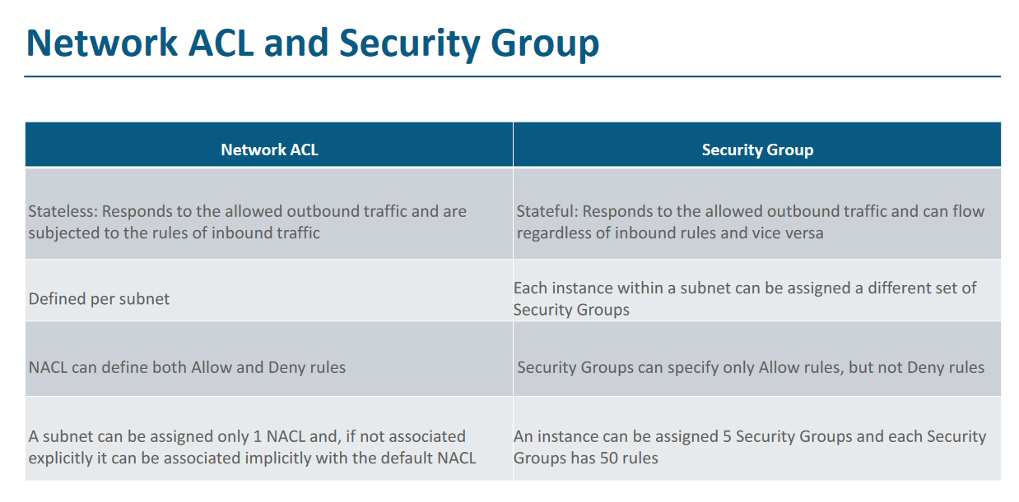

# **NAT – Network Address Translation**

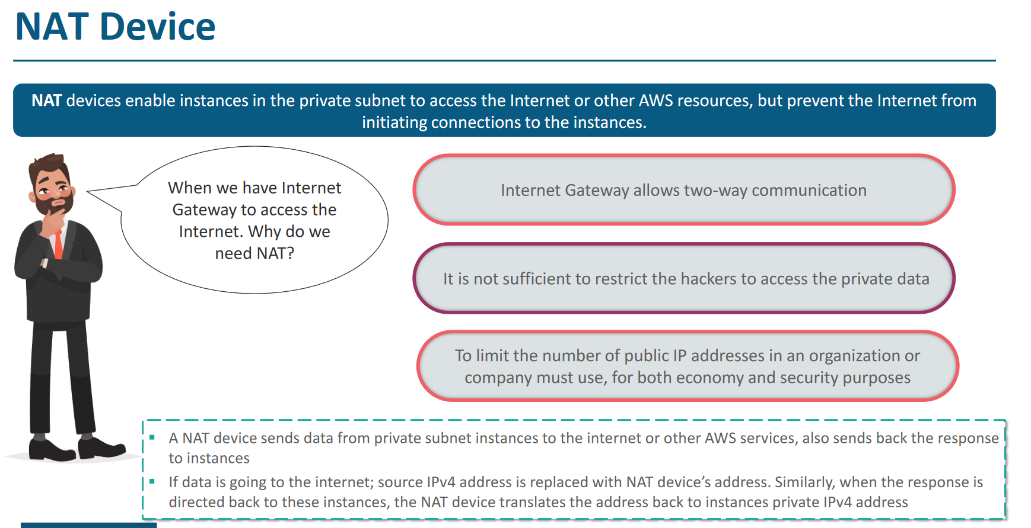

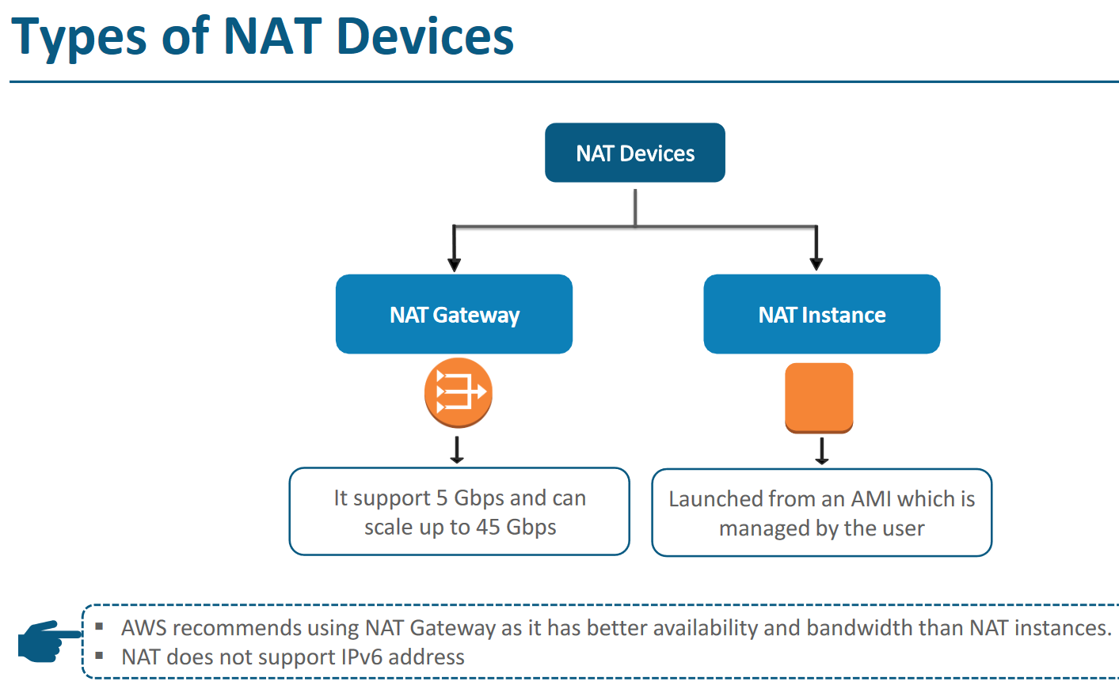

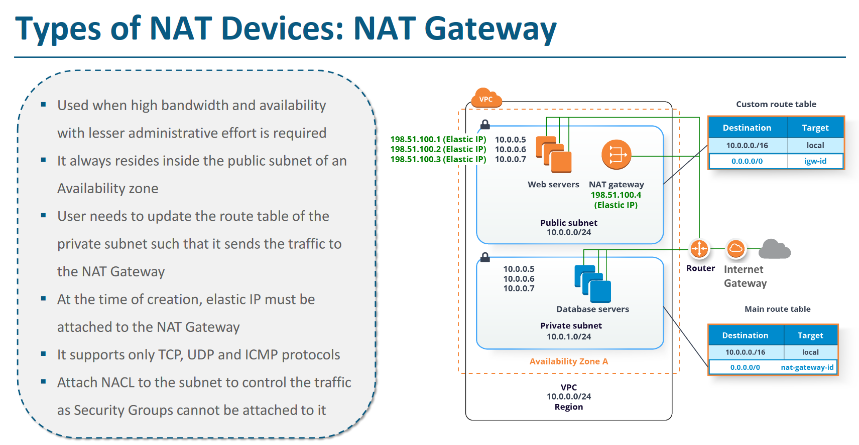

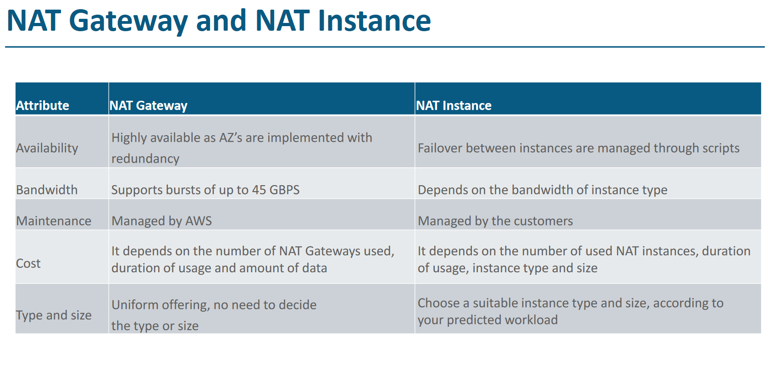

# **VPC Peering**

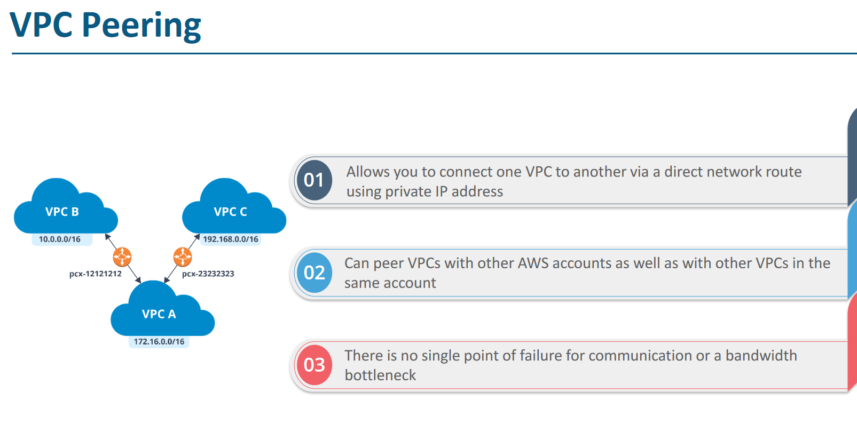

# **VPC END Points**

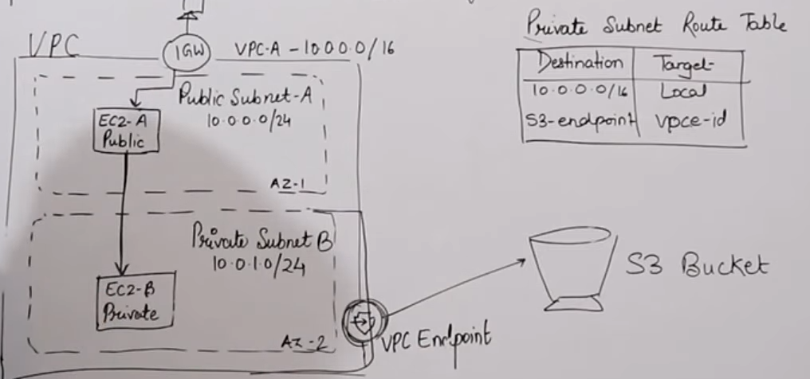

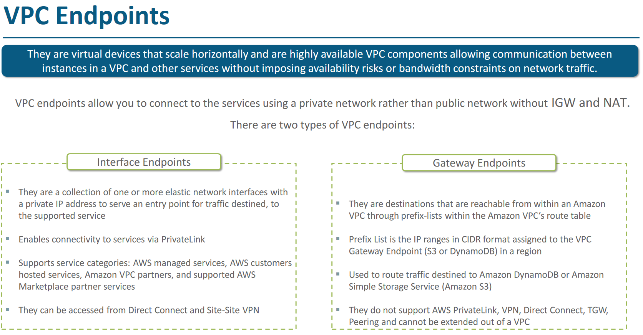

**GateWay End point ( Private Subnet Route table as entry to S3 vpc end point)**

If we don’t want to use the public internet ( means IGW or NAT) to connect to my private instance in private subnet then we can talk to any aws service from private subnet through VPC end point.

Using NAT is very expensive so when we work with private instances, we always use vpc end point to stablish connect to other aws service like S3, Dynmo DB etc.

**Interface Endpoint (Private link)**

It is Elastic Network interface with private IP

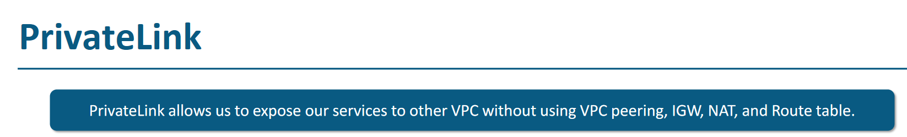



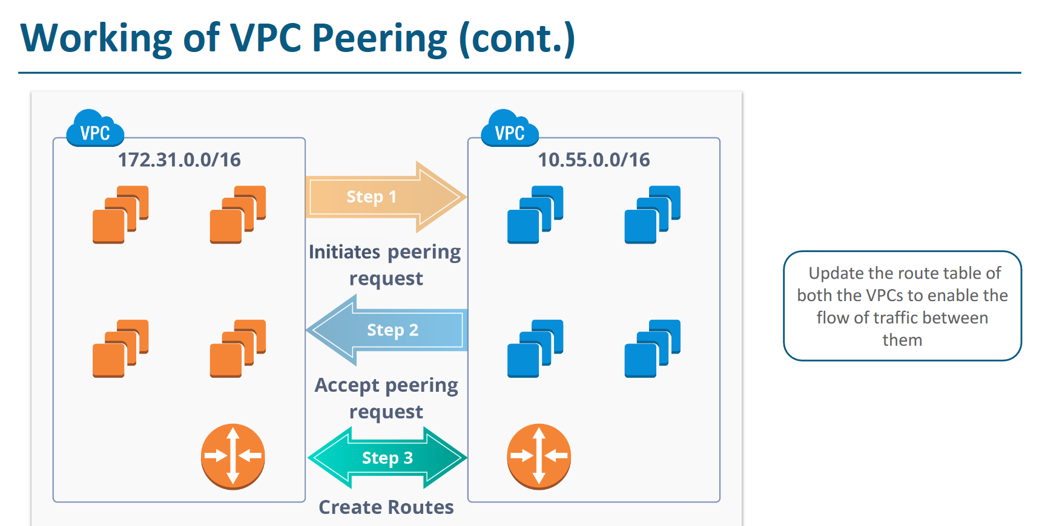

# **VPN and Direct Connect (DC)**

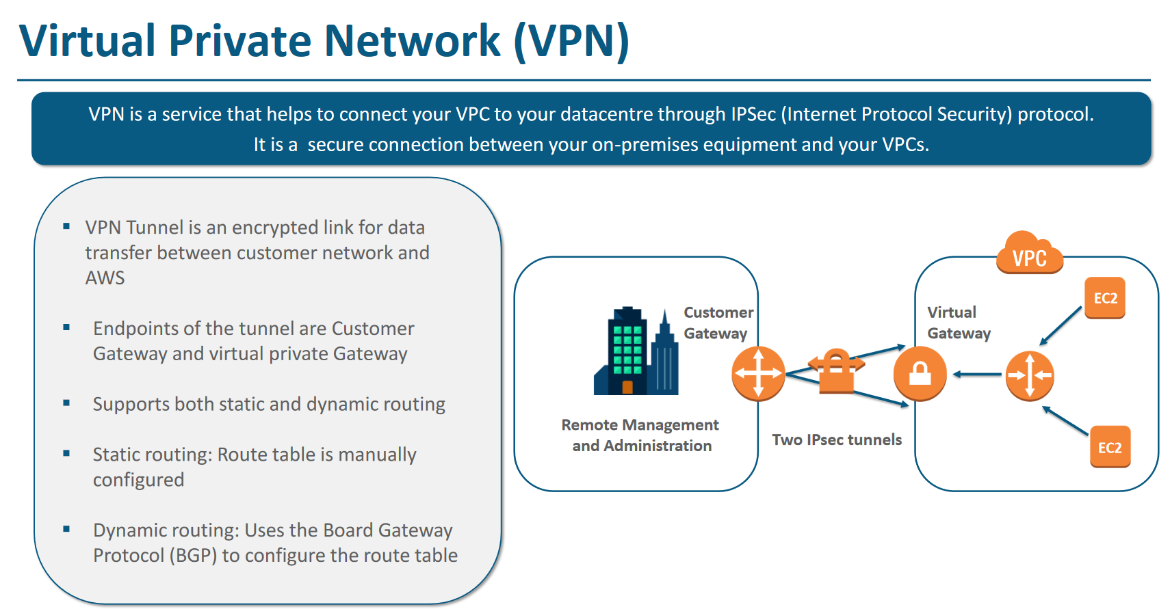

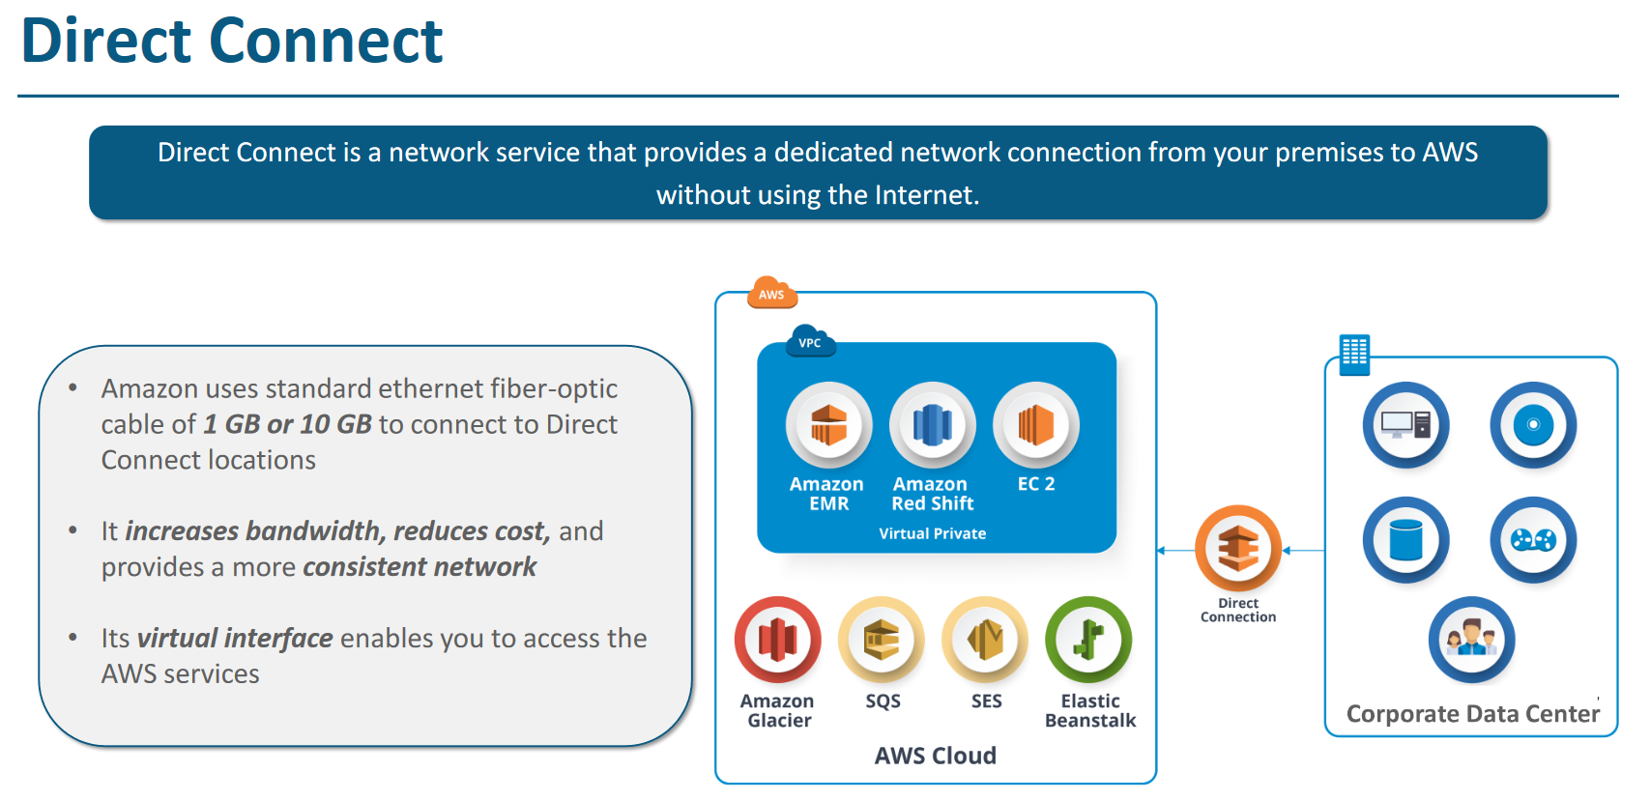

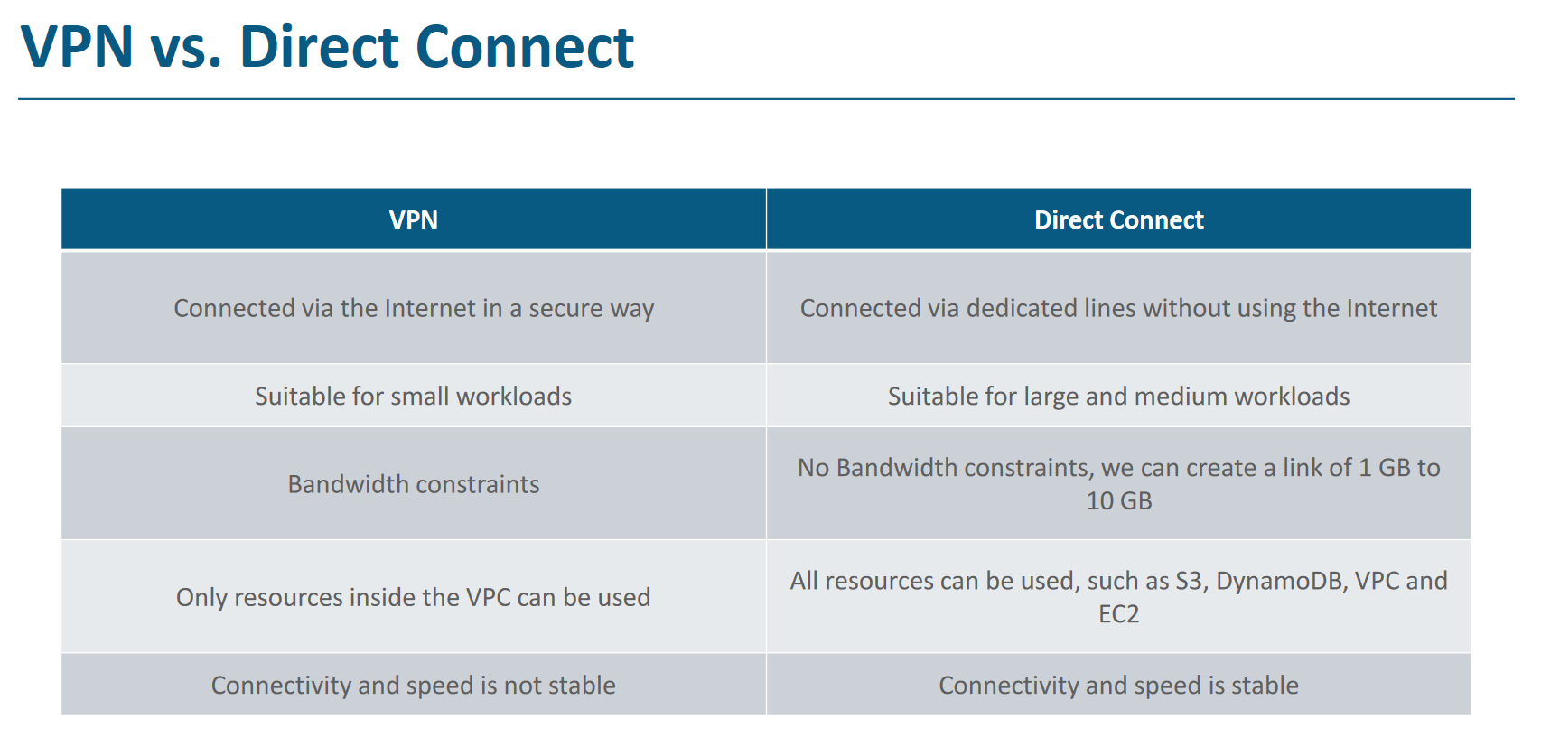

# **Monitoring – CloudWatch**

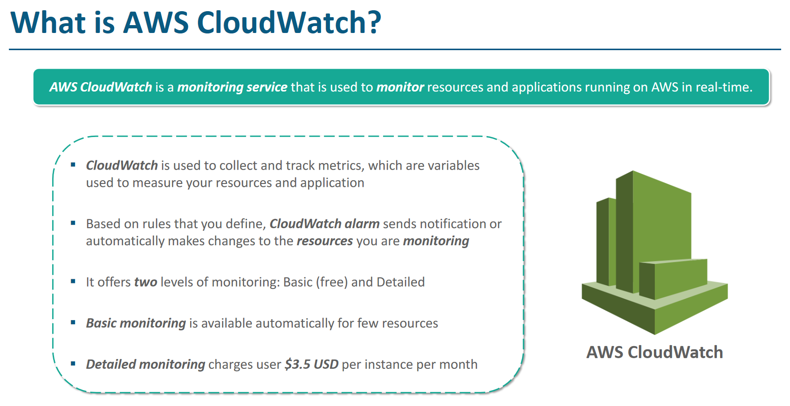

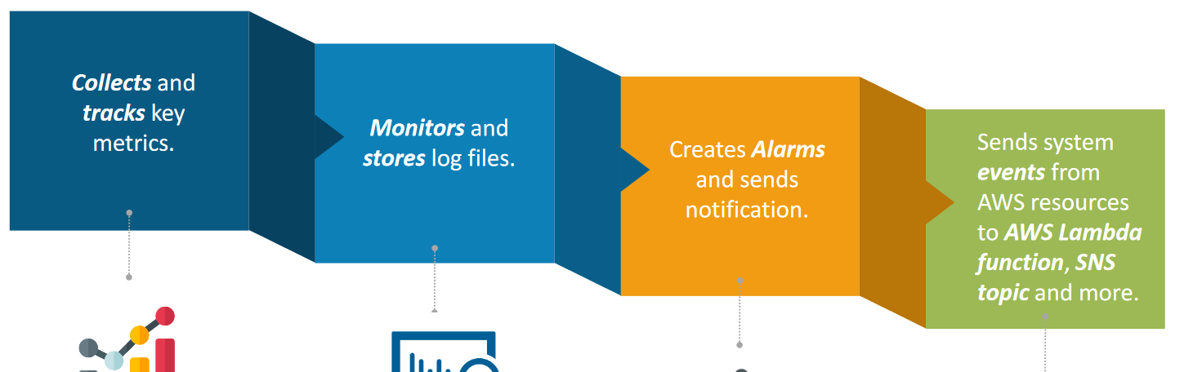

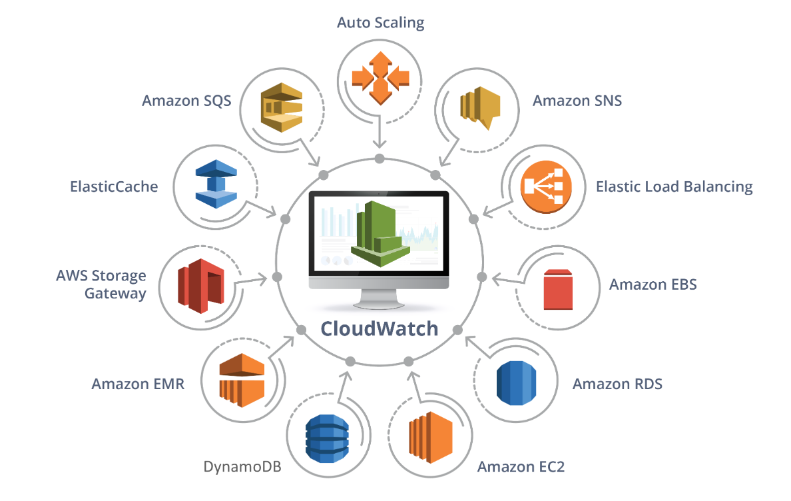

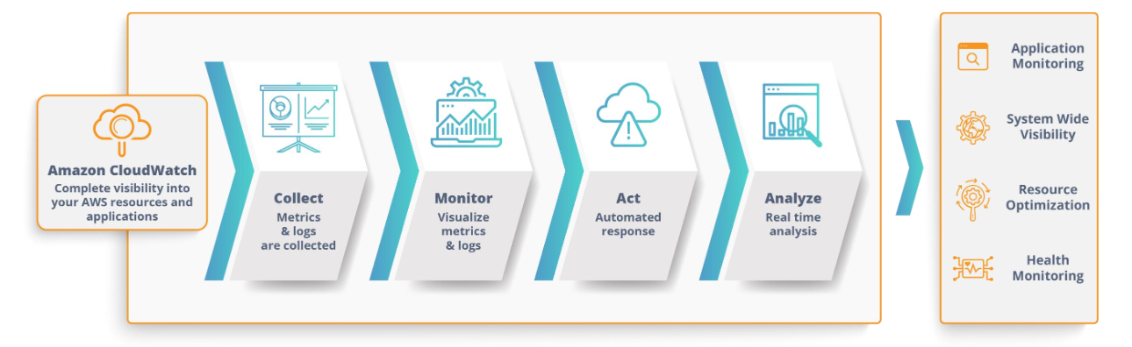

# **Monitoring - AWS CloudTrail**

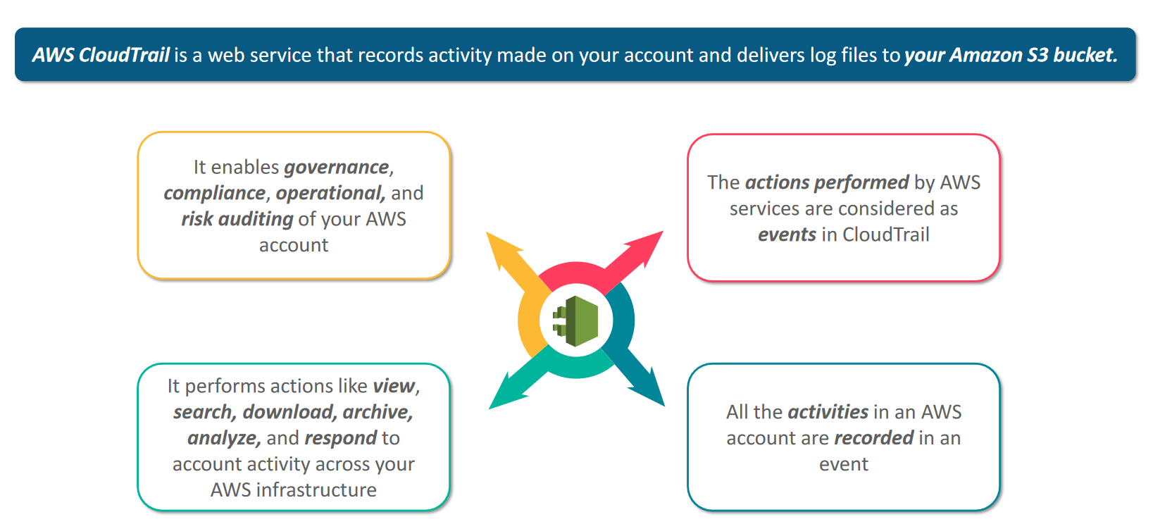

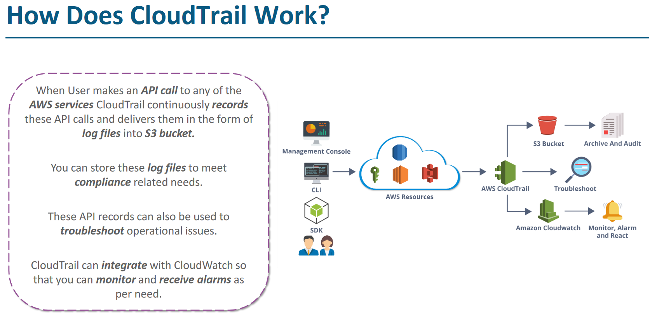

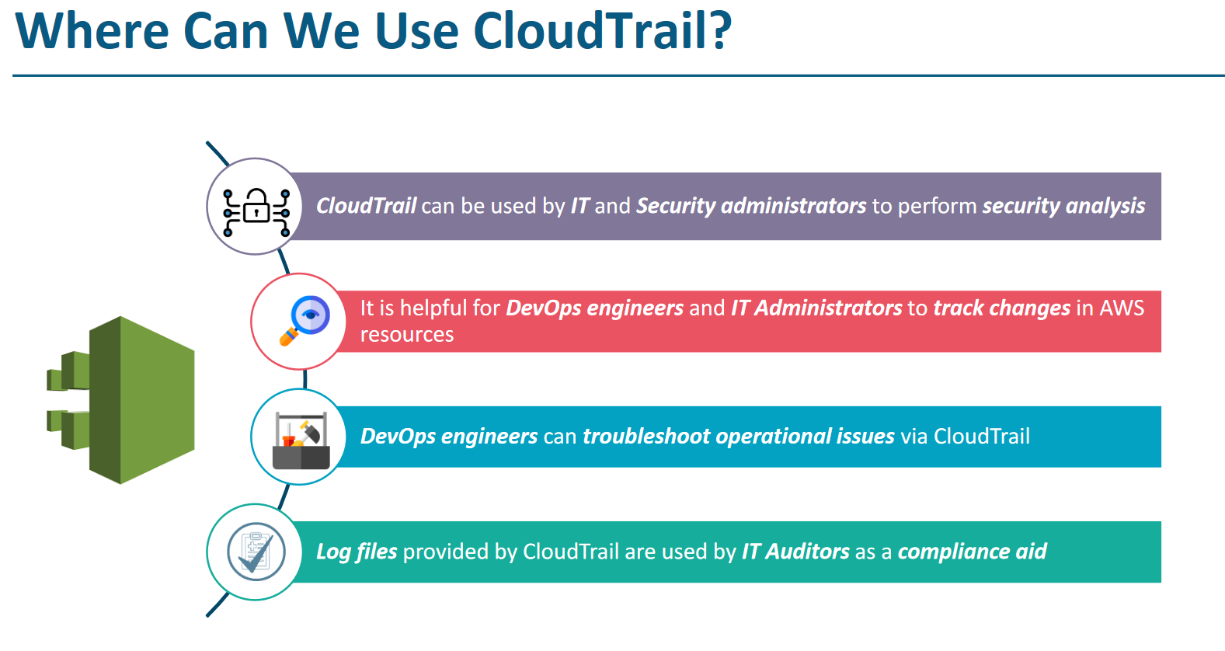

# **AWS Trusted Advisor**

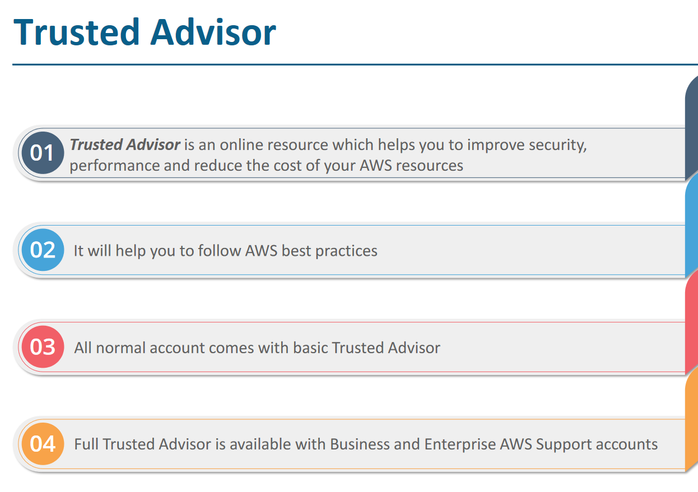

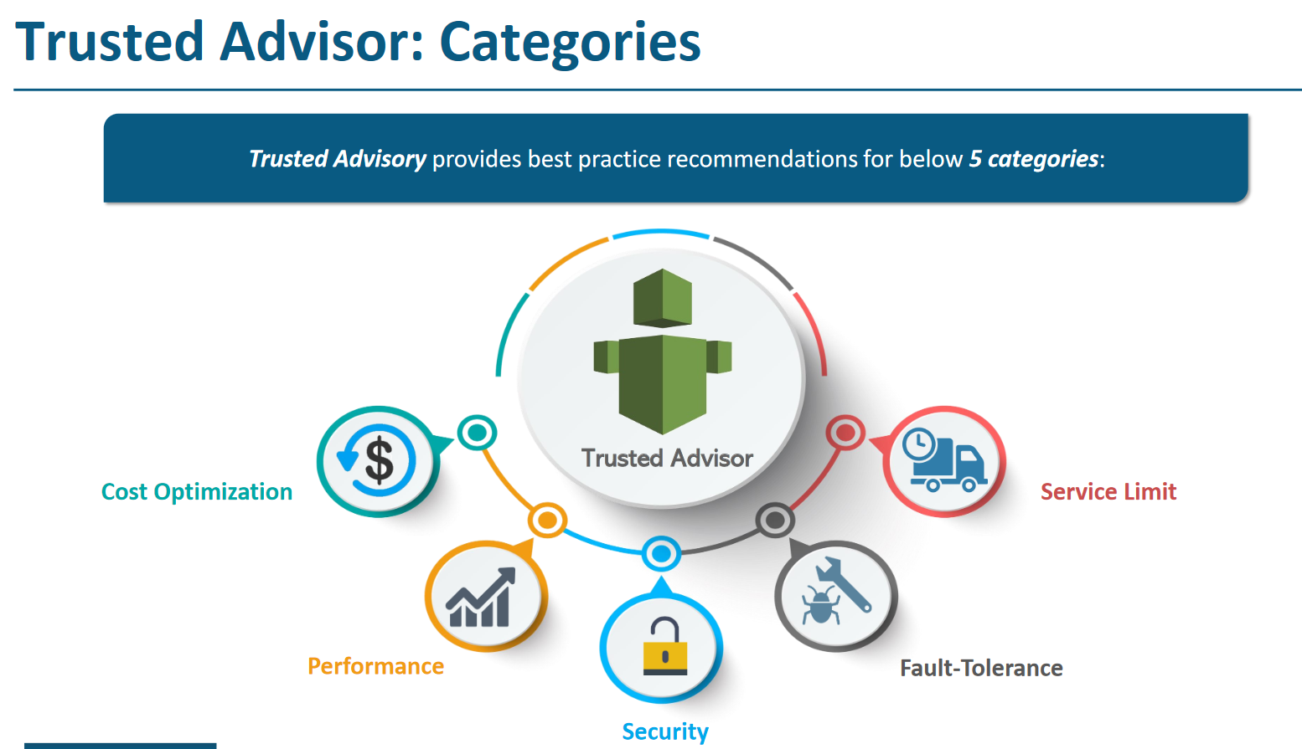

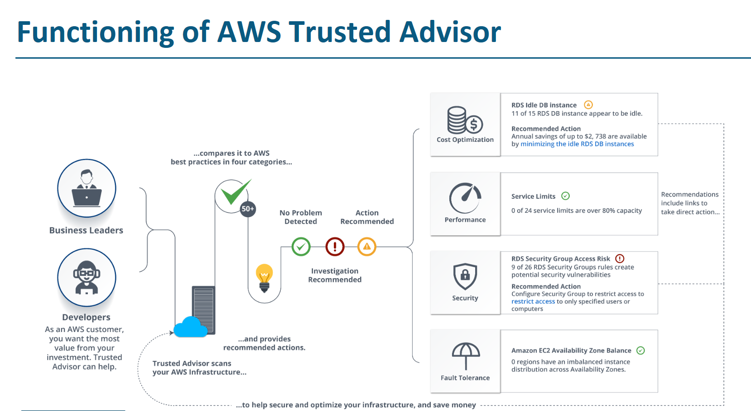

# **Application Services**

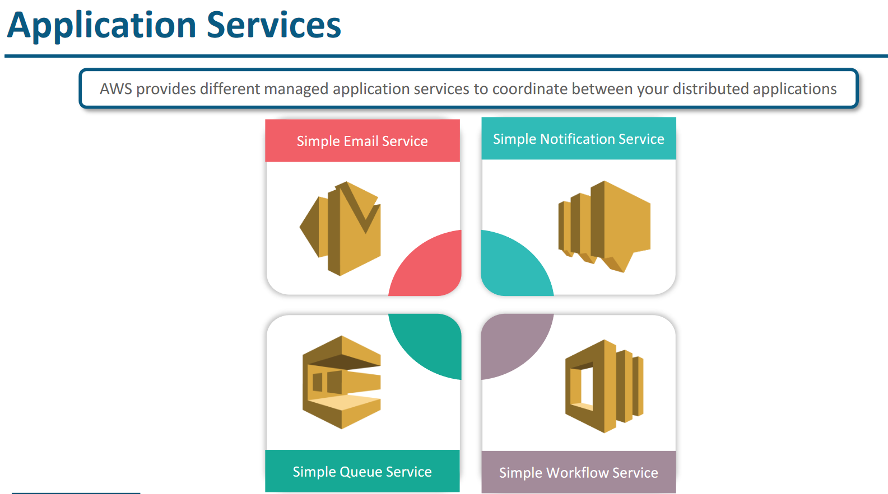

# SES – Simple Email Service

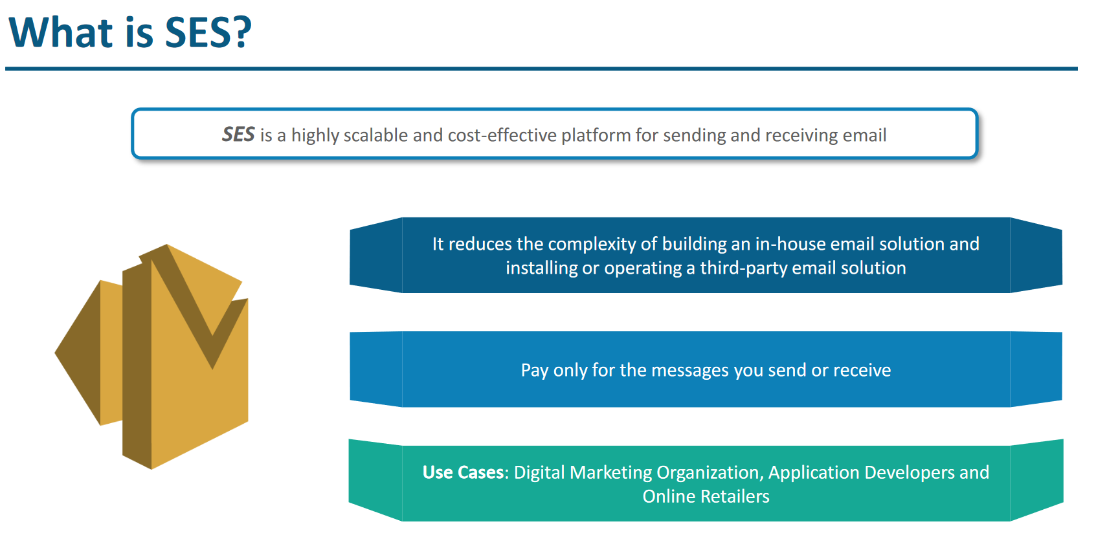

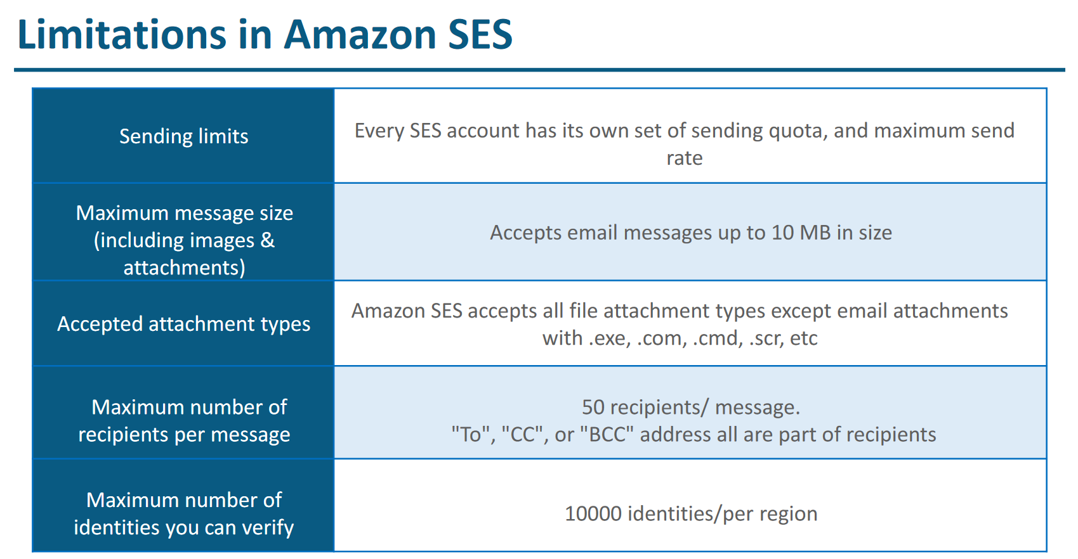

# SNS – Simple Notification service

SNS follow One to many model means 1 publisher publish a message to topic and many subscriber can consume its duplicate copies.

Publisher ------------🡪 Topic--------------🡪 consumer 1

Consumer2

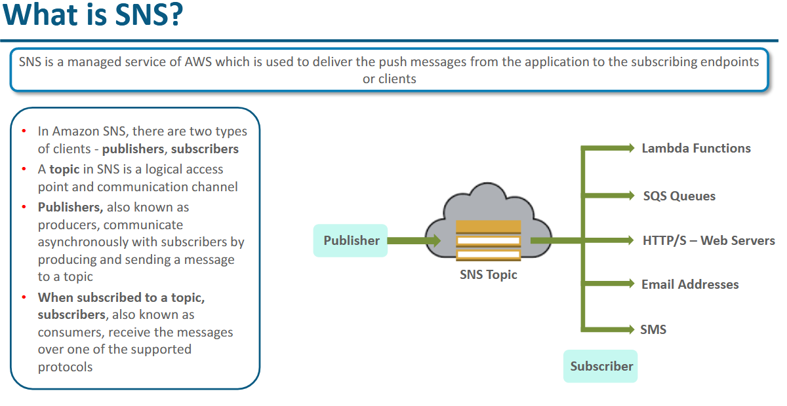

# SQS – Simple Queue Service

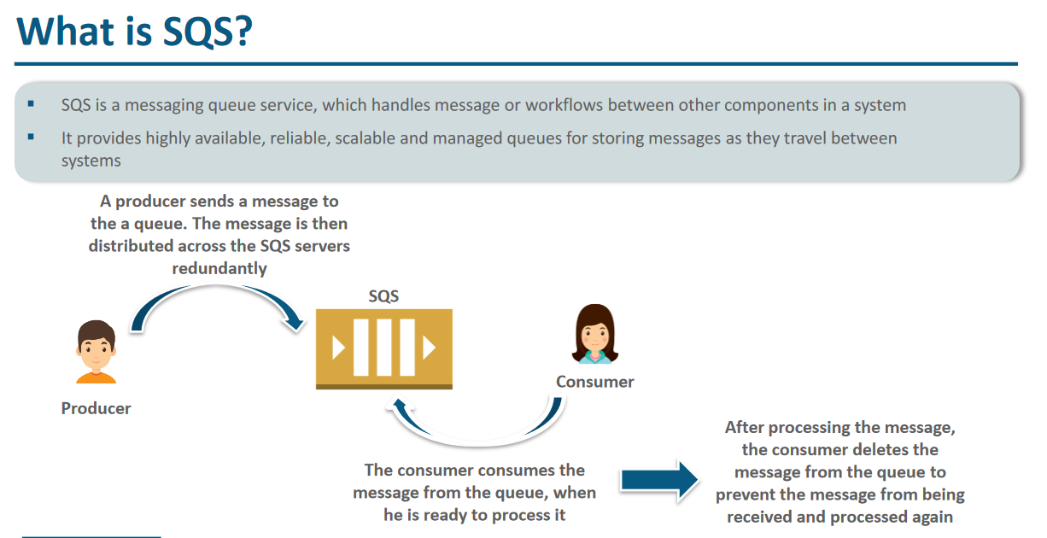

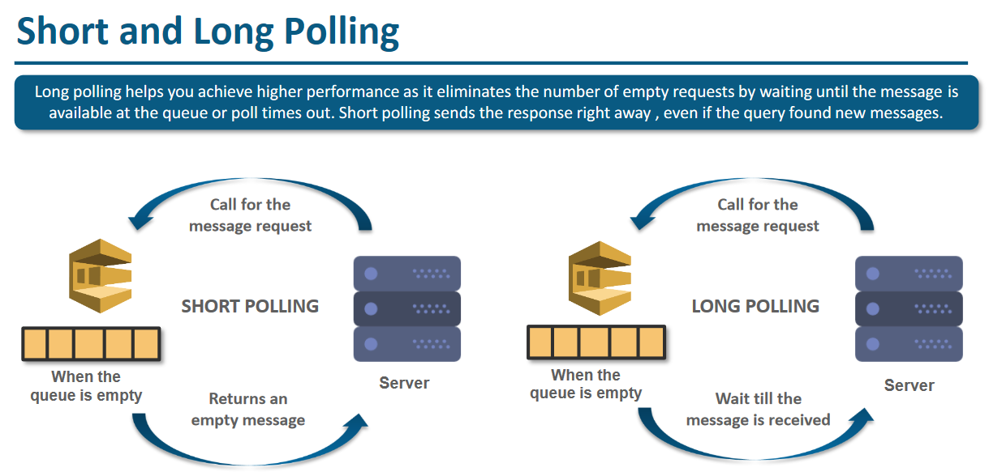

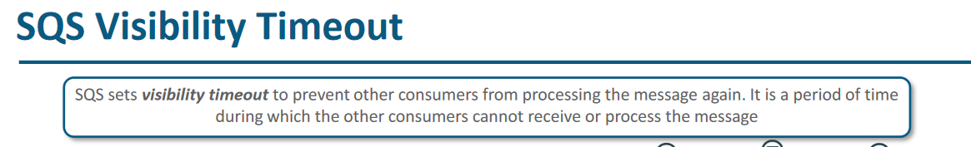

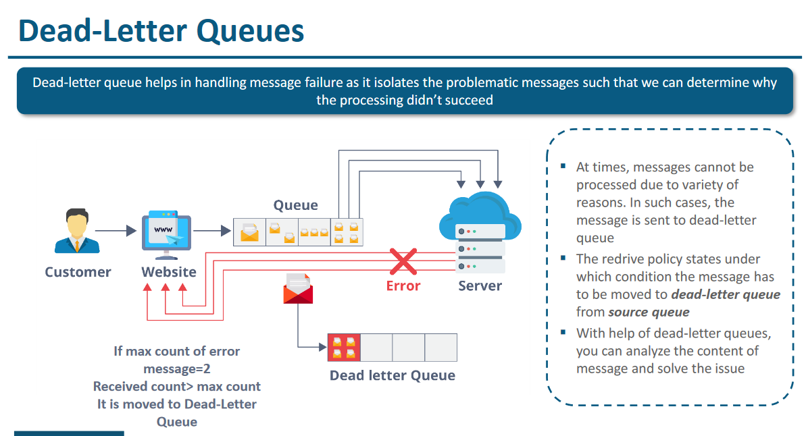

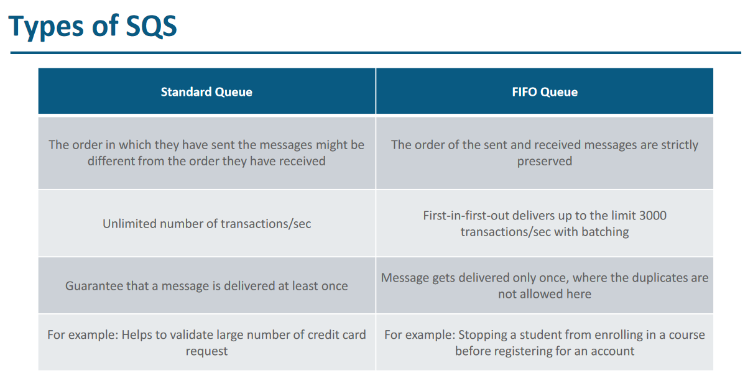

# **AWS SWF**

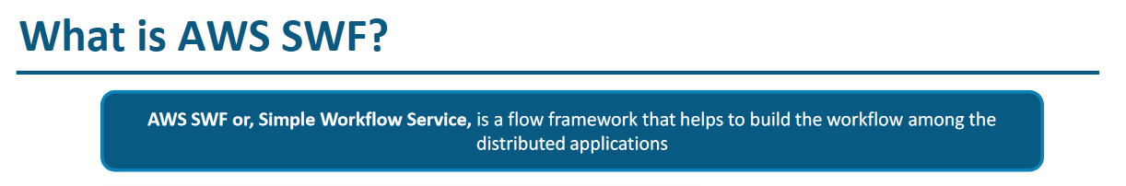

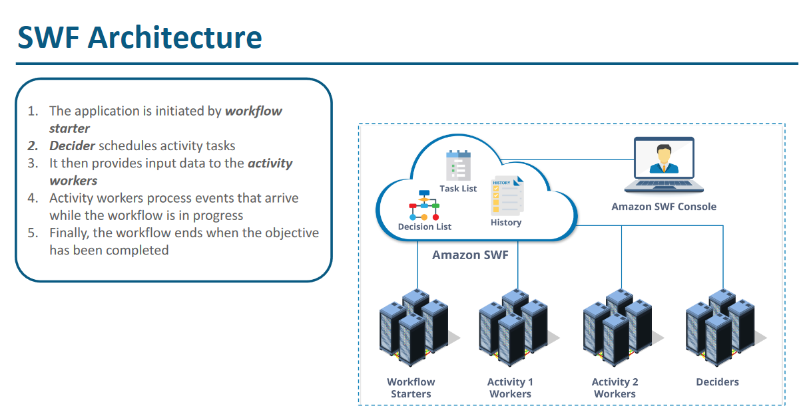

# Amazon MQ

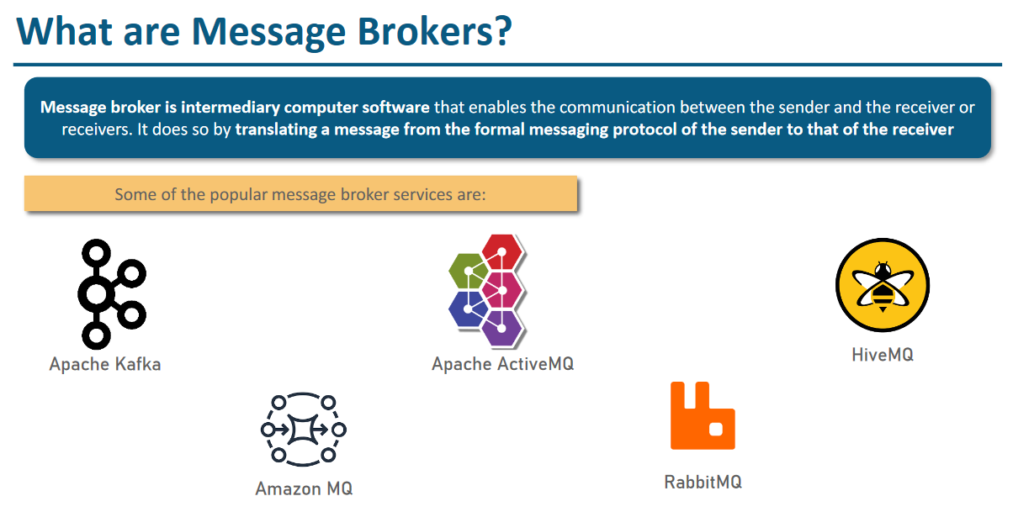

# **Amazon Event Bridge**

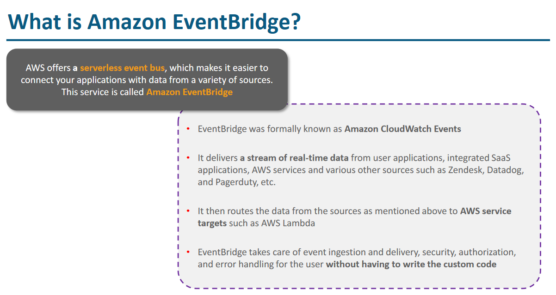

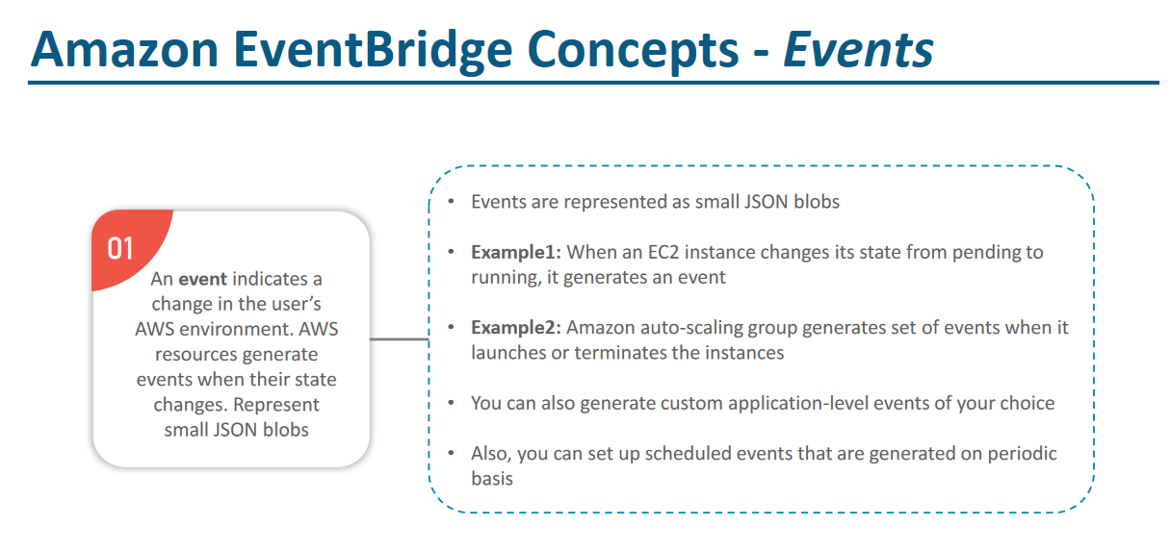

# **AWS Lambda**

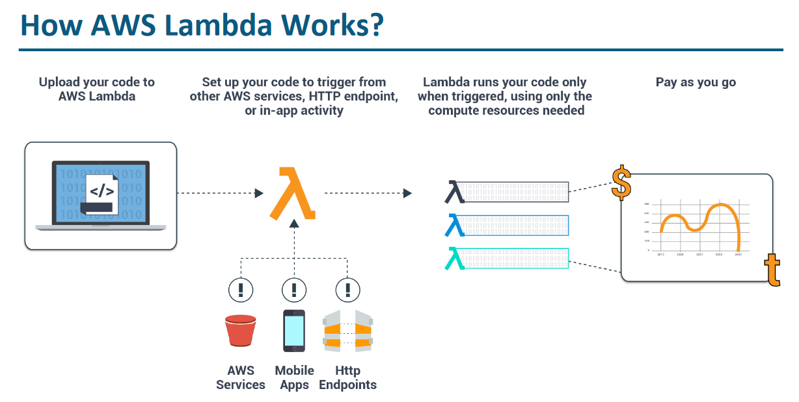

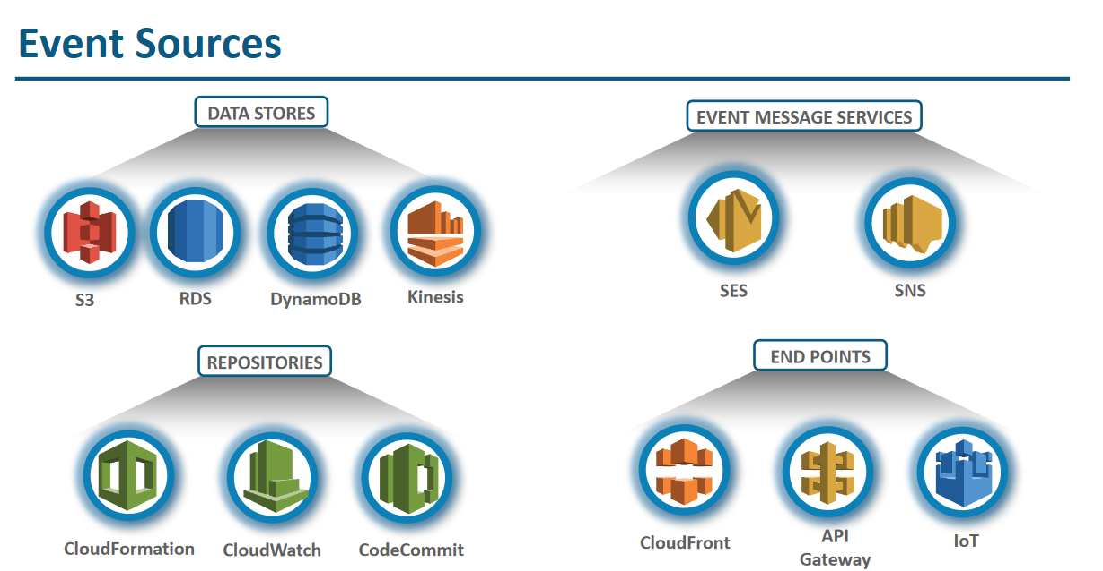

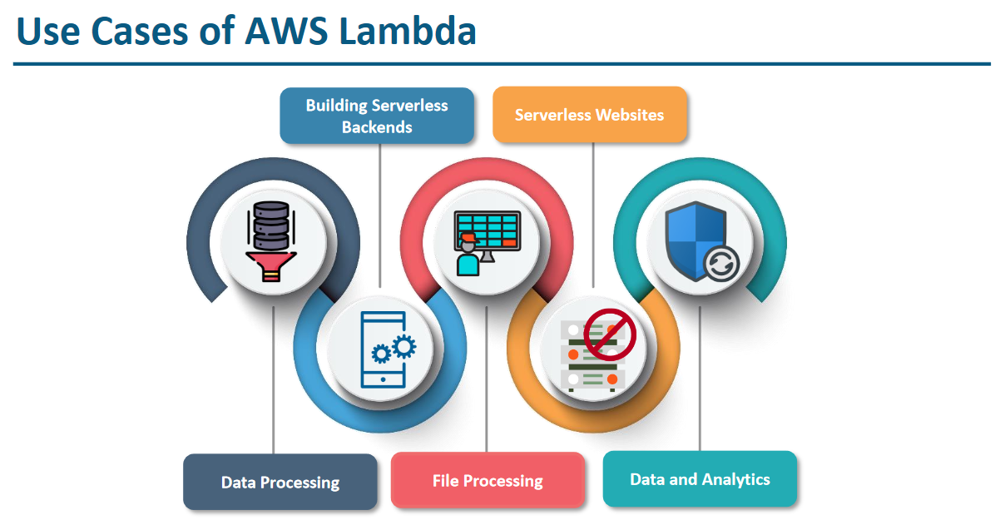

# **AWS SAM – Serverless Application Model**

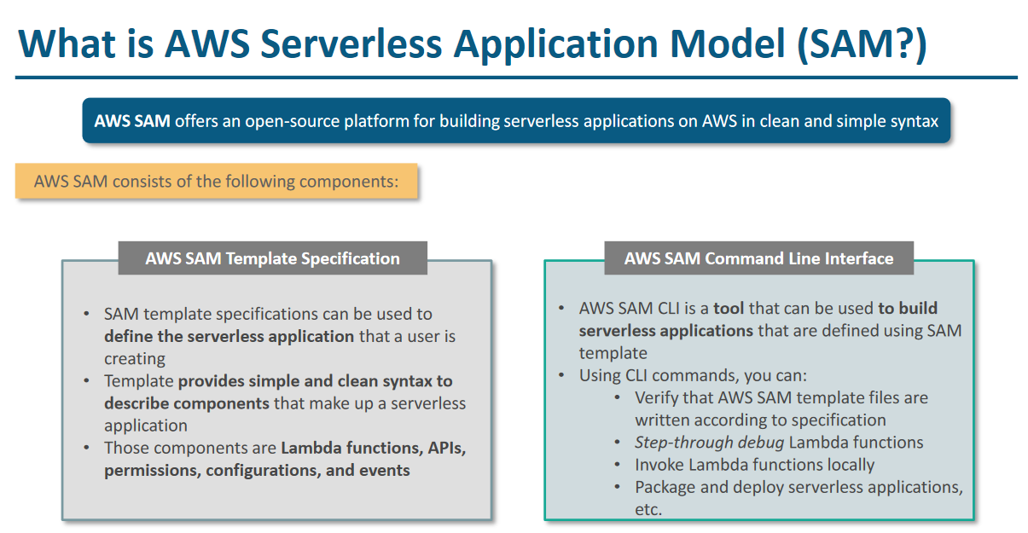

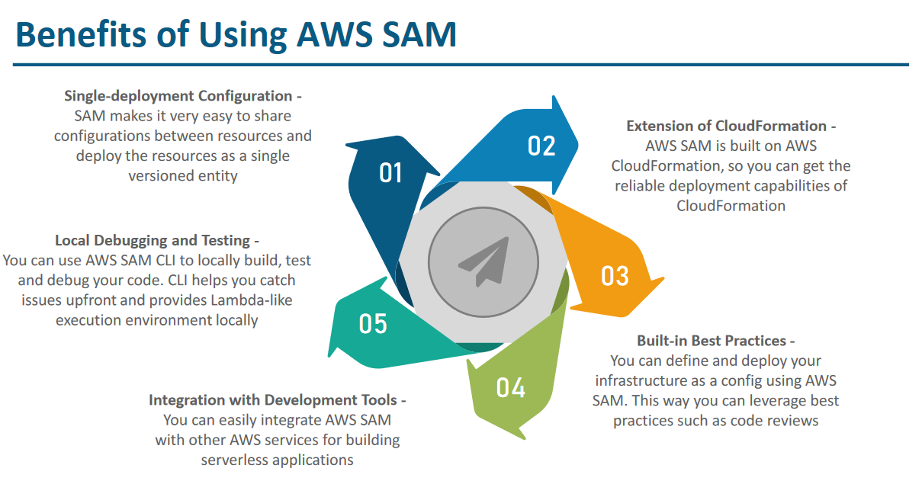

# **Cloud Front (CDN – content delivery network)**

